Capture with confidence
Sennheiser and Neumann showcase microphone and monitoring highlights at IBC

Wedemark/Amsterdam, 20 August 2019 – Whether it’s the latest wireless gear, tools for immersive audio or class-leading equipment for the studio: The Sennheiser and Neumann solutions shown at IBC (stand 8 D.50) guarantee excellent audio quality for productions of any type and size. Highlights presented include: Sennheiser’s entry-level 2.4 GHz XS Wireless Digital systems for DSLR/DSLM audio; the professional SK 6212 UHF mini-bodypack transmitter and EK 6042 camera receiver for location and studio work; and the Neumann KH 750 DSP subwoofer and Neumann NDH 20 studio headphones for critical monitoring applications.

Producers and creators visiting stand 8 D50 will discover a wide choice of wireless microphone systems, with series including the XSW-D, AVX, evolution wireless, and Digital 6000 and Digital 9000 systems. These provide high-quality wireless transmission in various frequency ranges – 2.4 GHz, 1.9 GHz and UHF – for prosumer and professional use.

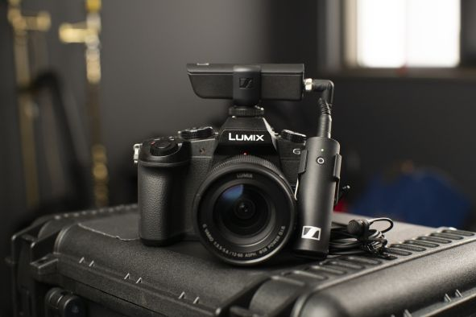 | 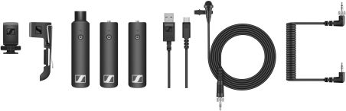  XS Wireless Digital operates on 2.4 GHz for license-free worldwide use – pictured above is the XSW-D ENG Set

Wired on-camera microphones on show include the popular Sennheiser MKE series and Sennheiser’s industry-standard MKH 8060 and MKH 416 shotgun microphones as well as Neumann KMR 81 i and KMR 82 i.

Quality audio for your DSLR/DSLM: Sennheiser showcases the wired camera microphones MKE 400 (mini-shotgun), MKE 440 (stereo) and MKE 600 (shotgun, left to right) | 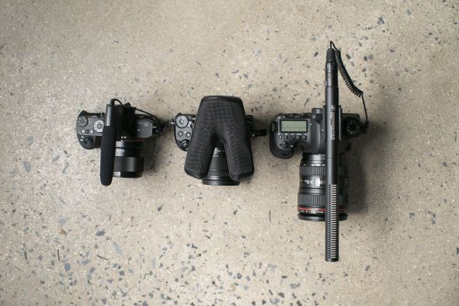

Studio and location monitoring
When it comes to accurate monitoring via headphones, Neumann’s NDH 20 headphones are an outstanding solution for the studio. They are joined by Sennheiser’s classic HD 25 as well as the HD/HMD 300 series headphones and headsets for the production studio and ENG work.

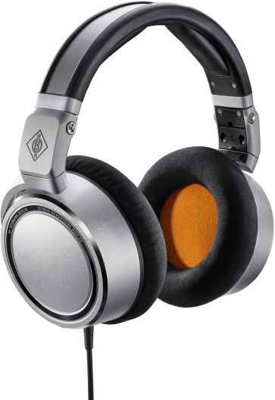 | The Neumann NDH 20 studio headphones

No presentation of audio solutions at IBC would be complete without Neumann’s studio monitors. These can be experienced in a stereo set-up in two configurations: two KH 80 DSP monitoring loudspeakers with a KH 750 DSP subwoofer, and two KH 310 monitoring speakers with a KH 750 DSP. Visitors can see both set-ups controlled by the Neumann.Control software.

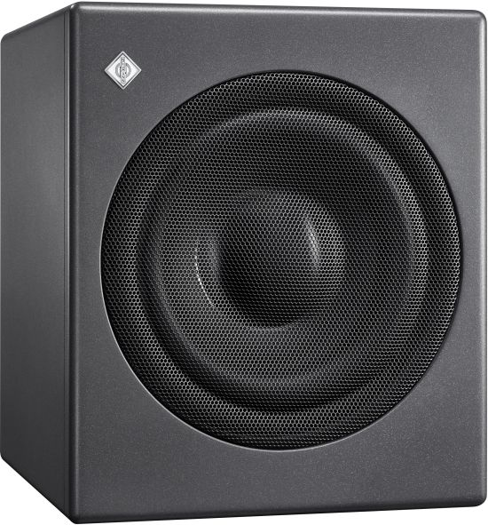  The KH 750 DSP is a particularly compact subwoofer for broadcast, music and post production studios | 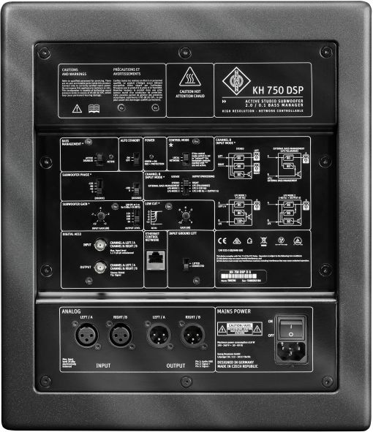

Neumann studio microphones on show include the BCM 104, KM 184, TLM 103 and the U 67.

AMBEO Immersive Audio
In the AMBEO immersive audio area, two full end-to-end workflows for multi-channel and Ambisonics productions will be displayed. A particular highlight of this set-up is the opportunity for visitors to create an audio mix for both workflows in VR – all via the immersive interface of dearVR SPATIAL CONNECT from Dear Reality.

Also on display is the prototype of the AMBEO Sports Microphone Array for capturing 360° audio.

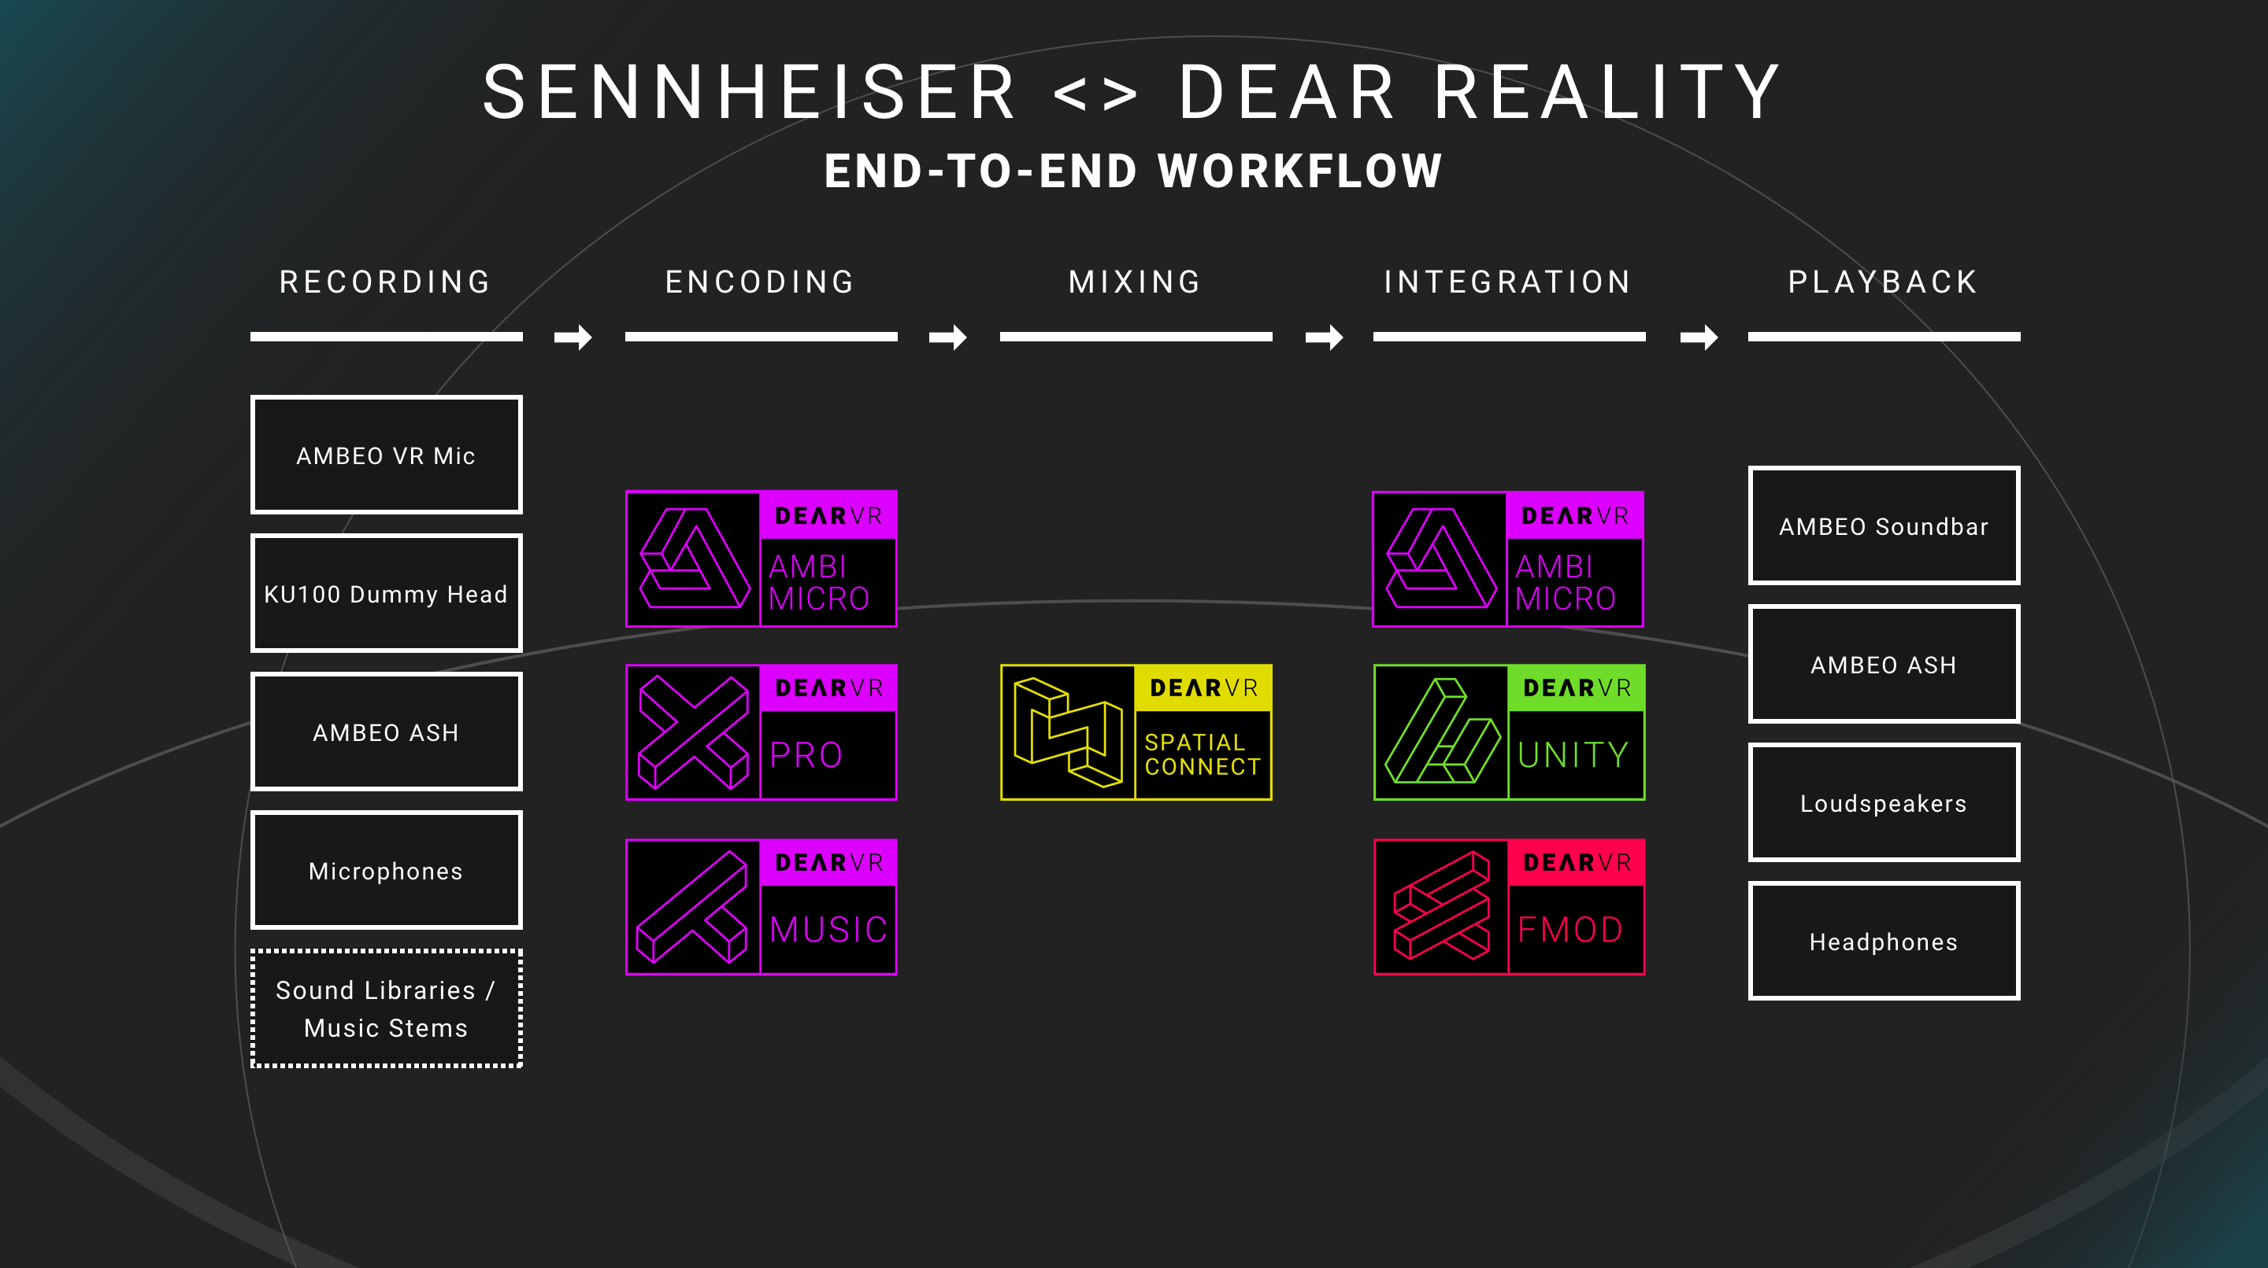 | Sennheiser and Dear Reality will show end-to-end workflows for immersive audio productions

Within the framework of the AMBEO for VR partnership program, Solid State Logic will show what a live immersive television mix recorded with the Sennheiser AMBEO VR Mic and various spot microphones can look like. Live workflow demos include decoding and mixing and will take place at the SSL stand (Hall 8, D.83) at 4 p.m. every day.

Visit Sennheiser and Neumann at IBC, Hall 8, Stand D.50.

The images in this press release can be accessed here: http://sennheiser-brandzone.com/pincollection.jspx?collectionName={ff920b6f-e984-4acd-a9f6-5b67c7f37351}

About Sennheiser and Neumann
Shaping the future of audio and creating unique sound experiences for customers – this aim unites Sennheiser employees and partners worldwide. Founded in 1945, Sennheiser is one of the world’s leading manufacturers of headphones, loudspeakers, microphones and wireless transmission systems. Since 2013, Sennheiser has been managed by Daniel Sennheiser and Dr. Andreas Sennheiser, the third generation of the family to run the company. As part of the Sennheiser Group, Georg Neumann GmbH, known as “Neumann.Berlin”, is the world’s leading manufacturer of studio microphones. Founded in 1928, the company has been recognized with numerous international awards for its technological innovations. Since 2010, Neumann.Berlin has expanded its expertise in electro-acoustic transducer design to also include the studio monitor market, and has recently added studio monitoring headphones to its portfolio. In 2018, the Sennheiser Group generated turnover totaling €710.7 million.
www.sennheiser.com | www.neumann.com

Global Press Contacts

Andreas Sablotny Stephanie Schmidt
andreas.sablotny@neumann.com stephanie.schmidt@sennheiser.com
T +49 (30) 417 724 – 19 +49 (5130) 600 – 1275

