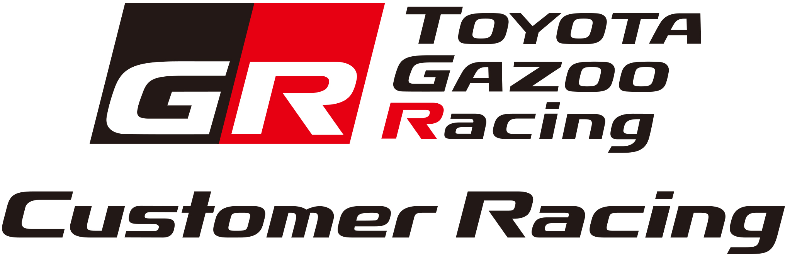
Monday 16 March 2020
TOYOTA Motorsport GmbH

GR Supra GT4 granted SRO GT4 homologation. First customers confirmed.

The new GR Supra GT4 race car has successfully achieved homologation in the GT4 category following technical examinations and track tests by the governing Stéphane Ratel Organisation (SRO).

SRO officials scrutinised the GR Supra GT4 in detail prior to testing its performance on track at Circuit Paul Ricard in southern France last week, in order to determine the appropriate Balance of Performance, which is applied to all GT4 cars in order to ensure equal competition.

Development of the GR Supra GT4 at TOYOTA Motorsport GmbH (TMG) began in early 2019 and included an exhaustive test programme, covering more than 12,000km at circuits around Europe. With lead test driver Stéphane Ortelli contributing his experience, as well as drivers from a range of backgrounds, GR Supra GT4 cars were optimised in a variety of conditions.

Designed to appeal to drivers of all levels, the GR Supra GT4 benefits from its unique Intelligent GT4 Racing System which, through user-friendly electronics and automatic functionality, minimises distractions to allow the driver to focus fully on racing the car.

Performance comes via a three-litre in-line six-cylinder engine with single twin-scroll turbo charger which has been tuned to 430hp, combined with a 7-speed sports automatic transmission driving the rear wheels. Ravenol provides lubricant technology to ensure reliability and high performance.

With GT4 homologation secured, the first GR Supra GT4 race cars will be delivered to customers immediately, ready to participate in a range of different series around Europe.

Ring Racing, located near the Nürburgring, has purchased two cars and will enter one car in the ADAC GT4 Germany championship, which features six events this year, and another car at the nine-round Nürburgring Langstrecken Serie, formerly known as VLN. Ring Racing will additionally operate one of their cars in the Nürburgring 24 Hours on behalf of Novel Racing.

France-based CMR will also compete with two GR Supra GT4 cars this year, with one car taking on the challenge of the European GT4 Series and a second car participating in the six-round French GT4 Series.

In the United Kingdom, Speedworks Motorsport, already participating in the British Touring Car Championship with a Toyota Corolla, will enter one GR Supra GT4 for Sam Smelt and James Kell in the seven-round British GT series where GT3 and GT4 cars compete in the same races.

High customer demand for the GR Supra GT4 meant the first units were sold out quickly, and orders have already been taken for the next batch of cars to be produced, with deliveries planned for early summer.

High-resolution, copyright-free photography is available at www.tgr-dam.com.
GR Supra GT4 Technical Specifications
Chassis
Length | 4,460mm
Width | 1,855mm
Height | 1,250mm
Weight | 1,350kg *
Construction | Steel body with high-strength roll cage acc. to FIA regulations
Front splitter | Natural fiber composite
Rear wing | Natural fiber composite
Fuel tank | ATL FT3 safety fuel cell with fast refueling system (120 L)
Driver’s seat | OMP racing seat with six-point safety harness (FIA 8862-2009)
Engine & Transmission
Type | In-line six-cylinder, single twin-scroll turbocharger
Displacement | 2,998 cm³
Max. power | 430hp  different power sticks available to comply with BOP
Max. torque | 650Nm*
Engine management | Magneti Marelli ECU
Exhaust system | Akrapovič racing exhaust system with catalytic converter
Lubricants | Ravenol
Transmission | 7-speed automatic with paddle shift, rear-wheel drive
Differential | Motorsport-specification limited-slip differential
Driveshaft | GKN Motorsport high torque spec
Suspension, Steering, & Brakes
Front suspension | MacPherson strut
Rear suspension | Multilink
Shock absorbers | KW adjustable racing dampers
Steering | Electric, rack and pinion
Brakes （Front) | Six-piston racing calipers (Brembo), Steel 390mm brake discs
Brakes （Rear) | Four-piston racing calipers (Brembo), Steel 355mm brake discs
Tyres Front/Rear | 305/660-18 Front / 305/660-18 Rear (Pirelli)
Wheels | OZ five-hole 11 x 18in
Electronic Control System
Traction control | Standard
Motorsport ABS | Standard
8" Driver display | Standard
Data logger | Standard
Rear view camera | Option
Tyre pressure monitoring system | Option
Suspension travel sensors | Option
Illuminated car number | Option
Equipment
Fire extinguishing system | Standard
Air jack system | Standard
Drinking system | Option
Homologated endurance package | Option

Contact

TOYOTA Motorsport GmbH
Email: alastair.moffitt@toyota-motorsport.com

TOYOTA Motorsport GmbH official website:
www.racingbytmg.com

TOYOTA GAZOO Racing’s GR Supra GT4 project is supported by the following partners:
