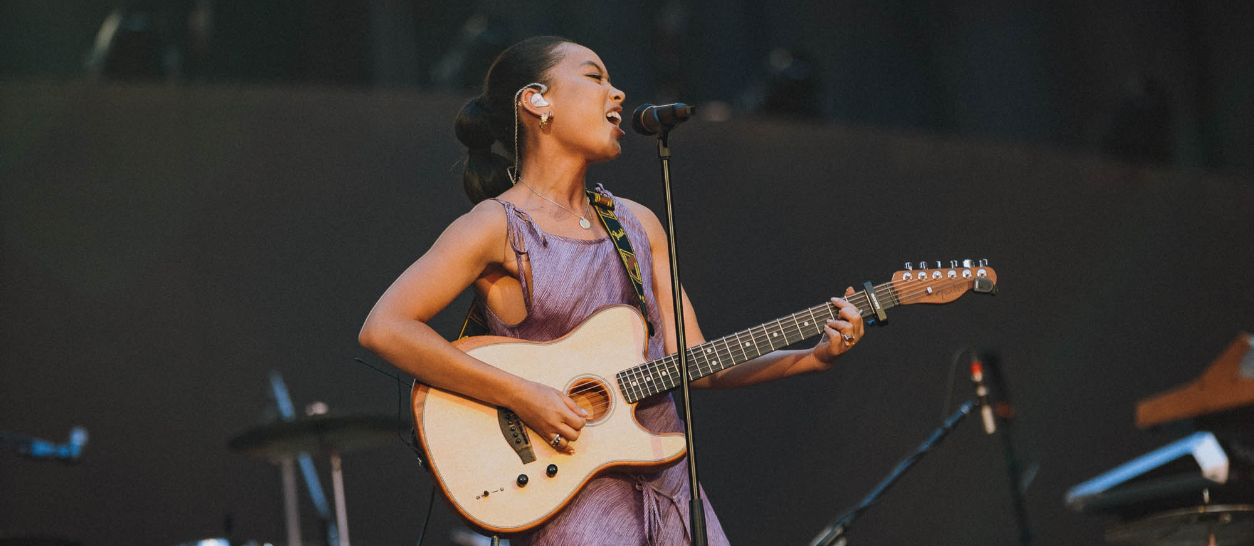
Photo credit: Tim Toda

BRITs Rising Star winner and music sensation Griff chooses Sennheiser’s Digital 6000 wireless microphone system

Digital 6000 delivers flawless audio and solid reliability

Wedemark, December 2022 – The 21-year-old music sensation from Hertfordshire, Sarah Faith Griffiths or, rather, Griff, has only been in the music business for a few years, but her candid and emotional lyrics, woven into uplifting melodies of songs like Black Hole, Good Stuff, and Head on Fire, won her the BRITs 2021 Rising Star Award. This year, the breakout star switched to Sennheiser’s Digital 6000 wireless microphone system, which has given her extra freedom on stage thanks to its exceptional RF robustness.

With over 300 million total streams and more than four million monthly listeners, Griff has amassed a large and zealous fanbase. Her 2022 debut headliner tour across the US, Europe and UK saw her play to thousands of enthusiastic fans, and she supported some of the world’s best-selling artists, including Ed Sheeran and Florence + the Machine.

Tim Boardman has acts like Solange, Tyler the Creator, AJ Tracey, Giggs, Ty Dolla $ign, Tori Kelly, Kodaline and Third Eye Blind to his list of credits, and he is now Griff’s tour manager, too. “Lionel Miller, our FOH, and I took over at the beginning of 2022 for her first US tour. It was a good time to bring in new people and try out the new gear for a very busy year ahead,” says Boardman.

Griff had used a competitor wireless microphone system on the first US leg, but when the team returned to the UK for the larger headliner concerts, they made the decision to switch to Sennheiser’s Digital 6000 wireless microphone system. “We’d had some amazing experiences with these systems on several other acts, and knew it would work well for Griff,” Boardman notes.

The system includes two channels of Digital 6000 for Griff’s vocals and two for her wireless guitar. “With D6000’s audibly better sound quality and exceptionally wide dynamic range, the system perfectly complements the existing Sennheiser and Neumann wired microphone package we have for the rest of the stage setup, which comprises e 835s, e 906s and Neumann 184s,” Boardman explains.

“We have both the MD 9235 capsule and another competitor capsule out with Griff, with the Digital 6000 system allowing us to easily swap between capsules, which is great,” says FOH Miller. “Rappers and singers seem to work really well on the MD 9235 capsule, and we have found it offers exceptional clarity on large-format systems.”

Griff switched to Digital 6000 during her debut tour and uses the SKM 6000 handheld transmitter both with a Sennheiser MD 9235 capsule and a competitor capsule  Photo credit: Ella Renton | 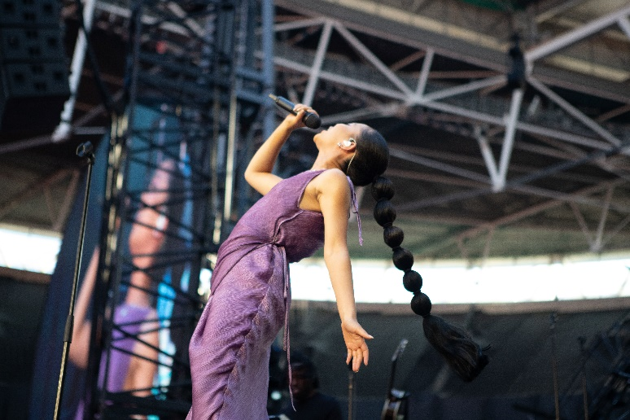

The system is provided by rental company Encore, which Boardman has been working with for over ten years after they were suggested to him by Big Nobby, FOH Engineer for American rock band, Tool.

“They’ve been a consistent, reliable supplier at all levels,” Boardman states. “We haven’t had to rely on Encore too much for support on the Digital 6000 as the system has been working perfectly for us, but they’ve handled regular service for Sennheiser’s G2, G3, G4 systems.”

Boardman and Miller agree that the Digital 6000 system has been a dream to work with, especially for easily finding space in the RF spectrum and for its Dante integration.

“We’ve had no issues whatsoever with D6000,” says Miller. “We have also really enjoyed working with Peter Craig [Relationship Manager, Sennheiser] and appreciated the constant support and attention from Sennheiser. Anything we needed has been accommodated and everyone we’ve met from the company has been great to work with.”

The team is also considering using Sennheiser IEMs, especially since Boardman has been a G2, G3, and G4 user for 15 years since he played in a band, “so the bullet-proof nature of all the units is something I know well!” he adds.

Having done several shows in Los Angeles, where Griff was lighting up the stage with Florence + the Machine at the Hollywood Bowl, Boardman is really excited to see her star continuing to rise as she embarks on new adventures in the New Year.

“We look forward to continuing working with Griff and seeing her win more accomplishments and acclaims,” Boardman concludes. “With the top-tier Digital 6000 on board, we are confident our wireless microphone system will always deliver the highest quality sound and the widest possible dynamic range, even in the most challenging RF environments.”

(Ends)

About the Sennheiser brand
We live and breathe audio. We are driven by the passion to create audio solutions that make a difference. Building the future of audio and bringing remarkable sound experiences to our customers – this is what the Sennheiser brand has represented for more than 75 years. While professional audio solutions such as microphones, meeting solutions, streaming technologies and monitoring systems are part of the business of Sennheiser electronic GmbH & Co. KG, the business with consumer devices such as headphones, soundbars and speech-enhanced hearables is operated by Sonova Holding AG under the license of Sennheiser.

www.sennheiser.com
www.sennheiser-hearing.com

Pro Audio Press Contact

Stephanie Schmidt
Stephanie.schmidt@sennheiser.com
+49 (5130) 600 – 1275

