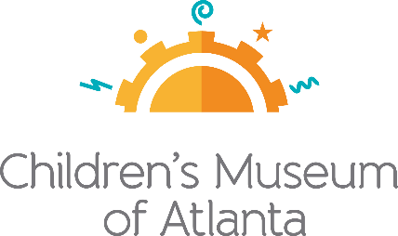
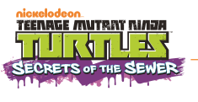

MEDIA CONTACT:
Alison Wentley
BRAVE Public Relations
404.233.3993
awentley@emailbrave.com
FOR IMMEDIATE RELEASE
Turtle Power! Nickelodeon’s Teenage Mutant Ninja Turtles™ Share Secrets of the Sewer, Ninja Tactics and Teamwork at Children’s Museum of Atlanta
Limited-time exhibits opens Jan. 18 – May 10, 2020

ATLANTA (December 11, 2019) – After more than three decades of battling evil and exemplifying teamwork, the beloved Teenage Mutant Ninja Turtles (TMNT) will appear in an exhibit for children and families to enjoy at Children’s Museum of Atlanta. The four funny “heroes in a half shell” will share life lessons and team-building skills with their crime-fighting tactics in Nickelodeon’s Teenage Mutant Ninja Turtles™: Secrets of the Sewer™ opening Jan. 18, 2020 in Atlanta.
In the exhibit, families will be transported to the underground home of the crime-fighting heroes to see what really happens in their secret hideaway. Teenage Mutant Ninja Turtles brothers Leonardo (the tactical, courageous leader in blue), Michelangelo (the free-spirited jokester in orange), Raphael (the aggressive tough guy in red) and Donatello (the scientist and technological genius in purple) invite families to their New York City sewer lair to train together and learn about the Turtles’ comedic, skillful strategies.
“Children and families will be transported when exploring this larger-than-life exhibit,” said Jane Turner, executive director of Children’s Museum of Atlanta. “Little ones will have the opportunity to learn about the value of team work and togetherness as they discover how each member of the Teenage Mutant Ninja Turtles plays a pivotal role in the group’s accomplishments.”
The Turtles are known and respected for their teamwork. As the TMNT’s sensei and adoptive father Splinter often tells them, “Together there is nothing you cannot accomplish.” Through team-building challenges, collaborative games and mind-teasing puzzles, families and friends will learn skills to help them successfully work together. A few examples include:
• Building a “bridge” together and thinking creatively as a team to overcome challenges.
• Working together to fling pizza disks at arcade style targets using a ninja-powered pizza shooter.
• Planning ahead and using patience to navigate the rope maze.
• Practicing ninja speed while playing a dexterity-based reaction time game.
• Creating a sewer pipe together and seeing where it goes.

The Turtles took the comic book world by storm in 1984—and since then Donnie, Raph, Leo and Mikey have brought Turtle Power to cartoons, movies, video games and toys!
Children and families across the nation will have the opportunity to explore Nickelodeon’s Teenage Mutant Ninja Turtles™: Secrets of the Sewer™ as it travels to children’s museums and science centers coast to coast.
This exhibit was produced by The Children’s Museum of Indianapolis and Nickelodeon.
The Children’s Museum of Indianapolis is a nonprofit institution committed to creating extraordinary family learning experiences across the arts, sciences and humanities that have the power to transform the lives of children and families.

###
About Children’s Museum of Atlanta:
Children’s Museum of Atlanta is the only educational venue of its kind in Atlanta, presenting educational programs and exhibits designed for young children ages 0-9. The mission of Children's Museum of Atlanta is to change the world by sparking every child's imagination, sense of discovery and learning through the power of play. With six permanent learning zones consisting of bright, creative and hands-on exhibits, the Museum supports inventive play-based exploration and experiential learning focused on the whole child. Core competencies for literacy, math and science are promoted throughout all exhibits and programming in alignment with the state and national Core Performance Standards. Children’s Museum of Atlanta also offers parties, memberships, field trips, summer camp and private events. For more information or to support Children's Museum of Atlanta, visit childrensmuseumatlanta.org or call 404.659.KIDS [5437].
Museum Admission: Plan ahead and save! Families can purchase timed tickets online in advance to save money and guarantee entry to the Museum. Babies under 12 months and members are admitted for free. All daily programs are included in price of admission. Group rates and military discounts are available. For more information regarding ticket and membership options, visit childrensmuseumatlanta.org.
Museum Hours: Monday, Tuesday, Thursday and Friday 10 a.m. – 4 p.m.; Saturday and Sunday 10 a.m. – 5 p.m.; Closed on Wednesdays. Please check the Museum website to confirm hours of operation.

