NAD Launches New M23 Hybrid Digital Stereo Power Amplifier

Masters Series power amplifier features Purifi Eigentakt™ amplifier technology to deliver true audiophile performance with exceptional value.

PICKERING, ONTARIO, CANADA January 19, 2022 – NAD Electronics, the highly regarded manufacturer of high-performance audio/video components, takes value and performance to a whole new level. The M23 Hybrid Digital stereo power amplifier (£2999 / €3499 / US$3499 / CDN$4599 MSRP), available in January 2022, builds on the Purifi Eigentakt amplification technology first introduced in the acclaimed M33 BluOS Streaming Amplifier - a once-in-a-decade amplifier innovation that will define the pinnacle of power and performance in the category for years to come. Continuing NAD's long-standing tradition in identifying and developing cutting-edge amplification technology, Eigentakt nearly eliminates harmonic and intermodulation distortion and noise while its load-invariant frequency response can drive even the most demanding of loudspeakers to their highest performance.
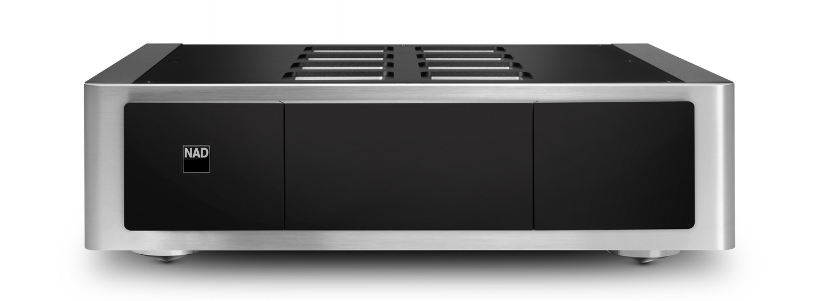
NAD Master M23 Stereo Power Amplifier (front)

According to Cas Oostvogel, NAD’s Product Manager, “The sonic character of the M23 is reinforced in the story told by the numbers. This is an amazingly powerful and transparent amplifier bringing new levels of refinement and dynamics at any level and sets a new benchmark for performance and value in its category.”

Powerful Eigentakt™ Amplifier Technology
The Masters M23 Hybrid Digital stereo power amplifier features Eigentakt™ amplifier technology, manufactured by NAD under license from Purifi. This new technology nearly eliminates harmonic and intermodulation distortion and allows for an even, wide, and load-invariant frequency response.

In common with the previous generations of NAD Hybrid Digital technology but unlike most Class D amplifier designs, the M23 offers a minimum of 200W per channel with amazing reserves of dynamic power at lower impedances. It is capable of beyond 260W dynamic power per channel even into 8 ohms, and beyond 520W into 4 ohms. It can effortlessly power any loudspeaker to live performance levels with amazing efficiency and low power consumption.

The M23 in bridge mode is the perfect addition to expand the power of an M33 BluOS Streaming Amplifier to create a 2 x 700W system or is an easy upgrade to power any high-performance separates system.

Thanks to the advanced Purifi Eigentakt amplifier technology, all this power comes at a lot less cost than traditional technology while delivering improved performance!

A Diverse Performer
It is easy to find amplifiers that can excel in one or two areas. The M23 HybridDigital stereo power amplifier featuring the Eigentakt amplification technology provides nearly unmeasurable distortion, ultra-high damping factor, and unconditional stability with any speaker.
Leaving old fashioned and power-hungry linear power supplies and Class A/B output stages behind, the M23 features proven switch mode power supplies and Class D output stages that are very linear over a wide bandwidth and provide consistent performance into all speaker loads. With tight, detailed sound, amazing control, and transparency, the M23 is a stereo power amplifier that truly does break down barriers to audiophile-grade sound.

NAD Master M23 Stereo Power Amplifier (rear)

Flexibility is another strength of the M23 with its RCA and XLR balanced inputs, bridge mode, three selectable gain levels, 12v trigger and auto sensing.

The M23 is the perfect addition to expand the power of an M33 BluOS Streaming Amplifier or power any high-performance separates system.

The M23 features all alloy casework that is elegant yet practical. Rigid panels with magnetic iso-point feet provide a solid foundation for the multi-layer circuit boards and intricate internal construction. The M23 employs a completely modern and fresh take on the traditional stereo amplifier, with a combination of features, performance and value for money not found elsewhere.

Key Features of the NAD M23 Hybrid Digital Stereo Power Amplifier
- Purifi Eigentakt™ amplifier technology
- Continuous Power Output: 2x200W into 8 ohms; 2x380W into 4 ohms
- Dynamic Power Output: 2x260W into 8 ohms; 2x520W into 4 ohms
- Bridged Power Output: 700W mono continuous into 8 ohms
- Virtually immeasurable noise, harmonic distortion, intermodulation distortion
- Wide, flat frequency response into any loudspeaker load
- Balanced (XLR) and single-ended (RCA) auto-sensing inputs
- Three-position adjustable gain control
- 12V trigger input

About NAD Electronics
Founded in 1972 and now sold in over 80 countries, NAD Electronics is renowned for its
award-winning line of high-quality components for audio, home theatre and custom
installation applications. Since the beginning, NAD’s commitment to four core values –
innovation, innovation, simplicity, performance, and value – have earned it a cult-like
following that catapulted it to becoming a household name amongst audiophiles and
music lovers alike. To this day, the brand continues to design and manufacture some of
the most acclaimed and affordable hi-fi components that include modern features and
technologies meant to appeal to a new generation of audiophiles.

contacts

Corporate Contact
June Ip
Marketing, NAD Electronics
media@nadelectronics.com

Corporate Contact
Jeff Touzeau (OLEX Communications – US/Canada)
Phone: 914-602-2913
E-mail: jeff@hummingbirdmedia.com

Steve Dalton (OLEX Communications - UK)
Phone: +44 (0) 7748-117-864
E-mail: steve@olexcommunications.co.uk

Links
Website: https://nadelectronics.com
Images: https://brandlibrary.lenbrook.com/galleries
Facebook: https://www.facebook.com/nadelectronics
Twitter: https://twitter.com/NADElectronics
Instagram: https://www.instagram.com/nadelectronics/

# # #

