Sennheiser @ ISE 2024

Sennheiser to Showcase its Global Partnerships and Alliances at ISE 2024
Interactive screen experience, scavenger hunt and partner booth exhibits all await attendees eager to discover Sennheiser’s collaborative innovations with industry partners

Barcelona, Spain, January 25, 2023 – Sennheiser, the first choice for advanced audio technology that makes collaboration and learning easier, is excited to showcase its industry partnerships and alliances at Integrated Systems Europe (ISE) 2023 in Barcelona, Spain on January 30 – February 2.

Located in Hall 3 of the FIRA Barcelona, Gran Via, the Sennheiser booth (3C500) will feature an interactive touchscreen for attendees to easily discover the Sennheiser technology and collaborations that streamline integration and deliver engaging experiences.

At ISE 2024, integrators, consultants, and end-users can explore the full potential of Sennheiser products when paired with solutions produced by its global partners and alliances. Throughout the event, Sennheiser is collaborating with 20 leading manufacturers from their partner network, including Airtame, Audac, AVer, Crestron, Lightware, Lumens, Q-SYS, Xilica, and more, to deliver an in-show campaign that highlights the benefits of their combined solutions.

Sennheiser + Partners and Alliances = The Perfect Pair
ISE attendees are encouraged to participate in an app-led scavenger hunt across Sennheiser and partner booths. Participants will be rewarded with exclusive Sennheiser-branded socks and the chance to win a TeamConnect Bar Medium.

ISE attendees can participate in the scavenger hunt by completing the following steps:
- Download the Scavify app.
- Search for ISE24 and join the hunt. At the event, complete a series of tasks, with each task worth a certain number of points. Tasks can be completed in any order, and the more points earned, the more chances to win. Just for entering and getting started with the activities, entrants receive a free pair of Sennheiser socks.
- Visit Sennheiser booth 3C500 to claim free Sennheiser socks.
- Engage with the Sennheiser touchscreen experience to learn more about Sennheiser’s partners and how to get the most out of an investment in Sennheiser solutions.

More information about Sennheiser at ISE can be found here. To book an appointment during the show, please get in touch with the press contact listed below.

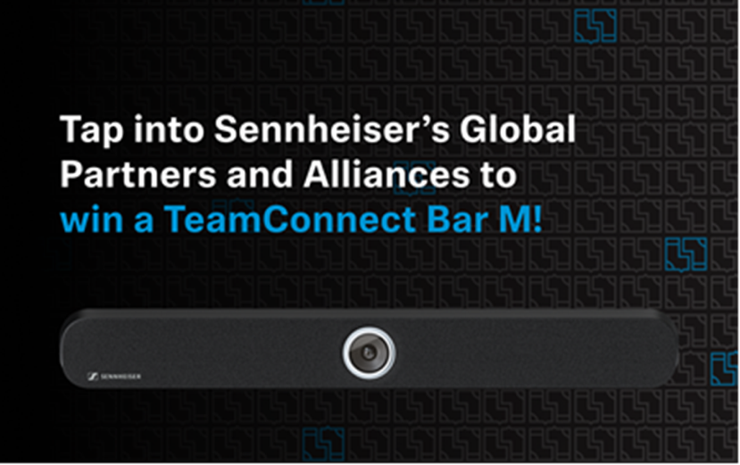

Keeping the Momentum Going
Over the past couple of months, Sennheiser has made several announcements with some of its key industry partners. Most notably, Sennheiser has gained support for its TeamConnect Ceiling Medium, with announcements with AVer, Crestron and Lumens detailing how Sennheiser’s newest ceiling microphone works seamlessly with their solutions to provide camera tracking and high-quality audio.

Be on the lookout for more exciting news from Sennheiser and its partners in the coming weeks and months, with announcements ranging from additional application certifications to relationships that further enhance its mission of making collaboration and learning easier.

About the Sennheiser brand
We live and breathe audio. We are driven by the passion to create audio solutions that make a difference. Building the future of audio and bringing remarkable sound experiences to our customers – this is what the Sennheiser brand has represented for more than 75 years. While professional audio solutions such as microphones, meeting solutions, streaming technologies and monitoring systems are part of the business of Sennheiser electronic GmbH & Co. KG, the business with consumer devices such as headphones, soundbars and speech-enhanced hearables is operated by Sonova Holding AG under the license of Sennheiser.

www.sennheiser.com
www.sennheiser-hearing.com

Global Press Contact
Jeff Horan
+1 860-598-7539
jeffrey.horan@sennheiser.com

