Magical Gifts for Musical Mothers
Making and recording music with professional tools

Wedemark, May 2022 – To show your love this Mother’s Day, why not help inspire her creativity and love of music? Whether it’s making or performing music, or recording or mixing in the home studio, every musician appreciates working with the best instruments available. To help you find the perfect gift, audio specialist Sennheiser has created a selection of superb presents that will really show her you care.

A mic for all seasons
Natural sound reproduction and incredible versatility: the MK 4
Easy to handle and excellent value for money, Sennheiser’s MK 4 mic is ideal for voices and acoustic instruments like guitars. It is just as at home in professional project studios, on stage or as a tool for home recordists. This large-diaphragm true condenser microphone delivers fine resolution and outstanding sound quality with a powerful warm sound.

The versatile MK 4 true condenser microphone makes your voice and instruments shine with powerful, warm sound | 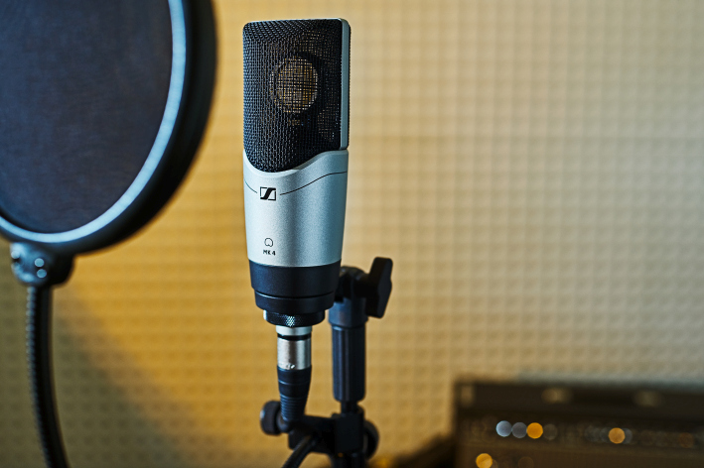

- Incredibly versatile mic for vocals and instruments
- True condenser, large-diaphragm design with a 24-carat gold-plated membrane
- For both stage and studio: full metal housing, internally shock-mounted capsule, low inherent self-noise and high maximum SPL

Maximum flexibility for vocals: the e 835 and e 845
Sennheiser’s best-selling e 835 and e 845 are dynamic cardioid and super-cardioid microphones that are perfectly suited to vocals. They project well and cut through high volumes on stage but are also great for home recording and semi-pro studios. Making vocals come alive, these are popular mics for crystal clear and natural sound without feedback, spill or handling noise. Their extremely durable metal construction means they’re able to take on the knocks of a life of performing. Close siblings, these mics share much in common but the super-cardioid pick-up pattern of the e 845 is better at rejecting noise from the side. Considering their amazing quality, these mics are excellent value for money.

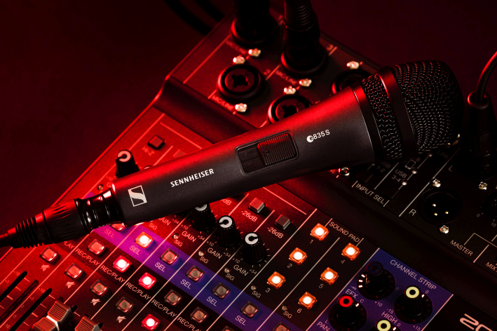 | The e 835 is Sennheiser’s best-selling vocal microphone – available with or without on/off switch

- Dynamic cardioid (e 835) and super-cardioid (e 845) microphones for speech and vocals with optional silent on/off switch (S versions)
- Clear reproduction and enhanced presence, cutting through high on-stage levels
- Consistent sound quality at varying distances and when moving off axis
- High sound pressure level, good feedback rejection
- Rugged metal housing and hum compensating coil

Extend every voice, capture every detail: the e 935 and e 945
This pair of vocal mics provide a step up in quality and extreme durability that can capture vocals with impressive intensity – even on louder stages. Like the e 835 and e 845 siblings, Sennheiser offers two related mics – the cardioid e 935 and the super-cardioid e 945 with a narrower pick-up pattern – which are both great for giving vocals more space with loud instruments, with their versatile and balanced frequency response suited to every genre of music. With a transparent high-end and warm but well-defined lower mids, even gentle voices have an impressive intensity and size, and vocal tracks in the band mix can be emphasized more easily. Both mics are extremely resistant to feedback as well as to the hard conditions of live gigs.

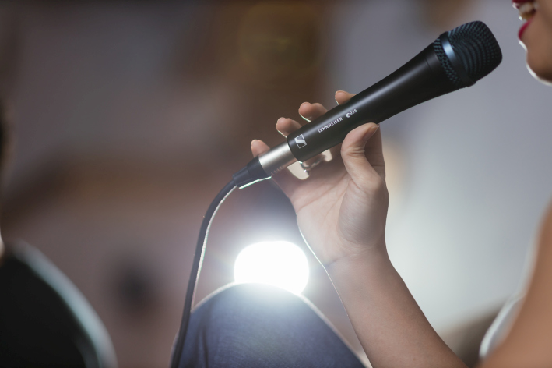 | The dynamic e 935 and e 945 microphones help to make your voice stand out with impressive intensity

- Dynamic cardioid (e 935) and super-cardioid (e 945) vocal microphones that clearly emphasize voices on loud stages
- High-end sound signature with transparent high-end and warm, defined lower mids
- Highly consistent directivity and high feedback rejection
- Extremely rugged metal housing, shock-mounted capsule and hum compensating coil

Amazing mics for guitars
The versatile guitar mic: e 609 Silver
If you’re looking to buy your mother a great everyday guitar mic, Sennheiser’s e 609 Silver is a good choice that’s suited for live performance and studio alike. This instrument mic is a rugged workhorse that has been specially developed for miking guitar cabs face on and extremely close to the signal source.

Famous flat design: the e 609 is a guitar cab specialist | 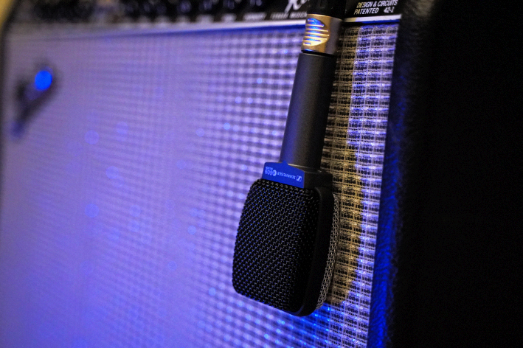

- Dynamic guitar/bass cab microphone with super-cardioid pick-up pattern
- Advanced shock-mount design and hum compensating coil
- Rugged metal body

Guitar sound the way it should be: e 906
Is she after a truly impressive pro instrument mic? Sennheiser’s e 906 captures the guitar sound just as desired: from clean to distorted, from gentle to aggressive. It provides natural, high-resolution sound without unwanted coloration. The transient response of the e 906 is great for every style of playing and genre: it even transmits riffs with an extremely hard punch, directly and honestly.

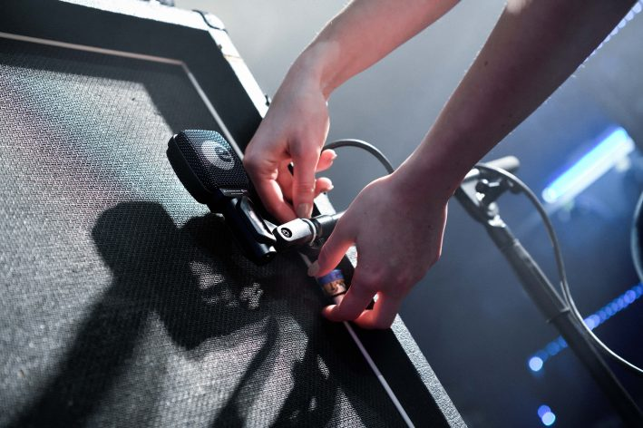 | The e 906 features extremely fast attack and full-bodied sound

- Dynamic super-cardioid guitar cab microphone with full-bodied, lively sound
- Extremely fast transient response
- Switchable presence filter with three choices of sound characteristic: boosted presence range, normal, attenuated presence range
- Shock-mounted capsule and hum compensating coil
- Rugged metal housing

Precise personal monitoring for live stages
Incredible in-ear monitoring: the IE 100 PRO
Whether performing on stage, or recording and mixing in the studio, monitors can be a musician’s best friend. Sennheiser’s dynamic IE 100 PRO in-ear monitors are a great gift that will let her perform with confidence. They will give her a precise acoustic overview for live performances thanks to their dynamic drivers that deliver a warm sound that’s both powerful and rich in detail. Even in extremely loud environments, they sound exceptionally distortion-free and defined. Tough enough for the rigors of live performance yet comfortable enough to wear for hours, these small but mighty in-ears will delight.

The IE 100 PRO in-ears with their precise, single-driver sound let you monitor with detail and perform with confidence

- Powerful, precise monitoring thanks to innovative dynamic 10mm transducers
- Broadband single drivers reduce acoustic stress through homogeneous, distortion-free reproduction
- Slim and ergonomic design with a secure fit and high level of wearing comfort
- Excellent shielding thanks to an optimized earpiece with silicone and foam tips
- Stage-proof cable with internal cable duct
- Also available as IE 100 PRO Wireless with Bluetooth module to connect to mobile devices, PCs or tablets

Step forward with wireless
Evolution Digital Wireless – EW-D Sets for vocals and instruments
There’s nothing like digital wireless microphones to free a performer and unleash their full potential. Sennheiser’s Evolution Wireless Digital (EW-D) is the ultimate digital UHF system for artists looking to take this step to freedom. It’s robust for a long life on the road, very easy to use in any RF environment and can be set up and operated via a smartphone or tablet with Sennheiser’s Smart Assist App.

EW-D utilizes advanced features that simplify set-up and guarantee a reliable wireless connection. Add to that the lowest latency and highest dynamic input range of any digital wireless system currently available, and you will understand why so many users see EW-D as the most powerful tool for those who put quality and performance above all else.

Whatever her musical passion, EW-D has brilliant packages that combine the receiver and the best mic for her performance – including the EW-D 835 Set with the superb e 835 microphone for vocals or the CI1 Instrument Set that can connect to guitars or other instruments via a wireless bodypack.

Step forward with wireless – Evolution Wireless Digital has all that is needed

- Wireless systems for vocalists and instrumentalists – easily set up and monitored via the Smart Assist App
- Auto scan creates reliable connections with minimal time and effort, with 56 MHz of tuning bandwidth and equidistant spacing enabling up to 90 channels
- Digital transmission in the UHF spectrum enhances range, reliability and scalability
- 134 dB audio input dynamic range eliminates need for sensitivity adjustments and preserves every detail

Craft the perfect mix
Your world class mix room: dearVR MIX
Dear Reality’s dearVR MIX turns any studio headphones into a world-class stereo mix room with carefully designed acoustics - all through advanced spatial audio technology that recreates the sweet spot of an ultimate mixing environment. Recreating multiple virtual reference rooms, this incredible plugin is a brilliant way to gain total confidence when monitoring an audio mix.

- Stereo headphone mixing plugin (AAX/VST3/AU) suited for all professional studio headphones
- Totally reliable judging of position, width, reverb and low-end
- Spatial Headphone Compensation supporting 46 models
- Three adjustable virtual world-class reference mix rooms with four mono and stereo loudspeaker positions
- Six additional non-studio listening environments

The mixing dream team: the dearVR MIX plugin and HD 400 PRO open studio headphones | 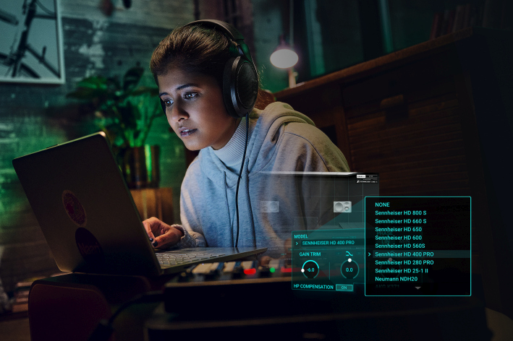

Discover their signature sound: HD 400 PRO
These outstanding reference-grade studio headphones will provide everything a musician could design when fine-tuning their signature sound. The open-back HD 400 PRO provide a wide and transparent soundstage for a natural and accurate listening experience. Their lightweight design and velour earpads provide the comfort needed during long sessions.

- Professional open-back studio headphones with neutral sound reproduction
- Lightweight design for all-day usage
- Angled transducers designed for low distortion at high SPLs provide a spacious and accurate soundstage
- Single-sided, coiled cable allows freedom to operate. For convenience, a straight cable is also included

Experience powerful studio sound with the HD 200 PRO
Sennheiser’s closed-back HD 200 PRO headphones are the perfect companion for monitoring – providing powerful studio sound anywhere. They offer detailed sound with significantly reduced ambient noise, making it easier to concentrate on the task at hand. Rugged, durable and exceptionally dynamic, they make every creative task a pleasure and have been designed for comfort over long periods of use.

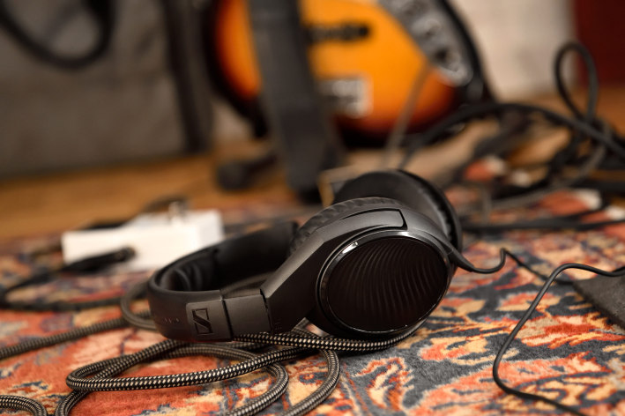 | The rugged HD 200 PRO play back powerful studio sound

- Closed, around-ear headphone design to reduce ambient noise
- Sennheiser’s proprietary transducers deliver an outstanding stereo sound reproduction with powerful, punchy bass
- The soft ear cushions and the ergonomic design provide enhanced fit and comfort
- Robust 2.0 m singled-sided cable, 6.3 mm (1/4”) stereo jack adaptor included

Created for the pros: HD 280 PRO
An accurate representation of audio is key when mixing or mastering work. When you give the HD 280 PRO, you’re giving her this professional edge. The closed-back HD 280 PRO boast extremely robust construction combined with the sound quality, modular design and aggressive noise isolation that is necessary in the field. Eloquent lows, a distinct midrange and clear-cut highs are what define the HD 280 PRO – making them the perfect companion for recording and mixing sessions.

The closed-back HD 280 PRO allow you to fully focus on the sound

- Closed-back monitoring headphones with accurate, linear sound reproduction
- High ambient noise attenuation
- Soft earpads for a comfortable fit
- Folding and rotating earcups for space-saving transport
- Tough, single-sided cable

Meticulously natural sound: HD 300 PRO headphones
The HD 300 PRO is an ideal gift for the musician who appreciates every nuance - and who will really appreciate these very special monitoring headphones. They deliver a linear frequency response – not interpreting sound but ensuring neutral transparency with a remarkable, three-dimensional quality. This natural, delicate sound reproduction is the key to ensuring good decisions when mixing audio. In addition, the HD 300 PRO represent a smart combination of wearing comfort and ambient noise attenuation, making it possible to work for hours with full precision and attention even in loud environments.

With a sound design modelled on the legendary HD 250 Linear, the closed-back HD 300 PRO deliver a remarkable sound quality and let you work with full precision and concentration

- Closed-back monitoring headphones offer highest resolution and accurate, linear sound reproduction
- Sound design modelled on the legendary HD 250 Linear
- Comfortable padding and viscoelastic earpads allow for long sessions
- Superior ambient noise attenuation in loud environments
- Perfect companion for your daily work due to long lasting materials and exchangeable cables

(Ends)

The images accompanying this press release can be downloaded here.
Product-only photos can be downloaded here.

Pricing information
MK 4: EUR 299 MSRP
e 835/e 835 S/e 845/e 845 S: EUR 99 MSRP
e 935/e 945: EUR 199 MSRP
e 609 Silver: EUR 99 MSRP
e 906: EUR 199 MSRP
IE 100 PRO: EUR 99 MSRP (available in black, red and clear)
IE 100 PRO Wireless: EUR 149 MSRP (available in black, red and clear)
EW-D 835 Set: EUR 699 MSRP
EW-D CI1 Set: EUR 629 MSRP
dearVR MIX: EUR 89 (without VAT)
HD 400 PRO: EUR 249 MSRP
HD 200 PRO: EUR 69 MSRP
HD 280 PRO: EUR 99 MSRP
HD 300 PRO: EUR 199 MSRP

About the Sennheiser brand
We live and breathe audio. We are driven by the passion to create audio solutions that make a difference. Building the future of audio and bringing remarkable sound experiences to our customers – this is what the Sennheiser brand has represented for more than 75 years. While professional audio solutions such as microphones, meeting solutions, streaming technologies and monitoring systems are part of the business of Sennheiser electronic GmbH & Co. KG, the business with consumer devices such as headphones, soundbars and speech-enhanced hearables is operated by Sonova Holding AG under the license of Sennheiser.

www.sennheiser.com
www.sennheiser-hearing.com

Global Pro Audio Press Contact

Stephanie Schmidt
Stephanie.schmidt@sennheiser.com
+49 (5130) 600 – 1275

