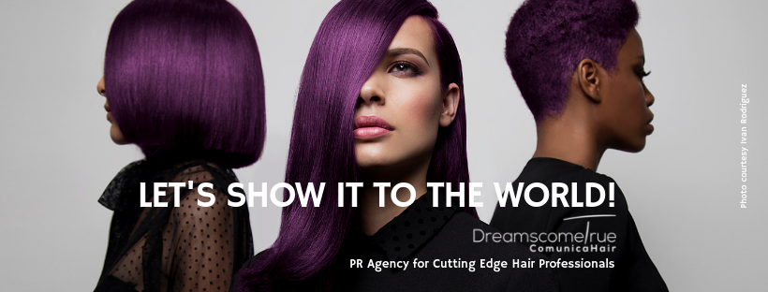
Specialised PR Agency for Cutting Edge Hair Professionals.
Creative Hairdressers are our clients.

For more information, please contact Marta de Paco
On +34670780664 or email press@dreamscometrue.es

Important:
These images are only available for editorial content.
Credits must be included.
Notification of their publication is expected.

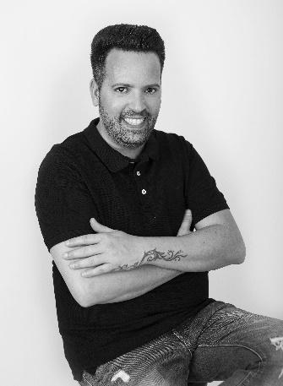
RAFAEL BUENO PELUQUEROS
AYLA Collection

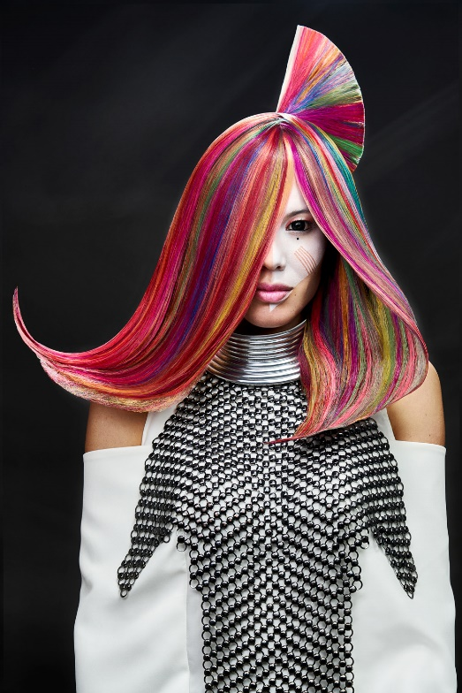
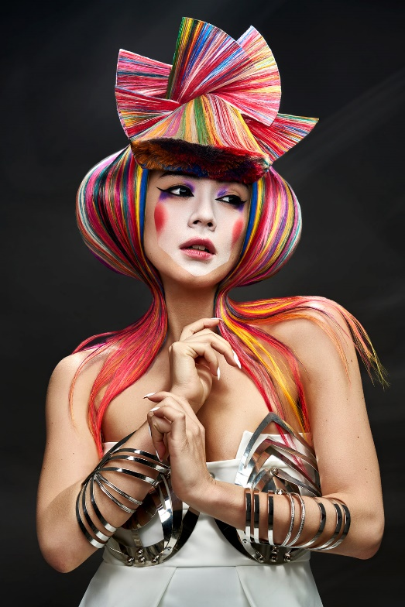
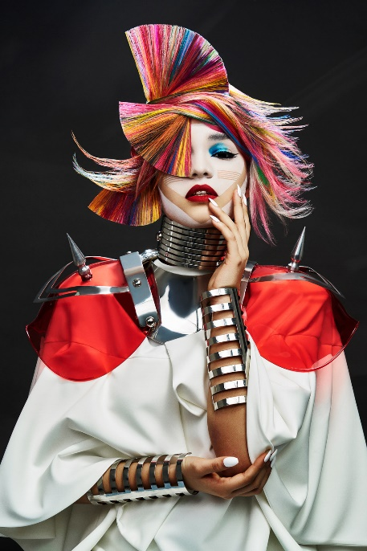

Hair: Rafael Bueno @Rafael Bueno Peluqueros
Hair Instagram @rafaelbuenopeluqueros
Hair Assistant: Moyses Utrera Instagram @moysesutrera
Photography: Alberto Zaldivar
Photography Instagram @albertozaldivar
Makeup: Lulu Pérez Makeup Instagram @_luluperez_
Makeup Assistant: Ariadna Caparrós Instagram: @ariadna_roji
Styling: Xisco Morales Styling Instagram: @xissciss
Products: Revlon Professional Instagram: @revlonprofessional_es
Models: Almar Gómez, Jennifer Medalle, Araceli Ayala, Emily Cordoba.
Instagram @almargsato @jennifermedalle @_emicaor_

RAFAEL BUENO PELUQUEROS
AYLA Collection

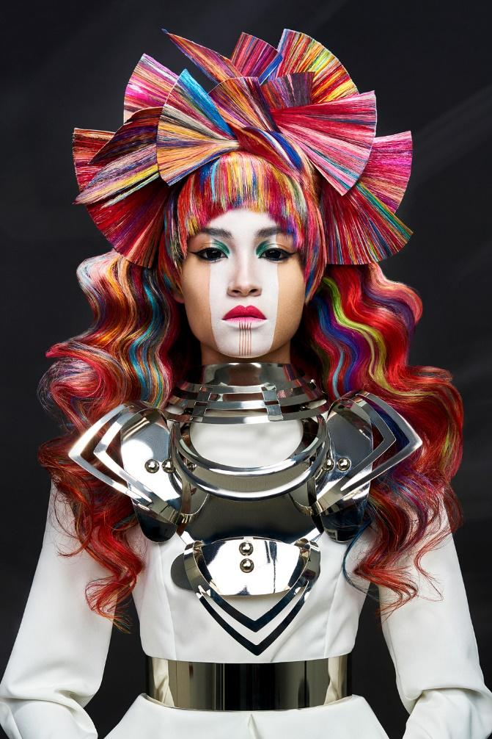

Ayla is the daughter of war, yet she has a sensitive temperament and hides her emotions. Ayla is the same one that conquered the heart of Süleyman, who risked his own life to save her.

Each color shows different nuances of her personality, though what stands out the most is the aggressive shape of her strand, which refers to her fighting character.
Textures mix to form a game of geometries as surprising as disturbing, which connects with her divine nature.
The hair is like a crown, a jewel capable of expressing all her power, as well as all the faces of her polyhedral personality.

