Neumann Miniature Clip Mic Systems brings detail and smooth open sound to the award-winning Six the Musical
Berlin, Germany, August 24, 2022 – Described as the show that “…brought magic, energy, modernity, and fun to the stage with a cast of queens that we all should hail” [mdtheatreguide.com], Six the Musical was first presented by Cambridge University students at the Edinburgh Festival Fringe five years ago. It has since gone on to professional productions in the West End, on Broadway and internationally, and won prestigious accolades such as the Best Original Score and Costume Design at this year’s Tony Awards, whilst also being nominated for Best Sound Design and six other creative categories. Neumann’s Miniature Clip Mic System (MCM) was provided by Stage Sound Services for the current UK & US Tours and brought “discreet but high quality mic’ing” to the band on stage.

Paul Gatehouse, a British sound designer and music mixer with over 20 years of experience working on first class musical theatre and film productions world-wide, was in charge of delivering the sound design for all productions of Six the Musical.
British sound designer and music mixer Paul Gatehouse chooses Neumann Miniature Clip Mic MCM System for the Six the Musical

“The premise of the of the show is that the Queens, the six wives of Henry VIII, are competing for who had the worst time during their marriage to Henry, in order to become the lead singer of their band,” explains Gatehouse. “The Queens are backed by an all-female onstage band, known as the ‘Ladies in Waiting’. The show is staged as a pop concert with heavy influence taken from major modern female pop icons, we have a fully silent (electronic) band apart from the acoustic guitar, hi-hat and cymbals, which require discreet but high quality mic’ing.”

With an onstage band of drums, bass, keys, and guitar, accommodating the microphones that would be almost invisible, but still pack a punch when it comes to the sound quality, was something that Gatehouse had to consider very carefully.

“We have chosen Neumann’s new MCM mics for the recent UK & US Tours because of the microphone’s natural sound, practicality and reliable mounting,” Gatehouse continues. “Within the band, anything with an acoustic source uses the MCM, as it has such a wide variety of uses and positions that we can get it into. The mounts and clips have been really well thought out and are further developed and robust than models we’ve seen before.”

When it comes to ease of use of the MCM microphone, Gatehouse leaves no room for doubt. “So easy! Both on the acoustic guitar and hi hat, crashes and ride cymbals we could get MCM mics exactly where we needed them and they feel very solid for a mic that’s on a gooseneck,” he explains.
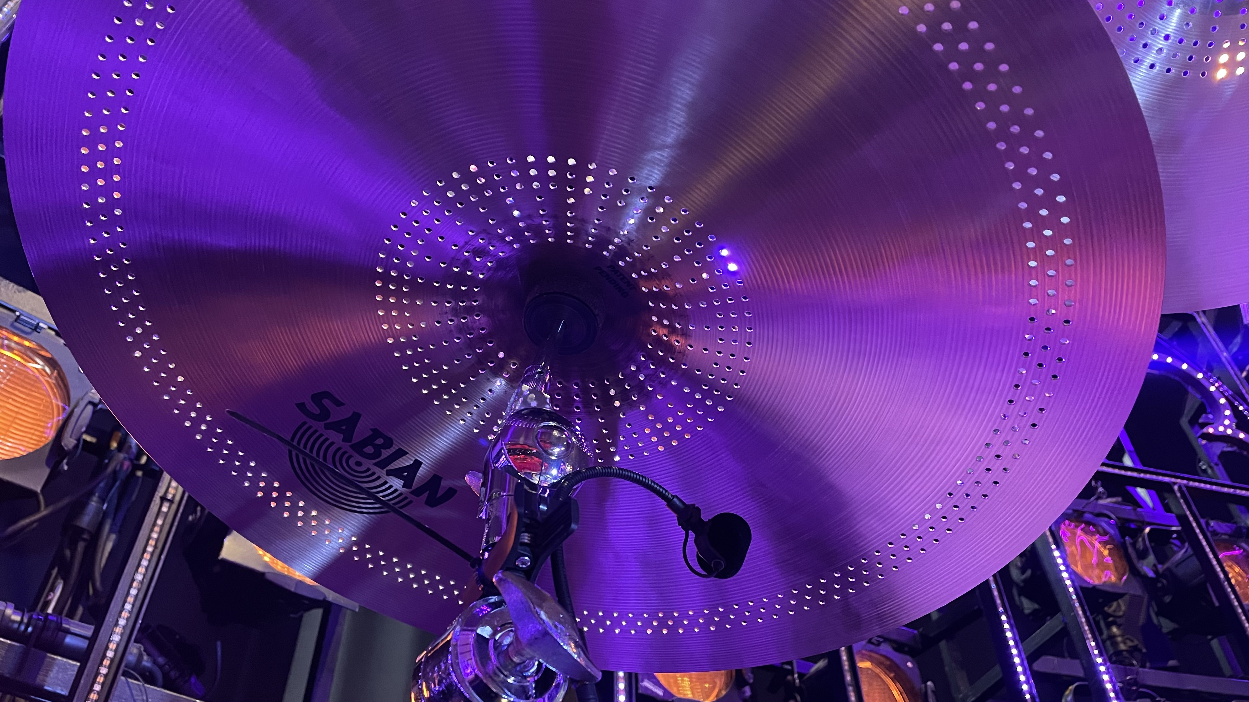

Paul Gatehouse notes how blown away he felt by the smooth character and open sound of the Neumann Miniature Clip Mic MCM System

Recalling the first time he heard the MCM System, Gatehouse notes how blown away he felt by the smooth character and open sound of the microphone, “right off the bat the tonality was noticeably more open sounding in comparison to the product we had been using.” he adds. Previously, Gatehouse felt he had to work harder to shape the sound due to microphone’s position, with MCM, he could save time during setup and EQ tuning especially “the EQ previously in place on those channels was removed, apart from a high pass filter.”

Equal to Gatehouse’s reaction, the band members instantly noticed the step up in sound quality: “Our guitar player immediately heard the difference in her IEMs, the mic conveyed the beautiful tone of our Taylor acoustic guitar in a very natural way,” Gatehouse comments.

The sources that Gatehouse is using the MCM System on are bright instruments. “But the high end we got from the mic was just like butter. Before, you’d be wanting to smooth things out with dynamic EQ, multi-band comp, etc, but this was no longer required with MCM,” he says.

After moving through various London venues, the chart-topping musical found its ‘forever home’ in the Vaudeville Theatre in September last year, where it is currently running through to April 2023. After using the MCM System on the most recent productions of the Six the Musical, Gatehouse is convinced he will be using the microphone again on future theatre shows.

“I’ll definitely be using MCMs on anything where miniature instrument mics come into their own, I think they’ll sound great on anything we throw at them,” he concludes. “The mics we were using before did their jobs brilliantly well and we had no complaints, but there was a clear improvement with the Neuman Miniature Clip Mic MCM System. The detail and smooth open sound are just incredible!”

About Neumann
Georg Neumann GmbH, known as “Neumann.Berlin”, is one of the world’s leading manufacturer of studio-grade audio equipment and the creator of recording microphone legends including the U 47, M 49, U 67 and U 87. Founded in 1928, the company has been recognized with numerous international awards for its technological innovations. Since 2010, Neumann.Berlin has expanded its expertise in electro-acoustic transducer design to also include the studio monitor market, mainly targeting TV and radio broadcasting, recording, and audio production. The first Neumann studio headphone was introduced at the beginning of 2019. Georg Neumann GmbH has been part of the Sennheiser Group since 1991, and is represented worldwide by the Sennheiser network of subsidiaries and long-standing trading partners. www.neumann.com

Press Contact Neumann:
Andreas Sablotny
andreas.sablotny@neumann.com
T +49 (030) 417724-19

