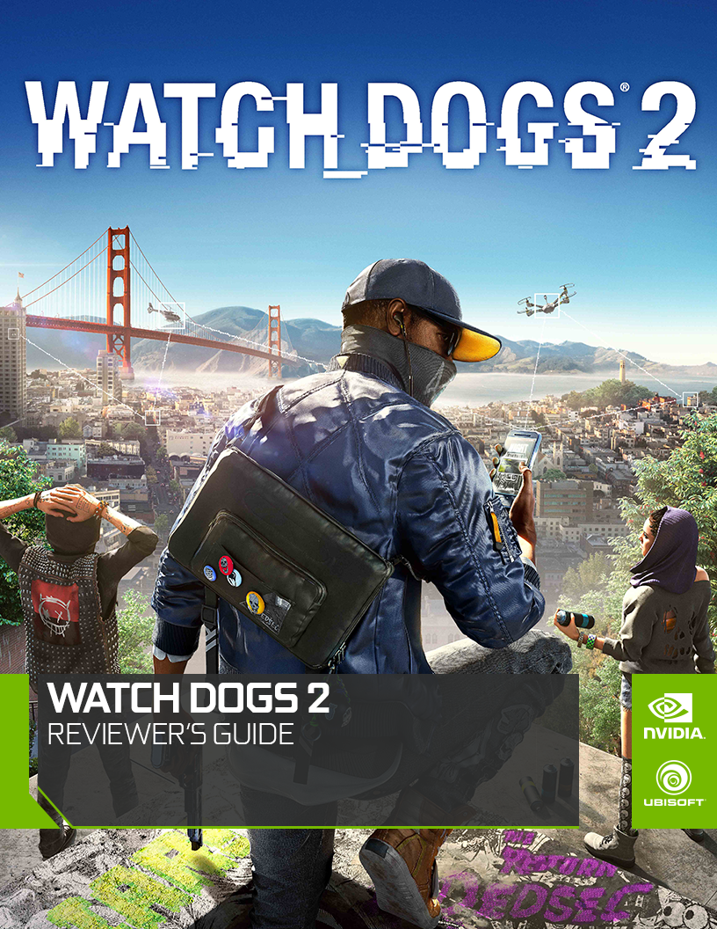

Contents
Watch Dogs® 2 3
Introduction 3
Key Features 4
NVIDIA Features 5
NVIDIA TXAA 5
NVIDIA HBAO+ 5
NVIDIA HFTS | Hybrid Frustrum Traced Shadows 7
Frustum Tracing 7
Hybrid Approach 8
Variable Penumbra Soft Shadow Filters 8
NVIDIA Ansel 11
How to use Ansel in Watch Dogs® 2 12
Ansel samples from Watch Dogs® 2 13
Recommended Driver & GPU 15
Recommended Game Ready Driver 15
Recommended GPU 15
GeForce Experience 16
NVIDIA GeForce Experience 16
NVIDIA G-SYNC 17
Enabling NVIDIA G-SYNC 17
NVIDIA Surround 18
Enabling NVIDIA Surround 18
NVIDIA Contact Information 19

Watch Dogs® 2

Introduction
Use hacking as a weapon in the massive & dynamic open world of Watch Dogs 2.
In 2016, ctOS 2.0, an advanced operating system networking city infrastructure, was implemented in several US cities to create a safer, more efficient metropolis.
Play as Marcus Holloway, a brilliant young hacker living in the birthplace of the tech revolution, the San Francisco Bay Area. Team up with DedSec, a notorious group of hackers, and expose the hidden dangers of ctOS 2.0, which, in the hands of corrupt corporations, is being wrongfully used to monitor and manipulate citizens on a massive scale.
With the power of hacking and DedSec by your side, launch the Hack of the Century, take down ctOS 2.0 and give freedom back to whom it belongs: the people.
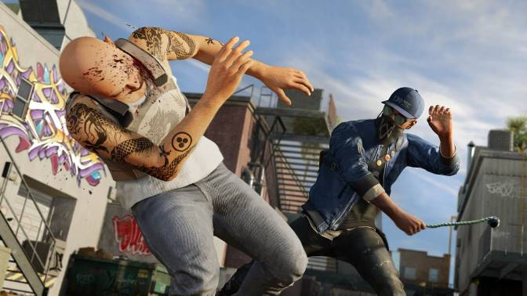

Key Features
WELCOME TO THE SAN FRANCISCO BAY AREA
- Explore a massive and dynamic open-world offering an incredible variety of gameplay possibilities. Hack your way through traffic while you engage in dangerous car chases through the winding streets of San Francisco, traverse the rooftops of the colorful and vibrant neighborhoods of Oakland, and infiltrate the cutting edge offices of Silicon Valley companies. There are many secrets to uncover in the birthplace of the tech revolution.

HACKING IS YOUR WEAPON
- Hack into the city’s infrastructure, every connected device, and everyone’s personal database. Take control of drones, cars, cranes, security robots, and much more. Hack your enemies and bystanders alike– manipulate them in different ways to trigger unpredictable chains of events. Every person, any vehicle they might drive, any connected device they possess can be hacked.

YOU ARE IN CTRL
- Use hacking and stealth to complete missions without killing a single enemy or combine hacking and your weapons for a more ferocious approach. Develop different skills to suit your playstyle, and upgrade your hacker tools – RC cars, Quadcopter drones, 3D printed weapons and much more.

SEAMLESSLY CONNECT WITH FRIENDS
- Stay connected to your friends with a brand new seamless multiplayer experience that includes both Co-op and Player vs. Player activities, all available in a shared open world experience.

NVIDIA Features
Watch Dogs® 2 features NVIDIA® Ansel™ capture technology, HBAO+™ shading technology, HFTS™ shadow technology, PCSS™ shadow technology, and TXAA™ anti-aliasing technology, providing GTX users a gaming experience with the utmost features, visual graphics and realism. Take full advantage of some of the best graphics technologies and architectural features available in GeForce GTX 10-series graphics cards with NVIDIA technologies.

NVIDIA TXAA
Post-Process Temporal Anti-Aliasing (TXAA) is used in numerous games to remove jagged edges from surfaces and to combat shader aliasing. It also prevents temporal aliasing, which is the distracting shimmering of anti-aliased edges when the camera, game elements, or player’s viewpoint are in motion. Before Post Process Temporal Anti-Aliasing became commonplace, NVIDIA developed TXAA, a hardware-based solution that combined MSAA with temporal filtering, anti-aliasing resolves, and NVIDIA secret sauce.
MSAA has increasingly become incompatible with game engines, or simply too expensive to use, in turn preventing the implementation of TXAA. In response, our developers have created a new post-process, platform-agnostic TXAA that’s faster, sharper, and clearer than the majority of Temporal Anti-Aliasing solutions used in today’s games.
NOTE: TXAA is not properly observed with static screen shots, only with scenes in motion.

NVIDIA HBAO+
NVIDIA HBAO+ (Horizon Based Ambient Occlusion) adds realistic Ambient Occlusion shadowing and shading around objects and surfaces that occlude light, with a considerably higher degree of precision than previous AO techniques. This helps scenes look less flat and more realistic. HBAO+ is a super-efficient method of modelling occlusion shadows, and the performance hit is negligible when compared to the existing implementations.
The following screenshots demonstrate the additional shading that enabling HBAO+ in Watch Dogs® 2 can provide.
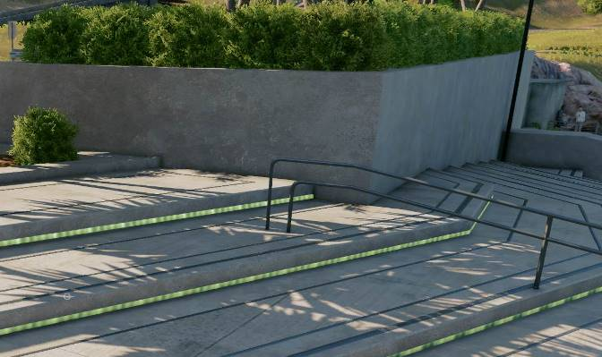
Figure 1 NVIDIA HBAO+ is set in the Video Settings.
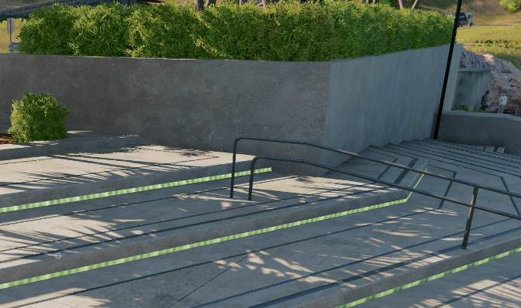
Figure 2 NVIDIA HBAO+ is set to off in the Video Settings.
To advance Screen Space Ambient Occlusion (SSAO) tech, the first goal NVIDIA had with HBAO+ was to make it fast enough to be rendered in full resolution on high end GPUs.
Our second goal was to maximize the efficiency of the implementation on DX11 GPUs, by optimizing the locality of the samples that are taken from the input depth buffer.
Our third goal was to make HBAO+ always look better than the original HBAO algorithm, especially on scenes with thin objects such as grass and leaves, which have always been problematic for the original HBAO algorithm.
More details on HBAO+ can be found by clicking here.

NVIDIA HFTS | Hybrid Frustrum Traced Shadows
One of the fundamental problems in computer graphics is generating accurate soft shadows from area light sources. Soft shadows provide valuable cues about the relationships between objects, becoming sharper near the casting object and softer further away.
NVIDIA HFTS is an advanced hybrid shadow technique that combines frustum tracing, variable penumbra soft shadow filters, and screen-space anti-aliasing. HFTS makes for more geometrically accurate and precise shadows that appear hard closer to the object, and softer the farther they extend. Additionally, NVIDIA HFTS addresses issues that other shadow technologies do not including shadow detachment, aliasing, and interference from overlapping blockers.

Frustum Tracing
Frustum Tracing is a form of Ray Tracing. A conventional ray tracer shoots a ray from a point in the scene into a stored hierarchy of triangles. Based upon where the ray intersects the hierarchy, a sub-set of triangles are then tested for intersection with the ray. This approach is problematic from the point of view of hierarchy construction, pure storage and incoherent memory access.
HFTS does not store a hierarchy of triangles, and thus circumvents this fundamental problem. Instead it creates a list of the screen pixels that map to a given light space texel. When triangles are rendered in light space, a frustum (bounding volume) is constructed using the triangle itself and the light direction. Then all of the screen pixels that map to it, are tested using a classic point-in-frustum algorithm. If a screen pixel is deemed to be inside the frustum, then it is marked as in shadow.
A new hardware feature of the GPU called Conservative Rasterization ensures that even the smallest triangles do not escape being frustum traced.

Hybrid Approach
When NVIDIA released PCSS (Percentage-Closer Soft Shadows) technology, it was to build upon regular shadow mapping. It ddid this by shading each pixel in camera space, and then computing the penumbra size by analyzing the average distance to occluded objects. An advanced version called PCSS Ultra improved on the technique by removing aliasing on hardened shadows. This improved the quality of shadows that were observed in the distance.
NVIDIA HFTS is essentially a hybrid between two techniques; it is a frustum traced hard shadow with PCSS soft shadows. During the frustum tracing phase, the distance between the receiving screen pixel and the blocking triangle is recorded. This distance is attenuated and used as an interpolation factor between the hard shadow and the soft shadow. The result is razor sharp anti-aliased hard shadows near the point of contact that smoothly transition to super soft shadows further away.

Variable Penumbra Soft Shadow Filters
A variable penumbra soft shadow filter is used to perfect the form of the shadow, otherwise the soft shadow result would not be fully contained by the ray traced result.
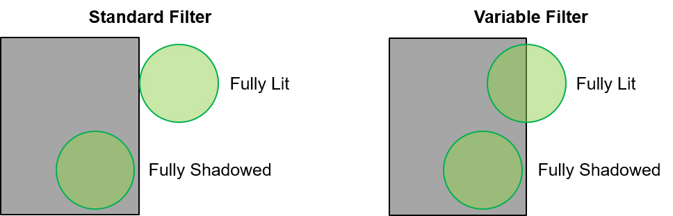
The variable filter removes issues when performing linear interpolations (lerps) between fully lit and fully shadowed pixels.

Shadow Screenshot Comparisons

Figure 3: Low Setting

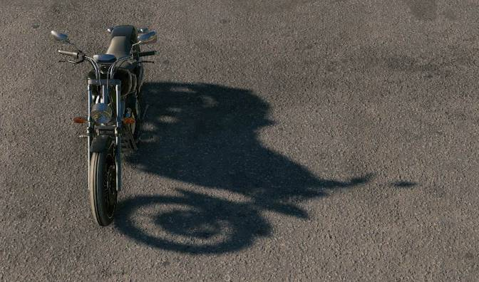
Figure 4: Medium Setting
Figure 5: High Setting
Figure 6: Very High Setting
Figure 7: Ultra Setting
Figure 8: PCSS Setting
Figure 9: HFTS Setting

NVIDIA Ansel
Gaming has evolved. It is no longer just about playing games. It is also about artistry and expression. Introducing Ansel, a new platform for artists. A new platform for expression. And a new platform for gamers. Think of Ansel as a camera that is integrated into your gaming experience that allows you to capture gameplay that was never before possible.
For years gamers have admired the in-game photos captured by professionals to display iconic moments and gameplay, screenshots featured on products ranging from posters to box art. But what if the casual user or gamer could do that too? This is where the revolutionary new Ansel technology comes into play.
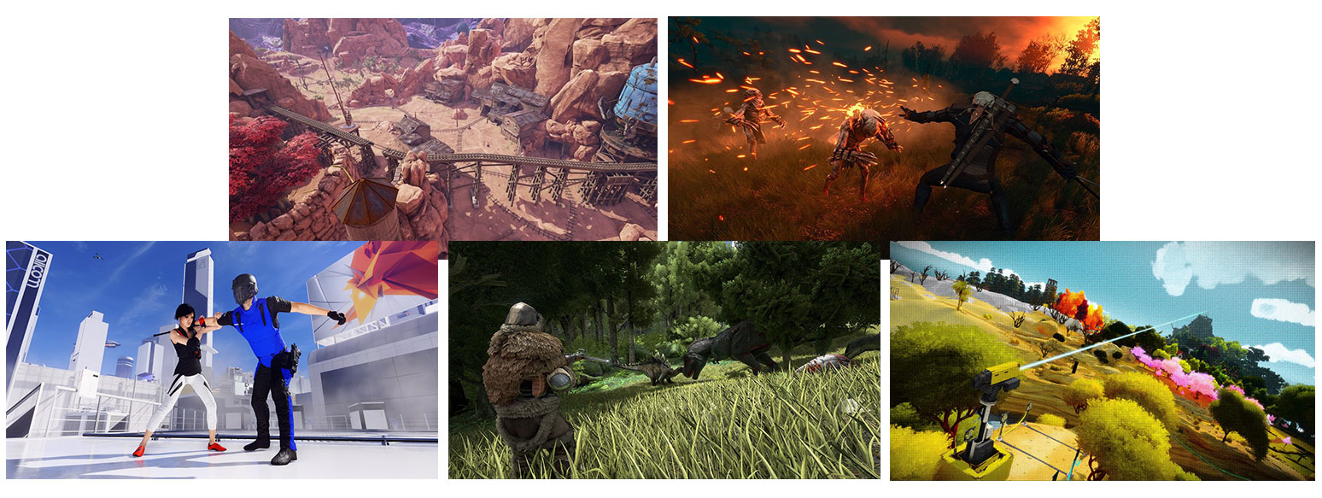
You’re no longer limited to screenshots of what you’re looking at in the game. In Watch Dogs® 2, Ansel allows you to remove the game UI and point the camera in any direction to compose the perfect shot. With Ansel’s Camera Mode, you can compose a shot from any angle, and then capture a 360-degree picture of the game world. Once captured, that image can be viewed in a VR headset, on a PC, or with your cell phone by moving it around to view the 360-degree image. These photos can even be viewed in full stereo using VR headsets or Google Cardboard.

How to use Ansel in Watch Dogs® 2
Activate Ansel by pressing ALT+F2, which will pause the game and bring up the Ansel overlay.
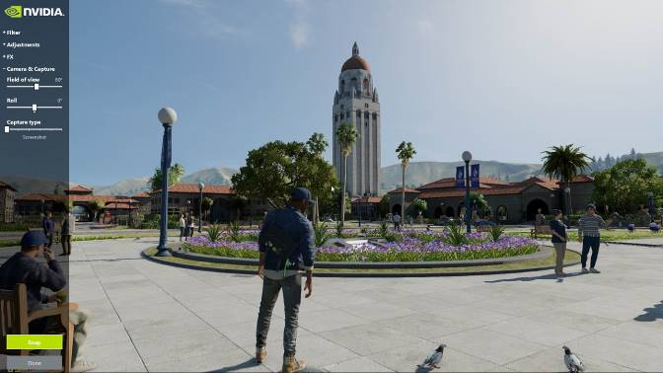

Ansel samples from Watch Dogs® 2
The following images were captured using solely Ansel without any third party editing software.
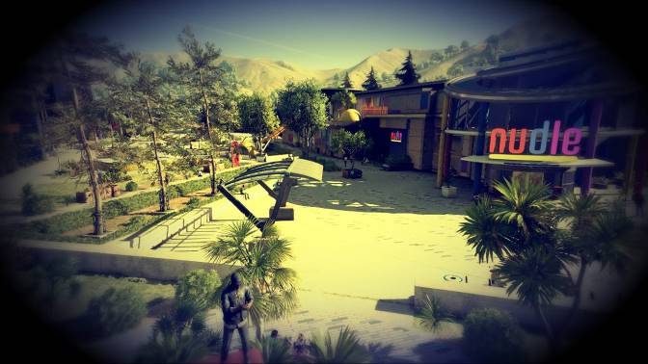

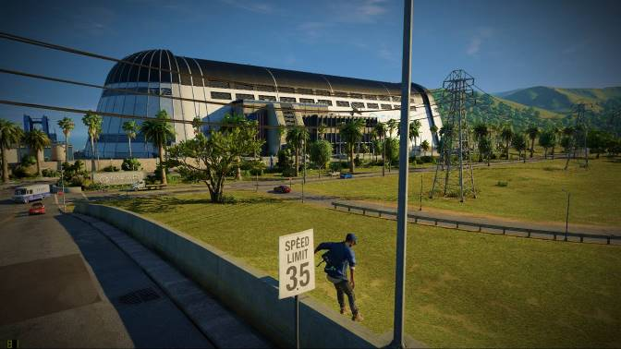
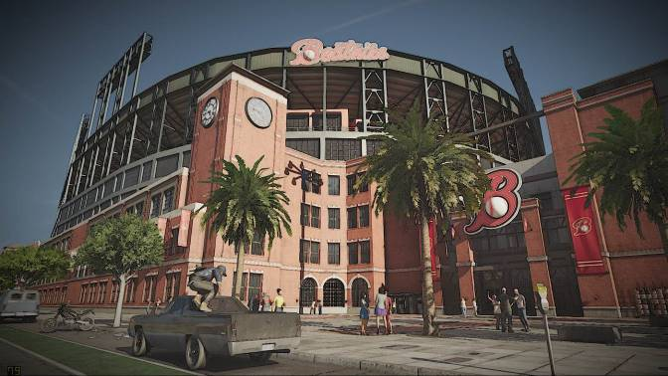
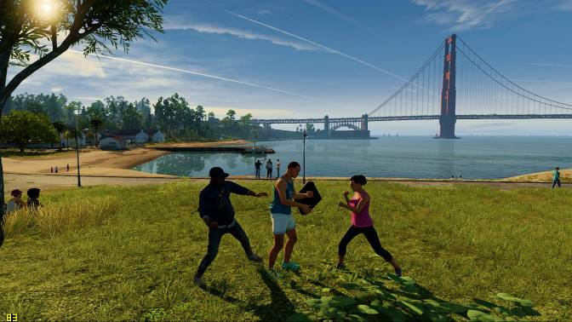

Recommended Driver & GPU

Recommended Game Ready Driver
NVIDIA recommends updating your graphics driver to the latest Game Ready graphics driver. This will deliver the optimal experience for Watch Dogs® 2 upon release. Contact your local NVIDIA PR manager for details.
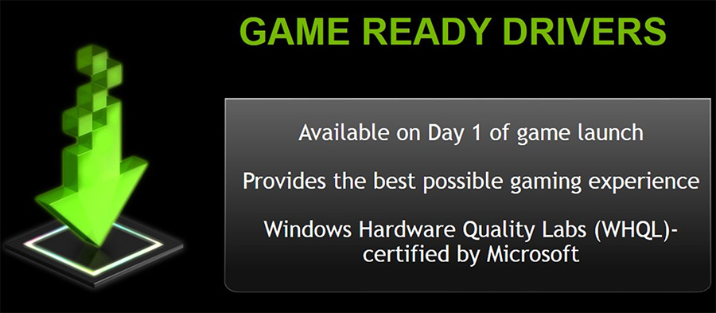

Recommended GPU
If you’re unfamiliar with our suite of game-enhancing effects, HBAO+ adds rich, realistic shadows around objects that occlude light, giving scenes extra depth and detail and TXAA anti-aliasing creates a smoother, clearer image than any other anti-aliasing solution by combining high-quality MSAA multisample anti-aliasing, post processes, and NVIDIA-designed temporal filters. Enabling all of these graphics settings will require a powerful graphics card, such as the GeForce GTX 1060. In addition to giving you the performance to play Watch Dogs® 2, the recommended GeForce GTX 1060 graphics card supports our vast array of critically acclaimed technologies, giving you the definitive gaming experience, unmatched by any other platform.
SPECIFICATION | SCREEN RESOLUTION | PRODUCT
VERY HIGH | 2560 x 1440 | GeForce GTX 1080
HIGH | 1920 x 1080 | GeForce GTX 1060
MINIMUM | 1600 x 900 | GeForce GTX 660

GeForce Experience

NVIDIA GeForce Experience
GeForce Experience is an application from NVIDIA that optimizes your PC in two key ways. First, it maximizes your game performance and game compatibility by automatically downloading the latest GeForce Game Ready drivers. Second, GeForce Experience intelligently optimizes graphics settings for all your favorite games based on your hardware configuration. 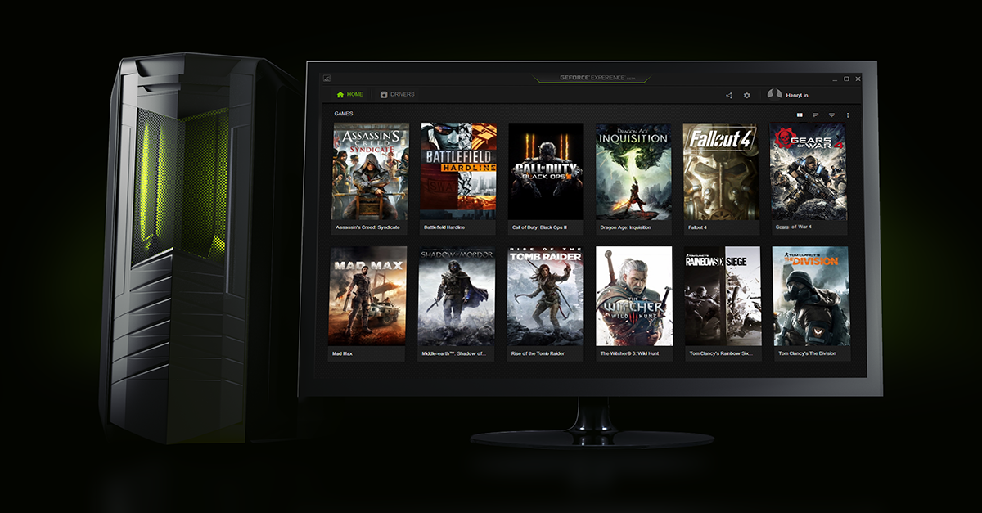
GeForce Experience is fully compatible with Watch Dogs® 2 and can help you get the proper settings for your specific configuration by using the Optimal Playability Settings. To do this, simply select the Optimize button in GeForce Experience once you have the game installed. GeForce Experience will automatically configure your game settings to give you the best experience possible. There are quite a few graphics options in Watch Dogs® 2 and if you don’t want to spend the time to dial in the settings yourself, you can easily get started playing right away with one click.
Download the Client: http://www.geforce.com/drivers/geforce-experience/download

NVIDIA G-SYNC
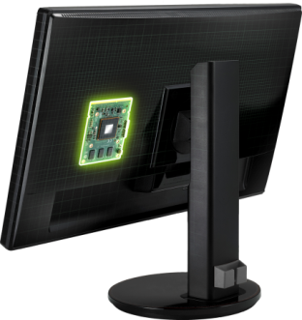
NVIDIA G-SYNC display technology eliminates screen tearing, and reduces display stutter and input lag, to deliver the smoothest and fastest gaming experience possible. G-SYNC is comprised of a hardware logic board installed inside your monitor that works in conjunction with existing NVIDIA GPUs. The only other requirement for the smooth delivery of variable frames to the display is a G-SYNC optimized GeForce driver. The distinction of G-SYNC and current display technologies is that the rate at which game frames are delivered is now determined by the GeForce GPU, and not the fixed refresh rate of your display. With G-SYNC, we give complete control of your games to the GPU allowing for a completely smooth and tear-free gaming experience.

Enabling NVIDIA G-SYNC
To enable NVIDIA GSYNC, simply open the NVIDIA Control Panel and navigate to the Set up G-SYNC tab on the left hand side, then make sure you have NVIDIA G-SYNC enabled.
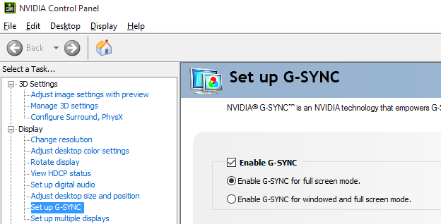

NOTE: If you have any questions regarding NVIDIA G-SYNC, please contact your local NVIDIA PR Manager or navigate to http://www.geforce.com/hardware/technology/g-sync.

NVIDIA Surround
With the power of GeForce GPUs, gamers are able to combine up to five displays to create the most immersive gaming environment possible. Here, you can leverage the latest NVIDIA display technologies including G-SYNC and 3D Vision and run them at resolutions up to 4K!
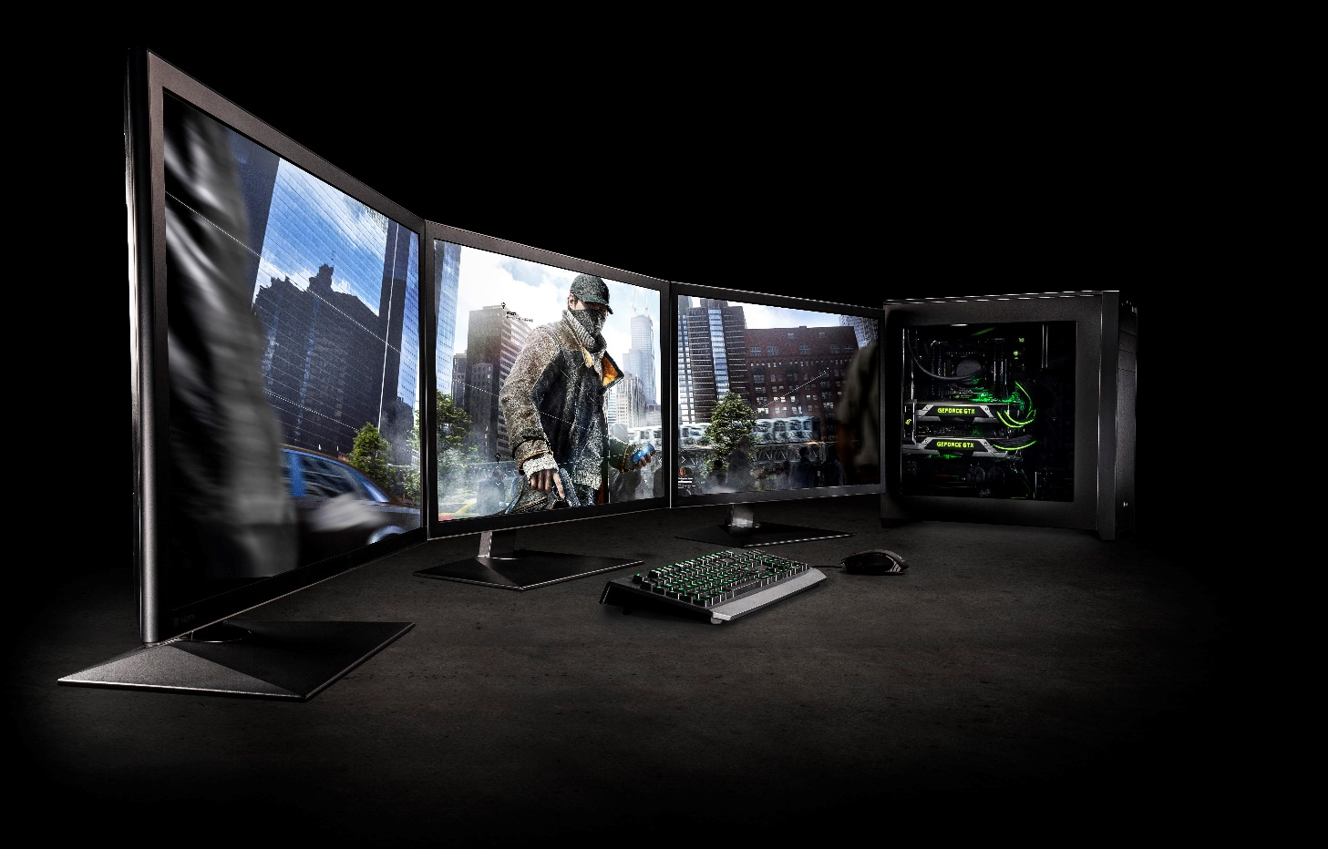

Enabling NVIDIA Surround
To enable NVIDIA Surround with Watch Dogs® 2, open the NVIDIA Control Panel. Within the navigation tree pane, under 3D Settings, select Configure SLI, PhysX, Surround and select Span displays with Surround. Click the Configure button to arrange displays and to adjust for bezel correction.
NOTE: If you have any questions regarding NVIDIA Surround, please contact your local NVIDIA PR Manager or navigate to http://www.geforce.com/hardware/technology/surround.

NVIDIA Contact Information
NVIDIA North/Latin America Public Relations
Brian Burke  Senior PR Manager, Gaming Technology & Cloud Gaming  Office: 512 401 4385  Cell: 512 694 6106  bburke@nvidia.com | Steve Kennedy  Technical Marketing Specialist  Office: 408 486 8713  Cell: 925 285 2748  skennedy@nvidia.com
Nick Stam  Senior Director, Technical Marketing  Office: 215 504 0321  Cell: 215 514 0400  nstam@nvidia.com | Sean Cleveland  Director, Technical Marketing, GeForce  Office: 408 562 7555  Lab Phone: 408 486 4115  Cell: 831 402 0145  scleveland@nvidia.com
Matthew Widener  Technical Marketing Manager  Office: 408 486 2588  Cell: 831 419 9253  mwidener@nvidia.com | Andrew Saunders  Technical Marketing Specialist, Monitors  Office: 408 566 7124  Cell: 804 402 9686  ansaunders@nvidia.com
Alexandre Ziebert  Technical Marketing Manager, Latin America  Cell: +55 11 96630 1074  aziebert@nvidia.com | Leo De Biase  Manager, Corp. Comms & Product PR, Latin America  Office: +55 11 5501 2037  ldebiase@nvidia.com

NVIDIA Europe Public Relations
Benjamin Berraondo  Senior Product PR Manager – GeForce EMEAI  Office: +44 118 903 3078  Cell: +44 7979 384482  bberraondo@nvidia.com  NVIDIA UK  100 Brook Drive  Green Park  Reading  RG2 6UJ | Lars Weinand  Senior Technical Marketing Manager, Europe  Office: +49 89 6283 50013  Cell: +49 173 7311540  lweinand@nvidia.com  NVIDIA GmbH  Haus 1 West, 3rd Floor  Flössergasse 2  81369 Munich, Germany
Sebastien Januario  PR Manager, Iberia  Office: +33 (0) 1 55 63 16 51  Cell: +336 73 98 73 23  sjanuario@nvidia.com  NVIDIA FRANCE  Le Colisée - Bâtiment B - 6ème étage  12, avenue de l’Arche – 92 400 Courbevoie  FRANCE | Denis Kozlov  Technical Marketing Manager, Russia / CIS  Office : +7 495 981 0300 extra 10738  Cell : +7 916 196 6495  dekozlov@nvidia.com
Christian Beer  PR Manager DACH  Office : + 49 89 6283 50055  Cell : +49 162 2164644  cbeer@nvidia.com  NVIDIA GmbH  Haus 1 West, 3rd Floor  Flössergasse 2  81369 Munich, Germany | Jen Andersson  PR Manager Northern Europe  Office: +44 (0)118 903 3047  Cell: +44 (0)7799 483 329  jandersson@nvidia.com  NVIDIA UK  100 Brook Drive  Green Park  Reading  RG2 6UJ
Stephane Quentin  Senior PR Manager France & Belgium Office  Office : +33 155 638 493  Cell: +33 6 825 68322  squentin@nvidia.com  NVIDIA FRANCE  Le Colisée - Bâtiment B - 6ème étage  12, avenue de l’Arche – 92 400 Courbevoie FRANCE | Irina Shekhovtsova  Senior PR Manager, Russia & CIS  Office: +7 495 981 03 00  Cell: +7 916 161 97 10  irinas@nvidia.com  NVIDIA Ltd  12 Dvintsev, 2nd floor  127018 Moscow  RUSSIA
Luciano Ballerano  PR Manager- Italy, Greece & Israel  Office: +39 0200618577  Cell: +39 3666760288  lballerano@nvidia.com | Pinar Ortakaya  PR Manager, Turkey  Cell: 90 541 3454334  portakaya@nvidia.com

NVIDIA APAC Public Relations
Jeff Yen  Senior Technical Marketing Manager, APAC  Office : +886 987 263 193  jyen@nvidia.com  NVIDIA  8, Kee Hu Road, Neihu  Taipei 114  TAIWAN | Melody Tu  Senior PR / Marketing Manager, APAC  Office: +886 2 6605 5856  metu@nvidia.com  NVIDIA TASA (TW/AU/SEA)  8, Kee Hu Road, Neihu  Taipei 114  TAIWAN
Searching Shi  Technical Marketing Manager, China  Office: +86-10 5866 1500  seshi@nvidia.com  NVIDIA Corp.  Unit 2901-2904, China World Tower 1  N0.1 Jian Guo Men Wai Avenue  Beijing, P. R.  CHINA | Steven Jin  PR Manager, China  Office: +86-10 5866 1500  jiyang@nvidia.com  NVIDIA Corp.  Unit 2901-2904, China World Tower 1  N0.1 Jian Guo Men Wai Avenue  Beijing, P. R.  CHINA
Kyle Kim  Technical Marketing Manager, Korea  Office: +82 2 6001 7186  kylek@nvidia.com  NVIDIA Korea  #2101, COEX Trade Tower, 159-1  Samsung-dong Kangnam-gu, Seoul 135-729  KOREA | Sunny Lee  Marketing Manger, Korea  Office: +82 2 6001 7123  slee@nvidia.com  NVIDIA Korea  #2101, COEX Trade Tower, 159-1  Samsung-dong Kangnam-gu, Seoul 135-729  KOREA
Luna Park  Marcom Manger, Korea  Office: +82 2 6001 7342  lunap@nvidia.com  NVIDIA Korea  #2101, COEX Trade Tower, 159-1  Samsung-dong Kangnam-gu, Seoul 135-729  KOREA | Kaori Nakamura  PR/Marketing Manager, Japan  Office : +81 3 6743 8712  knakamura@nvidia.com  ATT New Tower 13F  2-11-7 Akasaka,Minato-ku,  Tokyo 107-0052  JAPAN
Alex Chang  Technical Marketing Engineer, TASA  Office : +886 2 6605 5055  alechang@nvidia.com  NVIDIA  8, Kee Hu Road, Neihu  Taipei 114  TAIWAN | Chitoku Yato  Technical Marketing Engineer, Japan  Office: +81-3-6743-8775  cyato@nvidia.com

Notice
ALL INFORMATION PROVIDED IN THIS WHITE PAPER, INCLUDING COMMENTARY, OPINION, NVIDIA DESIGN SPECIFICATIONS, REFERENCE BOARDS, FILES, DRAWINGS, DIAGNOSTICS, LISTS, AND OTHER DOCUMENTS (TOGETHER AND SEPARATELY, “MATERIALS”) ARE BEING PROVIDED “AS IS.” NVIDIA MAKES NO WARRANTIES, EXPRESSED, IMPLIED, STATUTORY, OR OTHERWISE WITH RESPECT TO MATERIALS, AND EXPRESSLY DISCLAIMS ALL IMPLIED WARRANTIES OF NONINFRINGEMENT, MERCHANTABILITY, AND FITNESS FOR A PARTICULAR PURPOSE.

Information furnished is believed to be accurate and reliable. However, NVIDIA Corporation assumes no responsibility for the consequences of use of such information or for any infringement of patents or other rights of third parties that may result from its use. No license is granted by implication or otherwise under any patent or patent rights of NVIDIA Corporation. Specifications mentioned in this publication are subject to change without notice. This publication supersedes and replaces all information previously supplied. NVIDIA Corporation products are not authorized for use as critical components in life support devices or systems without express written approval of NVIDIA Corporation.

Trademarks
NVIDIA, the NVIDIA logo, and GeForce are trademarks or registered trademarks of NVIDIA Corporation in the United States and other countries. Other company and product names may be trademarks of the respective companies with which they are associated.

Copyright
© 2016 NVIDIA Corporation. All rights reserved. NVIDIA, the NVIDIA logo, and Ansel, HBAO+, HFTS, PCSS, and TXAA are trademarks and/or registered trademarks of NVIDIA Corporation in the U.S. and other countries. Other company and product names may be trademarks of the respective companies with which they are associated.
© ©2016 Ubisoft Entertainment. All Rights Reserved. Watch Dogs, Ubisoft and the Ubisoft logo are trademarks of Ubisoft Entertainment in the U.S. and/or other countries.

