SHELLEY LANE
Shelley Lane Salon

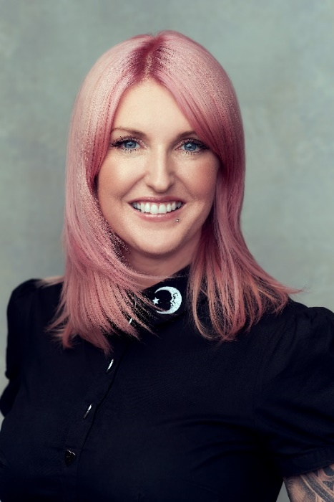
Shelley Lane is the director of Shelley Lane Salon. From Aberkenfig, a small Welsh town, she has shaped a very personal project that fully represents her. This boutique salon is a space entirely designed by her where she has wanted to reflect her way of feeling and experience her hairdressing, not only as a business but as a passion that has also become a way of living.
The space was previously the house where she lived her childhood, and maybe due to emotional connotations, she decided to make it her other home, her hairdressing salon, which opened in 2005. Se planned it not only as of the place where she could develop her dreams. It is also an invitation to her clients to accompany her in the great experience, making them feel at home. Her team is like part of her family. The members are very different yet united, above all, by their passion for hairdressing.

Shelley Lane discovered her vocation very young, at just 14 years old, when she started to work in a salon after school and on Saturdays. After that, she decided to train as a hairdresser for four years and by the end of her studies, she knew that she had found the engine of her life. Seeking excellence, she wanted to continue learning from the best, so she decided to train at the Vidal Sassoon academy.

In 2002, during a photo shooting, she discovered creative hairdressing and quickly felt a true fascination that marked a before and after in her career. Another key moment was in 2012 when she decided to train with many brands, as well as with different artists. In fact, she has not abandoned continuous training and has taken courses from Milk_shake, Z.one Concept, ghd, Vidal Sassoon, Wella, and Joico, among many others. All of this opened up a new perspective on the profession that led her to take a new turn in her life. She increased her self-confidence and began to participate in contests, where she won. With this projection, she was invited to participate in the 2014 Milk Shake Hair UK British tour, getting on stage for the first time and greatly enjoying the adrenaline of the shows. From there, and for 6 years, she travelled the world, making her work known and working as an international trainer in hairdressing and styling courses in the United Kingdom, New York, Australia, Canada, Italy, Portugal, Denmark, and many other countries.

In 2018 and 2019 she travelled around the globe offering demonstrations of her avant-garde looks, as well as educational workshops on fashion, bridal style, and editorials. She also participated in other events in the sector such as in the two Annual international Show of Z.one Concept and Milk_Shake Hair UK during the last 7 years.

As for her creative collections, she started in 2016 with "Elysium" and has not stopped to date. The first was followed by "Persephone" in 2017, "Moonlight" in 2018; "Efflorescence" in 2019, and "Pili-Pala" in 2021, with which she has received enormous recognition from the sector.

Shelley has been since 2017 an ambassador for Milk_Shake Hair UK and Global Educator for Z.one Concept Milk_Shake, of whom she is a member of the artistic team and with whom she has created the "Blue Velvet" (2017) and "Pure" (2018) collections. And, thanks to her knowledge in fashion and image, she has worked in the London Men's Fashion Week (2018) and the Paris Fashion Week (2020).

Awards and recognitions:

2021 - Finalist in the Avant-garde Hairdresser of the Year category in the HJ British Hairdresser Awards.

2019, 2018, 2017 – Finalist in the Avant-garde category in the International Visionary Awards, Alternative Hair Show.

2019 – Finalist in I Want Her Hair by Hair Magazine Awards.

2019 - Finalist in Ultimate Stylist by Salon Business Awards.

2018 – Finalist in the Salon Business Awards.

2017 - Finalist in the Avant-garde Hairdresser of the Year category in the HJ British Hairdresser Awards.

2016 – Winner of the Women Stylist of the Year in the Welsh Hair & Beauty Awards.

2016 – Winner in the Best Salon Team category in the Welsh Hair & Beauty Awards.

2014 – Winner in the Hairdresser of the Year and the Salon of the Year categories in the Welsh Hair & Beauty Awards.

