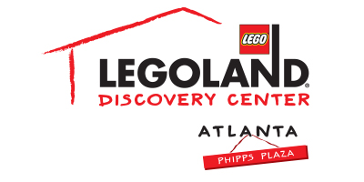

For More Information:
McKenzie Riley
BRAVE Public Relations 404.233.3993
mriley@emailbrave.com
FOR IMMEDIATE RELEASE

LEGOLAND® Discovery Center and Children’s Healthcare of Atlanta Celebrate the Biggest Birthday Party of the year!
Three days of Children’s Healthcare of Atlanta LEGO fun!

ATLANTA (June 18, 2018) – This summer, LEGOLAND® Discovery Center is joining Children’s Healthcare of Atlanta to give all kids the opportunity to celebrate the 40th Anniversary of the first-ever LEGO minifigure. On Tuesday, June 19 and Wednesday June 20, LEGOLAND Discovery Center is bringing the BRICK-tastic party to the kids at Children’s Healthcare of Atlanta for the biggest birthday party EVER! Activities will include a take home building activity and goodie bags. On Thursday, June 21, LEGOLAND Discovery Center will host a final celebration at the attraction for the kids, including a private meet and greet with Emmet, a minifigure build activity and LEGO coloring sheets.

LEGOLAND Discovery Center is partnering with Children’s Healthcare of Atlanta to provide kids the opportunity to celebrate from either the hospital or the attraction. Children’s Healthcare of Atlanta works to provide the best care, and best experience, for every child. With a three-day celebration of birthday-themed activities, LEGOLAND Discovery Center is excited to provide an unforgettable experience to some of the strongest kids in Atlanta!

WHAT: Minifigure Birthday Celebration with Children’s Healthcare of Atlanta

WHEN: Tuesday, June 19
2 p.m. to 3 p.m.
Wednesday, June 20
2 p.m. to 3 p.m.
Thursday, June 21
2 p.m. to 3 p.m.

WHERE: Children’s Healthcare of Atlanta – Egleston
Tuesday, June 19
Children’s Healthcare of Atlanta – Scottish Rite
Wednesday, June 20
LEGOLAND Discovery Center Atlanta in Phipps Plaza
Thursday, June 21

HOW: This is a private event for families of children in Children’s Healthcare of Atlanta. Media are invited to cover this event; please obtain advance confirmation from McKenzie Riley (mriley@emailbrave.com / 404.233.3993.)

