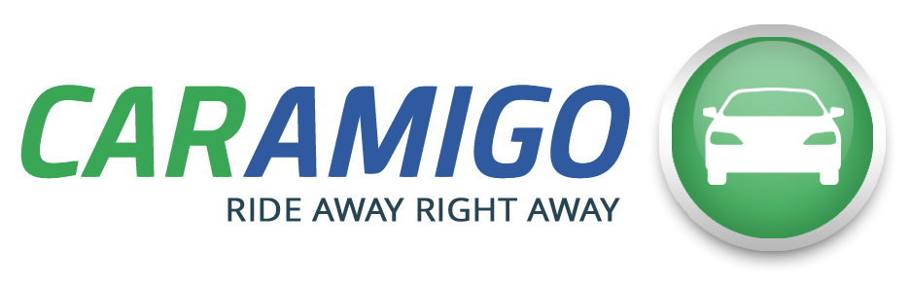 |  | 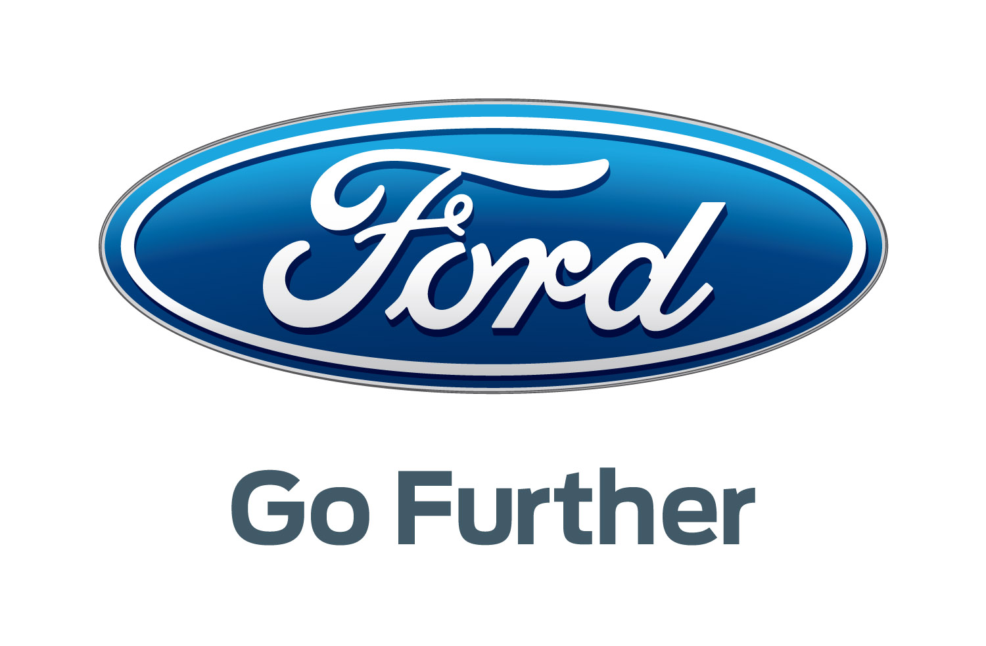

Press release
CarAmigo and Ford form partnership

Brussels, January 8th 2016 - CarAmigo, Belgium's first peer-to-peer car rental marketplace is delighted to announce that it has today signed a partnership agreement with Ford, a car manufacturer breaking new ground in alternative transport.
The aim of this partnership is to encourage current and future Ford owners to register their cars on CarAmigo. More specifically, when drivers buy a new car, or take one in for a service, Ford will tell them about the benefits of peer-to-peer car rental using CarAmigo and the possible savings.
Encouraging Ford owners to share their cars
Let us not forget that although private cars have significant financial implications for owners in terms of depreciation, insurance, taxes and other expenses, we only use them 5% of the time on average. This partnership will help Ford customers effectively make savings on the cost of owning a car while maximising car use. New Ford buyers can already work out their total potential savings – or even profits – by registering their car on CarAmigo and using the calculator available on www.caramigo.be/ford.
A more rational use of the car park
Peer-to-peer car rental is also one of the most effective ways to reduce road traffic by using cars more efficiently. The scheme is not just efficient; it is safe too. CarAmigo provides comprehensive insurance (in addition to Touring roadside assistance) for every rental. It also screens each rental customer and has even negotiated a deal with the Belgian tax authorities on behalf of car owners through an advance tax ruling.
Alex Gaschard, founder of CarAmigo, welcomes this partnership “Working with Ford will help CarAmigo expand its service and, as a result, help make peer-to-peer car rental more popular. Having a major car brand like Ford invest specifically in new modes of transport is something to celebrate. And it’s encouraging us to go even further to promote the benefits of the sharing economy”.
Thanks to Ford’s presence at the Brussels Motor Show and its sales outlets, this co-marketing campaign (supported by direct marketing, point-of-sale promotions and online communications) will reach many Ford customers in Belgium. And it will also then be extended to the Grand Duchy of Luxembourg.

About CarAmigo
CarAmigo is Belgium’s first peer-to-peer carsharing marketplace and connects car owners with people who need a car. It was recently mentioned in the national & international press as one of the most promising Belgian startups.
Thanks to CarAmigo, an owner can easily recoup some of his expenses by renting out his own car, with peace of mind since CarAmigo checks all drivers and provides a comprehensive all-risk insurance.
A driver in need of car can choose the one he needs, wherever whenever, with peace of mind since all cars benefit from a 24/7 roadside assistance.
So sign-up for free on www.CarAmigo.be, and ride away right away !

About Ford Motor Company
Ford Motor Company, a global automotive industry leader based in Dearborn, Mich., manufactures or distributes automobiles across six continents. With about 195,000 employees and 66 plants worldwide, the company’s automotive brands include Ford and Lincoln. The company provides financial services through Ford Motor Credit Company. For more information regarding Ford and its products worldwide, please visit www.corporate.ford.com.
Ford of Europe
Ford of Europe is responsible for producing, selling and servicing Ford brand vehicles in 50 individual markets and employs approximately 53,000 employees at its wholly owned facilities and approximately 68,000 people when joint ventures and unconsolidated businesses are included. In addition to Ford Motor Credit Company, Ford Europe operations include Ford Customer Service Division and 24 manufacturing facilities (16 wholly owned or consolidated joint venture facilities and 8 unconsolidated joint venture facilities). The first Ford cars were shipped to Europe in 1903 – the same year Ford Motor Company was founded. European production started in 1911.

###

Press contacts CarAmigo
- Alexandra Curelea: +32 2 340 92 46 or +32 487 38 66 17
- Laure Vandeghinste: +32 2 893 98 76 or +32 479 60 45 92
- Email: press@voice.be

Press contacts Ford
- Jo Declercq: +32 474 94 00 32
- Arnaud Henckaerts: +32 486 99 61 30

In essence it means that carsharing will not be considered earned income for private users, subject to conditions including the number of cars rented, the total length of the rental and the total income generated. See press release for more details http://caramigo.prezly.com/world-premiere-peer-to-peer-carsharing-provider-caramigo-concludes-a-ruling-agreement-with-the-tax-authorities
Among others in PwC’s World in Beta report: Who’s Who in Europe’s Mobility Equation (and the Unique Role they Play in Redefining the Playbook)

