For more information, please contact Marta de Paco
On +34 670 780 664 or email press@comunicahair.com

Important:
These images are only available for editorial content.
Credits must be included.
Notification of their publication is expected.

MANUEL MON
ORIGAMI Collection

2021 FÍGARO AWARDS WINNER
AVANT-GARDE CATEGORY

2022 CONTESSA AWARDS WINNER
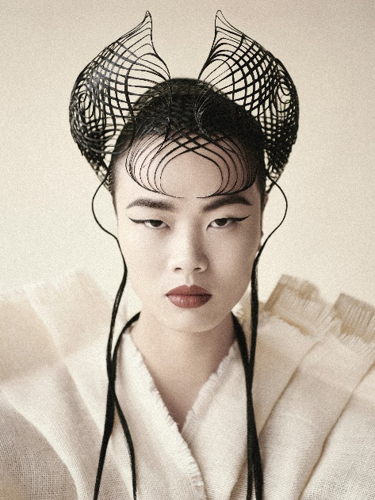
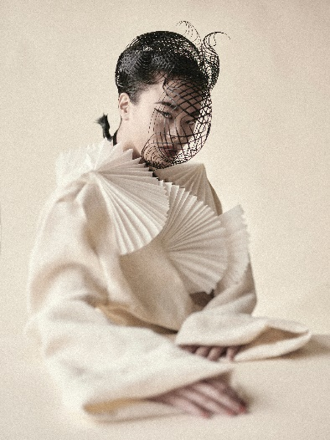
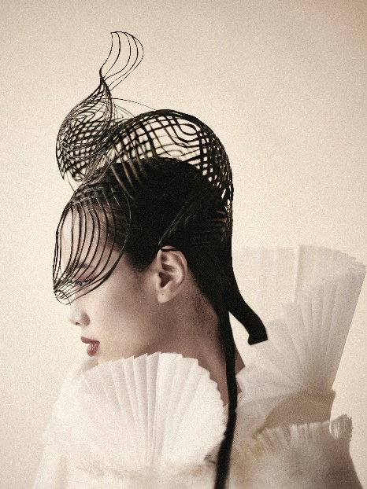
INTERNATIONAL HAIRSTYLIST OF THE YEAR CATEGORY

Hair: Manuel Mon | @manuelmonoficial
Photographer: Bernardo Baragaño | @vertigoestudio
Make up: María Montes y Helena Truébano | @__mariamontes__
Model: Mei Ruiz
Styling: Ana Gonzalez
Products: Revlon Professional | @revlonprofessional_es

MANUEL MON
ORIGAMI Collection

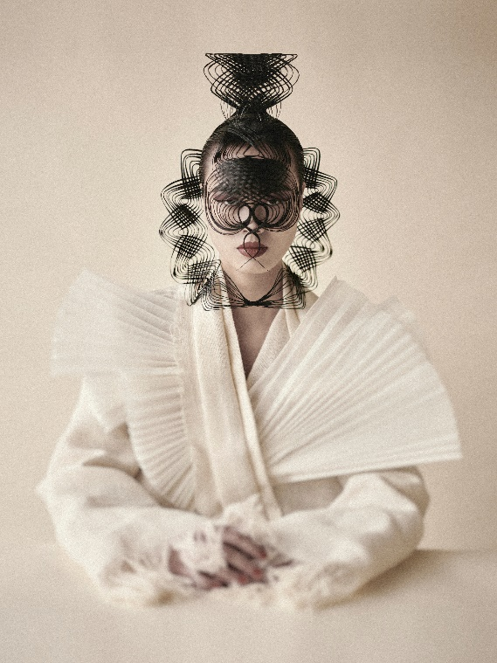

Origami draws hair towards the expressiveness of this art on paper. It’s a creative process that emphasizes the sensitivity of shapes and the accuracy of the work surface. Starting from this premise, balanced and natural images are created, without seams, without cuts, without artificial joints, elevating origami to manual art.

The collection shows natural hair in shape and color, creating meticulous fold patterns, with layouts, intertwining and pure and clean ends. The result is an artistic symmetry of oriental beauty.

