Sennheiser introduces TruVoicelift for TeamConnect Ceiling 2
Combining the convenience of Sennheiser’s ceiling mic array with next-level voice amplification

Wedemark, February 1, 2021 – Widely used in corporations and higher education institutions, TeamConnect Ceiling 2 has become a leading microphone solution for conferencing audio in business and distance learning applications. Now Sennheiser is opening a new chapter for its ceiling microphone array. A free firmware update brings TeamConnect Ceiling 2 into the heart of a voice amplification system: TruVoicelift ensures clearly audible in-room audio for classrooms, lecture halls, and boardrooms, with many easily controllable features that make for a pleasant and clear listening experience.

“We have many happy TeamConnect Ceiling 2 users across the globe, and we asked ourselves: What if they could use their existing tech for even more?” says Jens Werner, Portfolio Manager in Sennheiser’s Business Communication Division. “This was the starting point for designing the latest software update which adds the TruVoicelift functionality to TeamConnect Ceiling 2. It endows the mic array with many innovative features for perfect audio all the way to the back row.”

A free update for clear in-room audio
For existing TeamConnect Ceiling 2 (TCC2) implementations, users can now add the TruVoicelift functionality simply by installing the free firmware update (1.6.4) via the new version of the Sennheiser Control Cockpit app (4.3.0).

New users gain two solutions in one from the start and will be delighted by the ease of installation, freedom of movement and clear audio that TCC2 offers. Depending on the size and configuration of the room, additional TeamConnect Ceiling 2 microphones can be installed as audience mics, thus creating a completely touchless microphone solution that reduces potential hygiene risks.

TruVoicelift ensures clear in-room audio for business and education applications

Clever features for an even better listening – and presentation – experience
TruVoicelift is powered by an advanced frequency shift algorithm that delivers a few crucial extra dB of gain – an enhancement that could make all the difference to perfectly hearing the lecturer or CEO. At the same time, TruVoicelift also includes a “feedback prevention mute” function – if levels should get too loud, TCC 2 briefly mutes to prevent any feedback. Speakers can therefore relax and focus on their presentation, knowing that TeamConnect Ceiling 2 will provide optimum audio for their audience.

During pauses in speaking, if a pre-defined audio threshold is not reached, a noise gate will be activated that mutes TeamConnect Ceiling 2 to prevent any background noise from being amplified.

All TruVoicelift settings can be conveniently controlled via the Sennheiser Control Cockpit app. The app also allows you to easily create “priority zones”, i.e. areas where audio is predominantly picked up. This is helpful for any set-ups where audio usually comes from a defined place, such as the front of a lecture hall. Also, you can define “advanced exclusion zones”, enabling you to target and exclude noise sources with pinpoint accuracy, such as air conditioning or ventilation equipment.

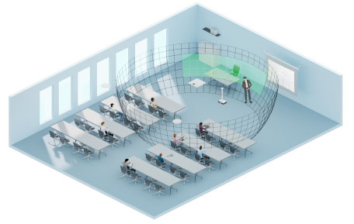 | The free Sennheiser Control Cockpit software allows you to determine priority zones for voice amplification to focus on the speaker (green = selected priority zone)

Jens Werner summarizes: “The free TruVoicelift update for TCC2 expands the feature set of the conferencing microphone array to a completely new usage scenario for both corporations and education institutions. TruVoicelift helps to establish pleasant audio levels in a room, and lets speakers be confident that they can be perfectly understood throughout the entire auditorium.”

Useful links:
Sennheiser Control Cockpit update (4.3.0)
TeamConnect Ceiling 2 firmware update (1.6.4)
More about TruVoicelift
Image link

About Sennheiser
Shaping the future of audio and creating unique sound experiences for customers – this aim unites Sennheiser employees and partners worldwide. Founded in 1945, Sennheiser is one of the world’s leading manufacturers of headphones, loudspeakers, microphones and wireless transmission systems. Since 2013, Sennheiser has been managed by Daniel Sennheiser and Dr. Andreas Sennheiser, the third generation of the family to run the company. In 2019, the Sennheiser Group generated turnover totaling €756.7 million. www.sennheiser.com

Global Press Contact

Stephanie Schmidt
stephanie.schmidt@sennheiser.com
+49 (5130) 600 – 1275

