Ultra I/O Reliability: RME MADIface USB, TotalMix FX Helps Power Bjork’s European
‘Utopia Tour’
The tour’s front of house engineer John Gale and musical director Matt Robertson turn to the 128-channel MADI interface and RME’s TotalMix software for ease and rock-solid reliability during all 11 show dates

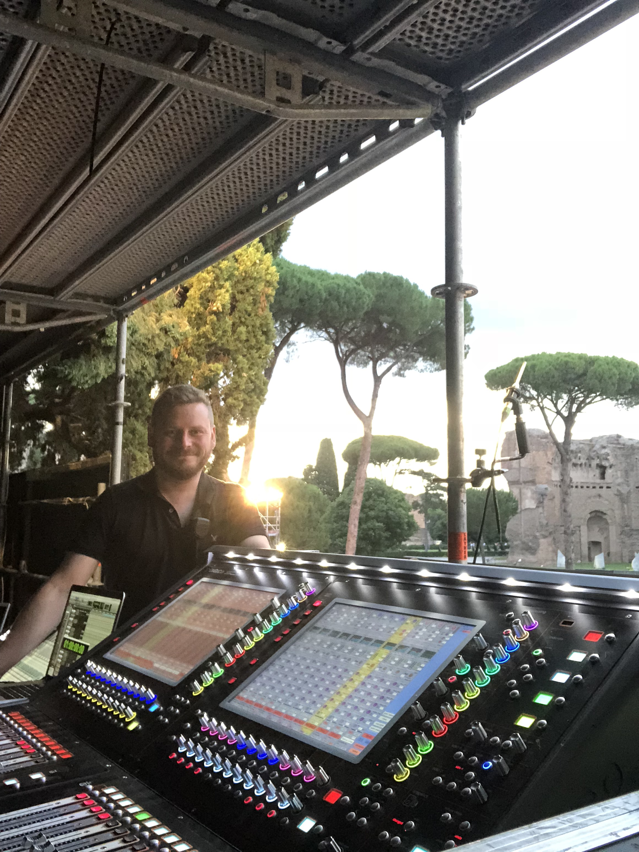
Boston, MA – July 19, 2018 – Icelandic pop singer-songwriter Bjork kicked off her latest European tour, dubbed the Utopia Tour, with back-to-back dates in her in hometown of Reykjavik as well as stops at major festivals, including All Point’s East in London and Primavera Sound in Barcelona.
During the 11-show tour, front of house engineer John Gale of Galeforce Sound employed two RME MADIface USB, compact, 128-channel interfaces which provide MADI I/O over USB 2.0. Gale used the main and spare IO into dual ProTools rigs for the live vocal and flute effects which were dealt with in timecoded ProTools sessions running specific plugins.
“The RME MADIface USB has been rock solid,” Gale said. “The key thing for me is the MADIface’s solid drivers and physical reliability. RME products have always sounded fantastic, but their reliability is what sets them ahead of the rest.”
Low Latency is Key
In addition to the MADIface’s reliability, the interface’s low latency is also critical for Gale. Due to the nature of the live performances, Gale said it’s particularly important to employ a unit that features a low enough latency that he can pass the audio in and out of ProTools quickly without any audible pops, glitches or perceived delays.
“We experimented with the buffer sizes to find a low setting that was rock solid,” explained Gale. “I’m using the MADIface in this situation for the vocal effects, like reverb and delays, on Bjork’s vocal microphone and also the live effects on the flute ensemble. I’m also sending these effects back to Bjork’s monitor engineer so it has to be as low latency as possible as she’s monitoring this on stage.”
Dynamic Duo: TotalMix & RME
RME’s TotalMix software enables unlimited routing and mixing to the company’s audio interfaces — an invaluable resource for Gale and musical director Matt Robertson during rehearsals and pre-show setup checks.
“The musicians on stage have TotalMix setups too, so that they can listen to their own mixed outputs, without having to have the monitor engineer switch to a particular scene or snapshot,” Robertson said. “There is also some very clever stuff you can do with TotalMix to route timecodes to various outputs and even back into the same device which can sometime be really useful. If you need a duplicate timecode output on 36, it’s easy to route it in TotalMix without having to make any changes to your playback session.”
Longtime Brand Loyalty
Gale purchased his first MADIface in 2008 and since then has used the interface on hundreds of tours as well as tracked live albums for artists that have then gone onto commercial release and used it for countless virtual sound-checks.
“RME products are so reliable it took me until this year to finally retire the HDSPe MADIface I purchased nearly 10 years ago only because I changed my computer,” Gale said. “I swear by them.”
Gale has used other MADI-based recording devices from other manufacturers, but often found himself up against issues such as the inability to receive a certain BNC MADI stream, yet his RME MADIface would read the same MADI stream with no trouble.
“Additionally, the drivers are so solid. I’ve used other products where I’ve had to keep reinstalling the drivers every few days, but with the MADIface I can’t remember ever having an issue,” Gale said. “They simply work and that, to me, is the most important thing — solid reliability and confidence that, come show time, it will work every time.”
For more on RME, visit rme-usa.com

About Synthax, Incorporated
Synthax Inc. is the exclusive USA distributor for RME digital audio solutions, Ferrofish advanced audio applications, myMix audio products, and ALVA cableware. We supply a nationwide network of dealers with these products for professional audio, broadcast, music industry, commercial audio, theater, military and government applications. For additional information, visit the company online at http://www.synthax.com.
Media Contacts:
Katie Kailus
Public Relations
Hummingbird Media
+1 (630) 319-5226
katie@hummingbirdmedia.com

Jeff Touzeau
Public Relations
Hummingbird Media
+1 (914) 602 2913
jeff@hummingbirdmedia.com

