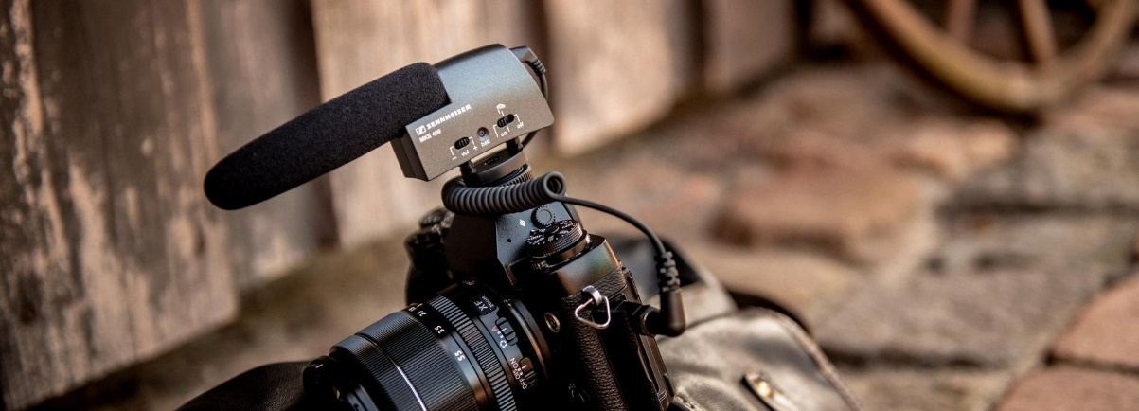

Father’s Day gifts for the best videos
Microphones from Sennheiser: Father’s Day gifts with perfect sound for passionate film-makers

Wedemark, 11 May 2020 – Father’s Day in 2020 will once again provide the ideal opportunity to show how much we value our fathers and partners and to surprise them with a carefully chosen gift. Like every year, originality is the key. Socks you have knitted yourself or a humorous printed t-shirt may well have their uses, but they rarely produce the rapturous response you were hoping for. Instead, how about giving them a present that will definitely put a smile on their face and offer lasting enjoyment?

Sound is emotion
If the “world’s best dad” is someone who enjoys using a camera in his free time or is even a passionate film-maker, the obvious solution is to delight him with a present that suits his passion – such as a high-quality microphone that immediately raises the video soundtrack to a completely new level.

If you want to see just how important sound is for the overall audio-visual experience, try this simple test: watch a scene from a popular Hollywood blockbuster and briefly switch off the soundtrack. The film is almost unrecognisable and the excitement disappears at a stroke – only with sound does real emotion come into play.

Ambitious amateur film-makers prefer to use DSLR cameras or mirrorless models (DSLM), which have been hugely popular for some time now, as well as camcorders – although, even in the latest generation, their integrated miniature microphones are usually of modest quality and are not particularly impressive with their limited sound image. By contrast, anyone who has ever used a “proper”, external microphone for video recordings will never want to go back to the built-in mike ever again.

When it comes to making convincing sound recordings, the first choice for (professional) film-makers around the globe is to use microphones from Sennheiser. The audio specialist’s product range includes many different possibilities for enriching the moving image with optimum sound, in keeping with the budget available and the task in hand. The microphones from the family-owned German company can be ordered with free delivery from the Sennheiser online shop and are without doubt the perfect gift for Father’s Day.

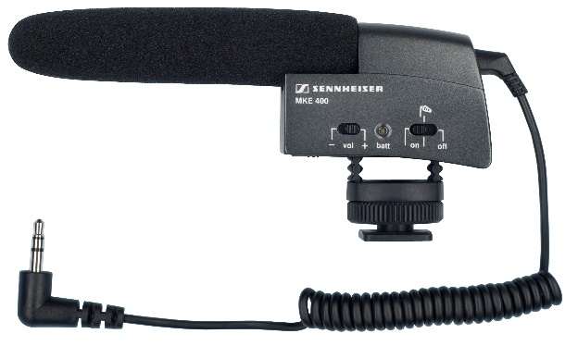  The MKE 400 is a very compact and lightweight on-camera microphone – and the perfect companion for your DSLR or DSLM | 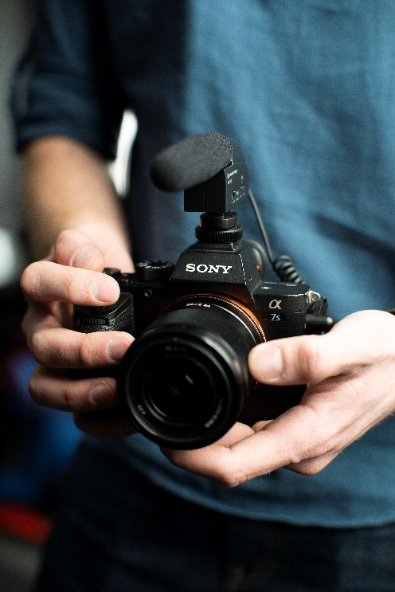

Top-quality sound in mono
An entry-level model with a professional standard is the Sennheiser MKE 400 – a compact, pleasantly lightweight mini-shotgun microphone that fits directly onto the camera shoe mount, while its super-cardioid/lobar pick-up pattern ensures that off-axis noise from the side is effectively rejected. The stereo jack plug (3.5 mm) of its connecting cable is simply plugged into the camera’s audio input, with power being provided by a single AAA battery. The Sennheiser MKE 400 is the perfect companion for passionate film-makers – a small microphone with a big sound!

For stereo fans
The Sennheiser MKE 440 stereo camera microphone features two microphones in a V-shaped configuration. The two shotgun microphones acoustically cover a stereo width equivalent to the image created by a 35-mm camera lens – ensuring homogeneous coverage of the entire field with particularly high speech intelligibility in the image focus. The MKE 440 can effortlessly handle a remarkable dynamic range from quiet whispers to loud rock music.

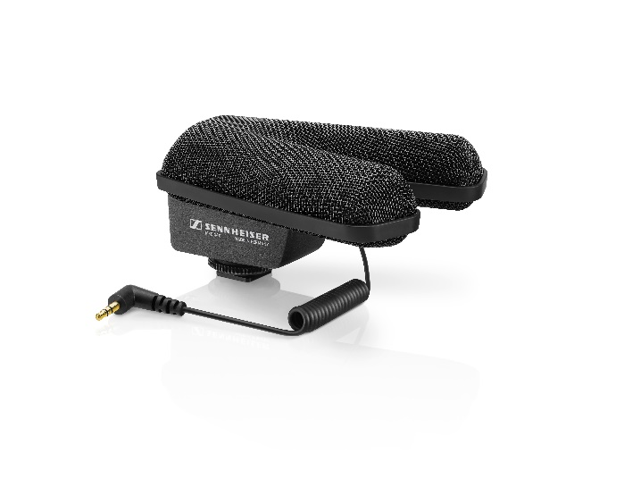  Natural stereo sound in a snap with the MKE 440 | 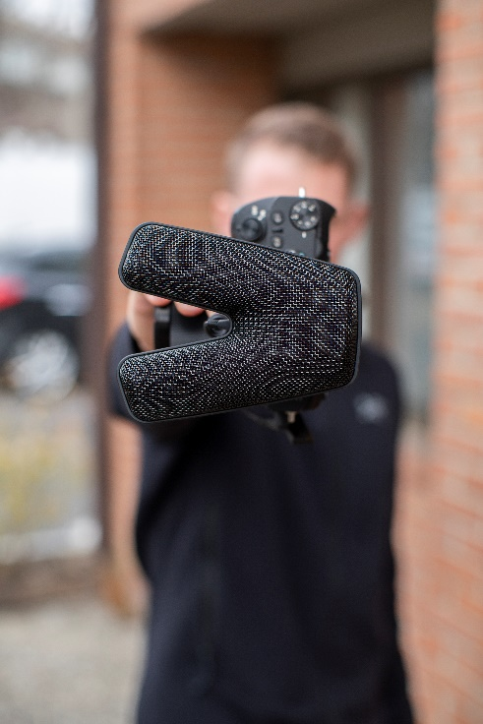

Shotgun microphone: focus on the action
It often makes sense during filming not to bring the camera too close to the subject, for example because you want to include more of the surroundings in the picture or you prefer that special look of a longer focal length. With its distinct pick-up pattern (super-cardioid/ lobar), the Sennheiser MKE 600 shotgun microphone delivers impressive performance in situations like these. Its sophisticated design ensures maximum possible attenuation of unwanted noise components coming from the side. If required, a switchable high-pass filter reduces structure-borne noise and wind noise. A matching foam windshield and a shock mount that fits onto the camera shoe mount are included with the MKE 600 – the cable needs to be ordered separately depending on the camera’s audio input. Also available as an accessory is a fur windshield for outdoor recordings.

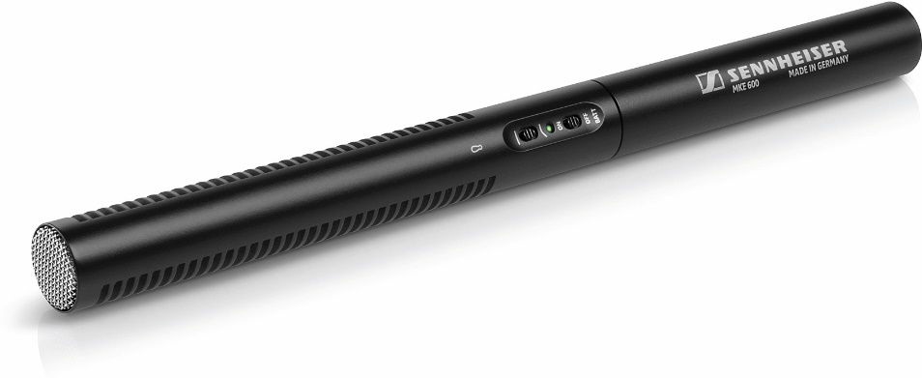 | The MKE 600 shotgun microphone focuses on the action
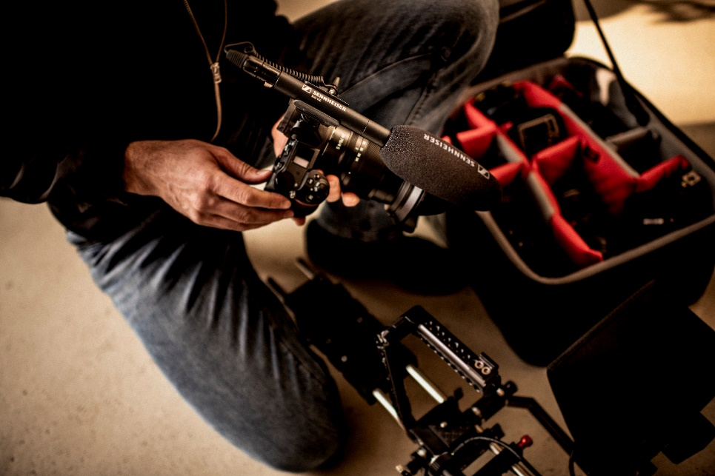

Wireless and tireless
For decades now, Sennheiser has been renowned for its innovative wireless technology, and stars throughout the world rely on the company’s wireless microphone systems for their live performances. Sennheiser’s proven know-how also goes into its products aimed at ambitious amateur film-makers – professional-sounding recordings without annoying cables needn’t necessarily be expensive!

Sennheiser has put together attractive “all-inclusive” packages as part of its XS Wireless Digital series. Of particular interest for film-makers is the XSW-D Portable Lavalier Set, which includes an ME 2-II clip-on microphone, an XSW-D transmitter, an XSW-D receiver for the camera, a cold shoe mount, 3.5 mm coiled cable, belt clip and a USB-A to USB-C charging cable. The set is ideally suited for interview situations, for example. The miniature microphone is clipped securely to the interview partner’s clothing, thus ensuring that the sound remains constant even when the camera is moved. The XSW-D components are so easy to use that even those people who generally have an aversion to all things technical will find their way immediately.

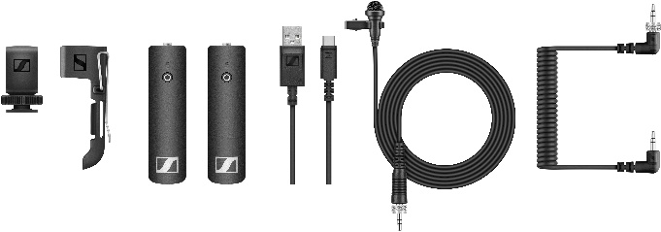  The XS Wireless Digital Portable Lavalier Set is an easy to use “all-inclusive” package | 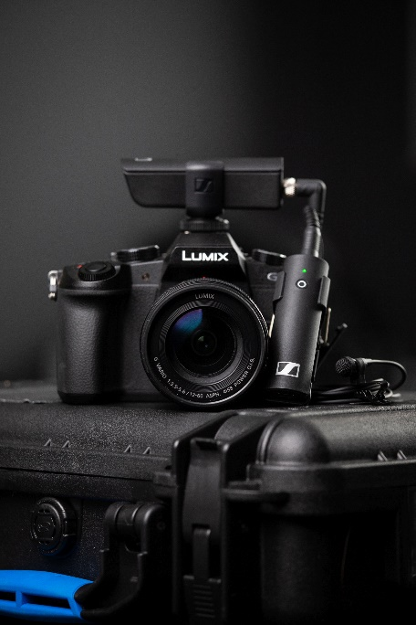

Wireless sound artists with the best (smartphone) connections
Smartphones are now ubiquitous, and their integrated video function means that users can quickly become a camera operator, film-maker and film director with little effort. Provided that the light conditions at the location are more or less acceptable, the quality of these videos is usually quite presentable – but as far as their built-in audio recording systems are concerned, even the latest generation of smartphones rarely deliver decent sound.

The ideal solution, therefore, is to use the Sennheiser Memory Mic, which features a pre-polarized condenser capsule for impressively clear sound. Using the microphone is surprisingly easy too: at the touch of a button, “one touch” audio/video synchronisation perfectly harmonises the sound with the recorded images – using an external microphone for your smartphone just couldn’t be easier! The Sennheiser Memory Mic connects with the smartphone via Bluetooth – automatically and with no need for troublesome cables. A further advantage: there is no risk of interruptions in transmission or sound drop-outs, as the audio and video tracks are not combined until synchronisation takes place using the free Sennheiser MEMORY MIC app.

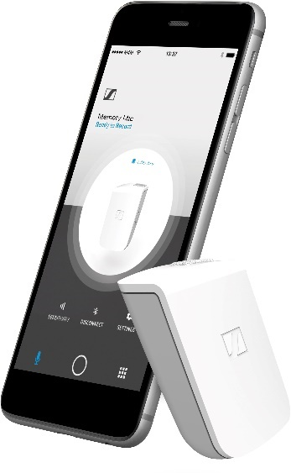 | Smartphone solution: The Sennheiser Memory Mic and app for Android and iOS

If you would like to add an atmospheric room component to supplement the direct signal, you can use the MEMORY MIC app to mix the microphone signal from the smartphone in any ratio with the Memory Mic’s audio signal, which is recorded wirelessly in excellent quality: WAV files with 16 bit/48 kHz and an audio frequency response from 100 Hz to 20 kHz. Enjoy film-making!

Price information:
MKE 400: EUR 199 (MSRP) / USD 199.95 (MAP)
MKE 440: EUR 349 (MSRP) / USD 349.95 (MAP)
MKE 600: EUR 299 (MSRP) / USD 329.95 (MAP)
XSW-D Portable Lavalier Set: EUR 299 / USD 299.95 (MAP
Memory Mic: on special offer until the end of May: EUR 99 (MSRP) / USD 99.95 (MAP)

More about the MKE camera microphones and the XS Wireless Digital series on YouTube: https://www.youtube.com/watch?v=nmv1FUd342Q
https://www.youtube.com/watch?v=0P_jo_GNA3Y

The images accompanying this press release plus additional photos can be downloaded at https://sennheiser-brandzone.com/c/181/b8Ptvhxm.

About Sennheiser
Founded in 1945, Sennheiser is celebrating its 75th anniversary this year. Shaping the future of audio and creating unique sound experiences for customers – this aim unites Sennheiser employees and partners worldwide. The independent family company, which is managed in the third generation by Dr. Andreas Sennheiser and Daniel Sennheiser, is today one of the world’s leading manufacturers of headphones, loudspeakers, microphones and wireless transmission systems. In 2018, the Sennheiser Group generated turnover totalling €710.7 million. www.sennheiser.com

Global Press Contact

Stephanie Schmidt
Stephanie.schmidt@sennheiser.com
+49 (5130) 600 – 1275

