5 seminars to improve your video
Take part in Sennheiser and Panasonic LUMIX live webinars

Wedemark, 14 June 2019 – Sennheiser Sound Academy and Panasonic LUMIX Academy will launch a new series of live training webinars that reveal how to create outstanding video content – that sounds as great as it looks. The free webinar series starts on June 21, explaining “How good audio lifts your video to a more professional level”. The live format means that participants will also have time to put questions to the specialists.

Providing the perfect blend of theory and practical tips and tricks for camera and audio, the Sennheiser/Panasonic LUMIX webinar series addresses a range of common scenarios such as video blogging, mobile journalism or documentary, and showcases best practices for setting up, shooting and delivering compelling and slickly produced content.

Sennheiser Sound Academy and Panasonic LUMIX Academy are launching  a free live webinar series  on creating outstanding audio-visual content | 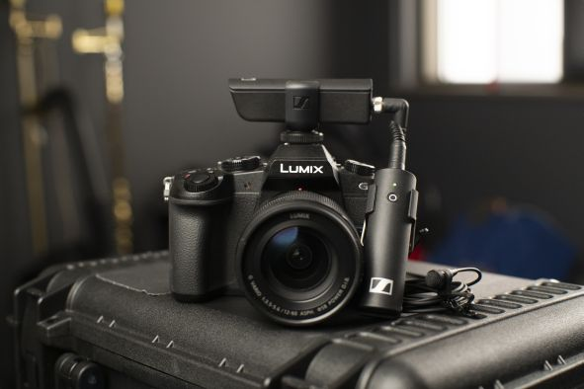

The webinars offer easy-to-follow guidance that’s ideal for everyone from complete beginners to those wishing to further develop their skills and take their videos to the next level.

The free online course is co-hosted by experts from Sennheiser Sound Academy and Panasonic LUMIX Academy and was developed following a highly successful program of face-to-face training workshops. For the first time, the live webinars will also make these essential courses available to enjoy anywhere and on demand on Sennheiser’s YouTube channel.

To participate, please register at www.sennheiser.com/webinars
Registration for each of the live webinars is open three weeks before the launch date of the episode, which are as follows:

Webinar 1 (June 21)
Introduction – How good audio lifts your video to a more professional level
(Audio basics, mic basics, psychology of sound to picture)

Webinar 2 (September 6)
Target group: MOJO (Mobile Journalists)
Tips & tricks – Choice of camera, set-up, material & audio tips and tricks

Webinar 3 (October 11)
Target group: Video Bloggers (Vloggers)
Tips & tricks – Choice of camera, set-up & audio tips and tricks, including lighting, framing, etc

Webinar 4 (November 1)
Target group: Documentary/Film
Tips & tricks – Camera set-up (including multicam setup), field recording & audio tips and tricks

Webinar 5 (December 6)
Immersive audio for video
(AMBEO portfolio and how to link it to video production)

Sennheiser Sound Academy and Panasonic LUMIX Academy look forward to taking you on the next steps on your journey into better audio and video.

About Panasonic
Panasonic Corporation is a worldwide leader in the development of diverse electronics technologies and solutions for customers in the consumer electronics, housing, automotive, and B2B businesses. The company, which celebrated its 100th anniversary in 2018, has expanded globally and now operates 591 subsidiaries and 88 associated companies worldwide, recording consolidated net sales of Euro 61.4 billion for the year ended March 31, 2018. Committed to pursuing new value through innovation across divisional lines, the company uses its technologies to create a better life and a better world for its customers.
To learn more about Panasonic: http://www.panasonic.com/global.

About Sennheiser
Shaping the future of audio and creating unique sound experiences for customers – this aim unites Sennheiser employees and partners worldwide. Founded in 1945, Sennheiser is one of the world’s leading manufacturers of headphones, microphones and wireless transmission systems. With 21 sales subsidiaries and long-established trading partners, the company is active in more than 50 countries and operates its own production facilities in Germany, Ireland, Romania and the USA. Since 2013, Sennheiser has been managed by Daniel Sennheiser and Dr. Andreas Sennheiser, the third generation of the family to run the company. In 2017, the Sennheiser Group generated turnover totaling €667.7 million. www.sennheiser.com

Global press contact

Amaya Albisu Stephanie Schmidt
amaya.albisu@eu.panasonic.com stephanie.schmidt@sennheiser.com
+ 49611235215 +49 (5130) 600 – 1275

