Sennheiser's Podcast Picks
International Podcast Day 2020

Wedemark, September 28, 2020 – Over the past years, podcasts have become a firm fixture in the international media landscape. For International Podcast Day 2020, Sennheiser recommends four special podcasts that you should check out - and the right audio equipment to get the most out of your favorite podcasts, both for listening and for producing them yourself.

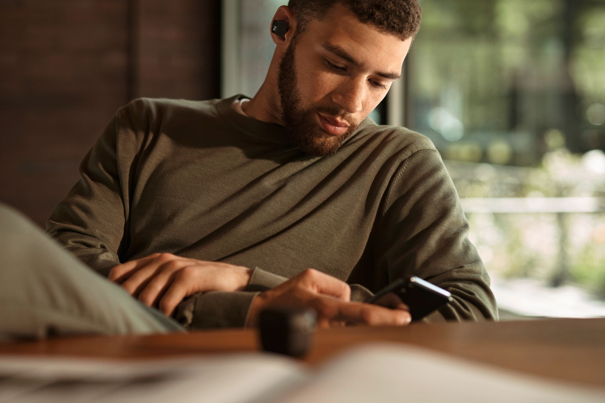

1 – AMBIENT
Nature podcast: Sound by Nature

Why should I subscribe to this podcast?
Sound By Nature delivers exactly what its name promises: chiefly, sounds of the great outdoors from California. Don’t just take our word for it, though. As the creator says himself, you should listen to this podcast “for relaxation, stress reduction, meditation, sleeping - or whatever you like”. Each episode usually lasts for an hour, offering a range of soundscapes such as wind, birdsong, campfires or thunder and rain. Sound By Nature provides a good exercise in acoustic attentiveness.
How can I listen to this podcast in the best way?
With Sennheiser’s new HD 560S around-ear headphones (MSRP: 199 EUR). Natural and accurate reference sound that divulges every detail, complemented by an outstanding low-frequency extension. Offering a frequency response of 6 Hz – 38 kHz, the HD 560S reproduces the entire frequency range with honesty. The headphones aim to show how a recording is intended to be heard, letting you experience the sounds of nature in great detail and making you feel as if you’re right in the middle of the action.

How can I produce a podcast like this myself?
With an AMBEO VR Mic (MSRP: 1,550 EUR), for example. If you are aiming for an immersive sound experience, this Ambisonics microphone, which has been specially designed for spatial sound recording, allows you to capture stunning 360° sound from a single spot. If you want to put an acoustic spotlight on a single sound source such as a bird singing, you should use a shotgun microphone like the MKH 8060 (MSRP: 1,300 EUR).

2 – AT HOME
Interview podcast: SmartLess

Why should I subscribe to this podcast?
In life, you always learn something new about yourself when you meet someone else – and this mantra is certainly true of SmartLess, presented by US comedy stars Jason Bateman, Will Arnett and Sean Hayes. Every week, they meet interesting people from popular culture and politics for a mix of thoughtful conversation and amusing anecdotes.

How can I listen to this podcast in the best way?
With Sennheiser’s new CX 400BT True Wireless earphones (MSRP: 199 EUR). Thanks to their bespoke acoustic system featuring Sennheiser’s 7mm dynamic drivers, the earphones deliver astonishing sound. Offering intuitive, customizable touch controls, all-day comfort and a great 7-hour battery life, the CX 400BT True Wireless earbuds keep pace with busy lifestyles. Meanwhile, thanks to their integrated equalizer and Sennheiser’s Smart Control app, the sound can be adjusted to your personal preferences – so that it is almost as unique as the guests on the podcast.

How can I produce a podcast like this myself?
With an MK 8 condenser microphone (MSRP: 699 EUR). This large-diaphragm studio microphone is particularly suited to professional voice recordings. Its pick-up pattern can be adjusted according to the task at hand, for example a figure-of-eight pattern for an interview situation.

3 – HYBRID
Video podcast: The Joe Rogan Experience

Why should I subscribe to this podcast?
With over 1,500 episodes under his belt, Joe Rogan is one of the most prolific podcasters in the game. On The Joe Rogan Experience, he has interviewed everyone from Elon Musk to Mike Tyson. Politics, health or relationships: no subject is off limits.

How can I listen to this podcast in the best way?
With Sennheiser’s MOMENTUM True Wireless 2 earbuds (MSRP: 299 EUR). They deliver the best possible listening experience at any time, thanks to the audio specialist’s 7mm dynamic drivers, designed and manufactured at the company’s headquarters in Germany. Their ergonomic design offers the perfect level of comfort for a podcast marathon. Active noise cancellation prevents you from being distracted, even in noisy environments, while the Transparent Hearing feature blends in outside sound at a touch. In addition, IPX4-rated weather resistance, intuitive, customizable touch controls and a great 7-hour playback time make these a great choice for enjoying your favorite podcast on the go.

How can I produce a podcast like this myself?
The MKE 200 (MSRP: 99 EUR) is a great choice when starting out. This directional microphone features an integrated windscreen and shock mount for optimized sound recordings to camera. It comes complete with 3.5mm TRS and TRRS cables for connection to DSLRs, DSLMs and mobile devices. For advanced users, we recommend the MKE 440 (MSRP: 349 EUR), a compact stereo microphone for cameras with a hot shoe and an external microphone connection.

4 – SPOTLIGHT
Audiophile podcast: Darko.Audio podcast

Why should I subscribe to this podcast?
Because for passionate audiophiles, nothing is more interesting than assessing the latest technology and products on the market. As well as providing an overview of the latest audiophile gear, John Darko interviews renowned music producers and industry figures.

How can I listen to this podcast in the best way?
As a true audiophile, you may want to dive into this podcast with Sennheiser’s HD 660S headphones (MSRP: 499 EUR). Designed for audio enthusiasts, the open, dynamic headphones offer natural, lifelike sound with crisp bass, excellent mid-frequency response and a gentle, pleasantly natural treble. The acoustic design ensures low harmonic distortion, while the headphones’ low impedance of 150 ohms and the supplied choice of cables allow you to enjoy the HD 660S with a variety of audio sources. For great comfort even during long podcast sessions, the headphones’ robust yet lightweight construction makes listening supremely comfortable. The elliptical ear cups are shaped to follow the anatomy of the ear, while thick padding on the headband and the replaceable ear cushions provides a relaxing and luxurious experience that places the listening enjoyment at center stage.

How can I produce a podcast like this myself?
Use a good studio condenser microphone like the MK 4 (MSRP: 299 EUR) or the MK 8 (MSRP: 699 EUR). Very demanding producers could also take a look at Sennheiser’s MKH series. These extremely life-like condenser microphones stand for sound recordings of the very highest quality and let you discover the soul of sound.

Start your own podcast with Sennheiser
Feel inspired to start your own podcast? Sennheiser has teamed up with music producer, sound engineer and professional podcaster Marc Mozart to help podcast beginners get started: The tutorial series "How to Podcast" offers a free podcast guide to kick things off - from concept creation to tips on the right recording software and the right microphone to marketing your very own podcast. The video series and all further information are available here: www.sennheiser.com/how-to-podcast

About Sennheiser
Founded in 1945, Sennheiser is celebrating its 75th anniversary this year. Shaping the future of audio and creating unique sound experiences for customers – this aim unites Sennheiser employees and partners worldwide. The independent family company, which is managed in the third generation by Dr. Andreas Sennheiser and Daniel Sennheiser, is today one of the world’s leading manufacturers of headphones, loudspeakers, microphones and wireless transmission systems. In 2019, the Sennheiser Group generated turnover totaling €756.7 million. www.sennheiser.com

Global Press Contact
Sennheiser electronic GmbH & Co. KG
Jacqueline Gusmag
Communications Manager Consumer
T: +49 (0)5130 600-1540
jacqueline.gusmag@sennheiser.com

