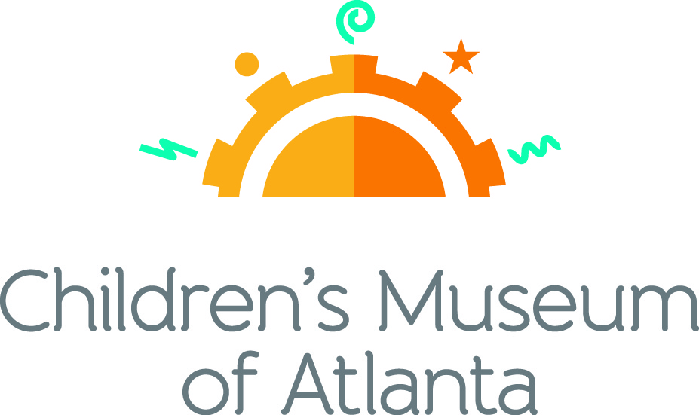

FOR MORE INFORMATION:
Becca Meyer/Jennifer Walker
BRAVE Public Relations, 404.233.3993
bmeyer@bravepublicrelations.com/
jwalker@bravepublicrelations.com

FOR IMMEDIATE RELEASE

Children’s Museum of Atlanta to host sun-sational fun in June
New Blue Man Group – Making Waves exhibit and special programming provide perfect summer entertainment

ATLANTA (May 15, 2017) – School’s out for the summer! Families are invited to take learning outside of the classroom and embrace the power of play at Children’s Museum of Atlanta. Whether children are discovering the science behind sound in the new Blue Man Group – Making Waves exhibit, joining the Mayor’s Summer Reading Club, celebrating Father’s Day at the Daddy Olympics or creating a moon lantern in honor of Eid ul Fitr, June is sure to be jam-packed with fun for all!

Feature Exhibit: Blue Man Group – Making Waves
June 10 – September 4, 2017
The national touring exhibit, supported by Harman/Becker Automotive Systems and created by the Boston Children’s Museum and Blue Man Group and powered by JBL®, will take the whole family through a multi sensory exploration of sound that provides an opportunity for everyone to play together while discovering the fun of music. The 1,500 square foot exhibit features six interactive stations where children will have an opportunity to see, feel and create sound just like the Blue Man Group.

Themed daily programming during Blue Man Group – Making Waves exhibit will occur through September 4, 2017. Programming subject to change and may be altered during special events. All programs included with admission unless otherwise noted.

Mini-Musical: A Sound Connection
Weekdays at 11 a.m., 12 p.m. and 2 p.m.; Saturday at 11 a.m. and 2 p.m.; Sunday at 12 p.m. and 2 p.m.
Children will join robot W.A.V.E. and Caveperson Sonar on a journey through the Earie Canal to experience the wonder of sound by listening to animals in the wild and learning to dance like a sounds wave!

Story Time
Weekends at 1 p.m.
“Zoola Palooza: A Book of Homographs” by Gene Barretta
An exclusively animal musical group, Zoola Palooza are in town to teach little ones all about homographs – words that are spelled the same but pronounced differently and have separate meanings.

Music & Movement: Surround Sound
Weekdays at 1 p.m.; Saturday at 11 a.m. and 3 p.m.; Sunday at 11 a.m.
What sound is created when a stick crashes into a trash can? What happens when a pencil hits a coffee cup? Children can join the Imaginators in learning that sound is all around us when making music through found objects!

Super Spectacular Science Show
Weekdays at 3 p.m. and Weekends at 4 p.m.
Professor Lab Coat and his assistants will lead a mesmerizing science demonstration for the entire Museum.
Eat A Georgia Rainbow
Sunday at 3 p.m.
Children will embark on a scavenger hunt and cold cooking activity with the Imaginators to learn more about fruits and veggies harvested in Georgia throughout the year.
Art Studio Projects
Weekdays 10:30 a.m. –3:30 p.m.; Weekends 11 a.m. –4 p.m.
Little ones can discover colors and explore artists from around the world through various crafts like making and decorating a banjo, experimenting with powder paint, blow paint and splatter paint as well as creating a noise maker from recycled objects.
Build It Lab
Weekdays, 10:30 a.m. –3:30 p.m.; Weekends 11 a.m. –4 p.m.
Children will put their woodworking and creative tools to the test in this supervised space where they have access to real tools and materials. Encouraging inventions, this Build It Lab will spark creativity by allowing young innovators to build items such as a rain stick and drum.
Science Bar
Weekdays 10:30 a.m. –2:30 p.m.; Weekends 11 a.m. –3:30 p.m.
Science is everywhere, especially on the mezzanine at the Museum! Step Up to Science is the new STEM exhibit area and features interactive exhibits about light, robotics and how the human body works! Families can saddle up to the science bar for a full menu of fun activities, knowledge and have their questions turned into answers by one of the STEM educators.
June Special Programming

Under the Big Top
June 1 – 9
- Mini Musical: Beebo and Ravioli’s Spectacular Circus
11 a.m., 12 p.m. and 2 p.m. Weekdays; 12 p.m. and 2 p.m. Sunday
Families are invited to step right up and help Imaginators Beebo and Ravioli create their very own circus! Children can be a high flying acrobat, silly clown or a ferocious circus animal!
- Music and Movement
1 pm. Weekdays; 11 a.m. Sunday
School is back in session! Little ones can go through a day in the life of clown school to learn how to juggle, limbo, hula hoop and more!
- Art Studio
10:30 a.m. – 3:30 p.m. Weekdays; 10:30 a.m. – 4 Sunday
Children can create a sand art necklace or a silly clown face to embrace the colors and elements that can be found at a circus.
- Build It Lab
10:30 a.m. – 3:30 p.m. Weekdays; 10:30 a.m. – 4 Sunday
Throughout the week, families can build a variety of circus-themed items including a big top mini carousel.

Mayor’s Summer Reading Club Kick-off
Saturday, June 3
Little ones ages 8 and under are invited to take part in the Mayor’s Summer Reading Club! Participants will receive a free book designated for his or her age group, including “A Color of His Own” by Leo Lionni for infants, “Amari’s Blue Ribbon” by the Atlanta Speech School for ages 2-4 and “Farmer Will Allen and the Growing Table” by Jacqueline Briggs Martin for ages 5-8.
- 11 a.m.: Special Guest Story Time
Atlanta First Lady Sarah Elizabeth Reed will read “Amari’s Blue Ribbon” by the Atlanta Speech School to show children how they can create a meaningful impact on society through exploring their curiosity and striking up conversations.
- 12 p.m. and 2 p.m.: Special Music and Movement
Kids are invited to join the Imaginators in game of charades to learn how different animals sound and move throughout the wild!
- 1 p.m. and 3 p.m.: Special Story Time
“Will Allen and the Growing Table” by Jacqueline Briggs Martin follows the story a pro athlete turned farmer who uses his problem solving skills to develop an old city parking lot into a community garden using urban farming methods.
- 11 a.m. – 4 p.m.: Art Studio
Inspired by the chameleon in “A Color of His Own,” kids can make their own beautiful rainbow bracelet. Families can also create a bug jar to collect bugs at home and see which beneficial bugs are helping plants grow – just like Farmer Will Allen used to help his community garden thrive.
- 11 a.m. – 4 p.m.: Build It Lab
Farmer Will Allen taught people throughout his community how to cultivate their own food. Children can create their very own planter to grow a bean plant at home.

Opening day of Blue Man Group – Making Waves
Saturday, June 10
To celebrate the grand opening of the new exhibit, families are invited to take part in special events.
- 12 p.m.: Mary Flannery’s Ghost Music Trio
The local trio will perform family favorites, such as All You Need is Love, Stand By Me, This Land is Your Land and more, to get kids moving and grooving through the brand-new exhibit.
- 2 p.m.: Omicron Gamma chapter of Sigma Gamma Rho Sorority Inc. Step Team
Little ones can step to a new beat as they watch a special step performance to learn that music can be made with our bodies too!

Father’s Day Celebration
Saturday, June 17 and Sunday, May 18
Children are invited to a special celebration to honor their incredible dad, grandpa or favorite uncle! On Sunday, June 18, dads can receive FREE admission when they stop by the visitor’s services desk and say, “I’m a proud dad!”
- 11 a.m. – 2 p.m. Saturday: Father’s Day Photo Booth
Kids can strike a pose with dad in the special Father’s Day photo booth for a keepsake that he’ll cherish forever.
- 1 p.m. Saturday and Sunday: Special Story Time
“I Love My Daddy” written by Sebastien Braun celebrates the bond that fathers share with their children through a look at the day in the life of a bear and his bear cub.
Children can also gather around for “The Perfect Father’s Day” by Eve Bunting to see how one little girl created a magical day for her dad in honor of Father’s Day.
- 11 a.m. and 3 p.m. Saturday; 11 a.m. Sunday: Special Music and Movement
It’s time for the Daddy Olympics! Kids and dads will team up to race against the clock in a variety of fun-filled games. The games will conclude with a special parade to celebrate the holiday.
- 11 a.m. – 4 p.m.: Art Studio
Saturday: After capturing a memorable picture for dad, children will have the chance to create their own hand-crafted picture frame for a special Father’s Day gift!
Sunday: Little ones can craft an All About Dad poster to show how much he means to them this Father’s Day.
- 11 a.m. – 4 p.m. Saturday and Sunday: Build It Lab
Children can build their own table top golf game for a special Father’s Day gift to play together throughout the years.

Meet the Holidays: Eid ul Fitr
Saturday, June 24
  - 11 a.m. and 1 p.m.: Islamic Speakers Bureau
The Islamic Speakers Bureau will lead a special story time and art activity to teach families about the Muslim holiday, Eid ul Fitr, which is the Islamic festival of the fast-breaking after Ramadan ends. Guests will create crafts that celebrate the theme of light and the phases of the moon, which mark time in a lunar calendar.
  - 12 p.m. and 2 p.m.: Special Story Time
“Ilyas & Duck & Fantastic Festival of Eid-Al-Fitr” by Omar Khawaja will teach children more about the fun and enchantment of the holiday, as well as its charitable nature.
  - 3 p.m.: Special Music and Movement
Little ones will discover traditional music and dancing used at Eid festivals around the world to celebrate the end of Ramadan.
- 11 a.m. – 4 p.m.: Art Studio
In honor of an important symbol in the Islamic religion, families can create moon lanterns to hang at home in celebration of the holiday.

For more information on the April program offerings or to support Children's Museum of Atlanta, visit childrensmuseumatlanta.org or call 404.659.KIDS [5437].

About Children’s Museum of Atlanta:
Children’s Museum of Atlanta is the only educational venue of its kind in Atlanta, presenting educational programs and exhibits designed for young children ages 0-8. The Museum’s mission is to spark imagination and inspire discovery and learning for all children through the power of play. With six permanent learning zones consisting of bright, creative and hands-on exhibits, the Museum supports inventive play-based exploration and experiential learning focused on the whole child. Core competencies for literacy, math and science are promoted throughout all exhibits and programming in alignment with the state and national Core Performance Standards. The Children’s Museum of Atlanta also offers parties, memberships, field trips, summer camp and private events. For more information or to support Children's Museum of Atlanta, visit childrensmuseumatlanta.org or call 404.659.KIDS [5437].

Museum Admission: General Admission is $15.95 (plus tax) for anyone 1 – 100 years old. Babies and members are admitted for free. All daily programs are included in price of admission. Group rates and military discounts are available. For more information regarding ticket and membership options, visit childrensmuseumatlanta.org/plan-your-visit/faqs/.

Museum Hours: Monday, Tuesday, **Wednesday, Thursday and Friday 10 a.m. – 4 p.m.; Saturday and Sunday 10 a.m. – 5 p.m. Please check the Museum website to confirm hours of operation.
**As part of its summer hours, Children’s Museum will be open on Wednesdays from 10 a.m. – 4 p.m. now through July 31, 2017

Facebook: https://www.facebook.com/childrensmuseumatlanta
Twitter: https://twitter.com/ChildMuseumATL
Instagram: https://www.instagram.com/childrensmuseumatlanta
Pinterest: http://pinterest.com/cmatlanta
###

