For more information, please contact Marta de Paco
On +34 670 780 664 or email press@comunicahair.com

Important:
These images are only available for editorial content.
Credits must be included.
Notification of their publication is expected.

XARO FERRI
ADUHO Collection

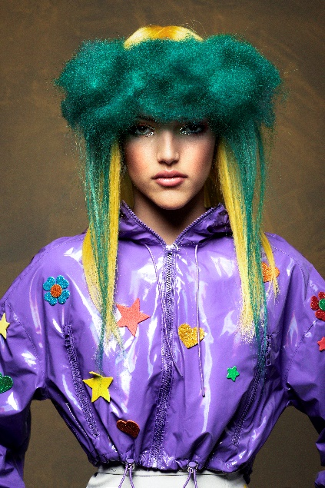
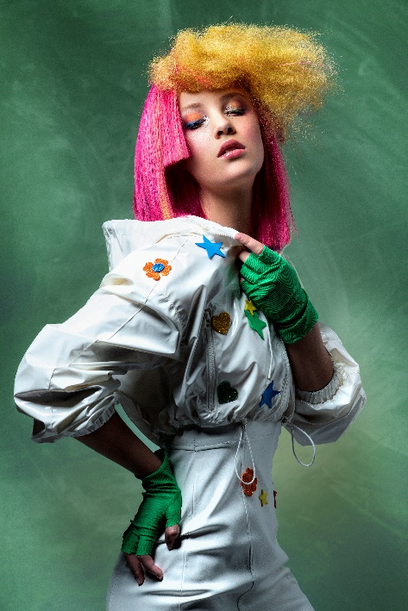
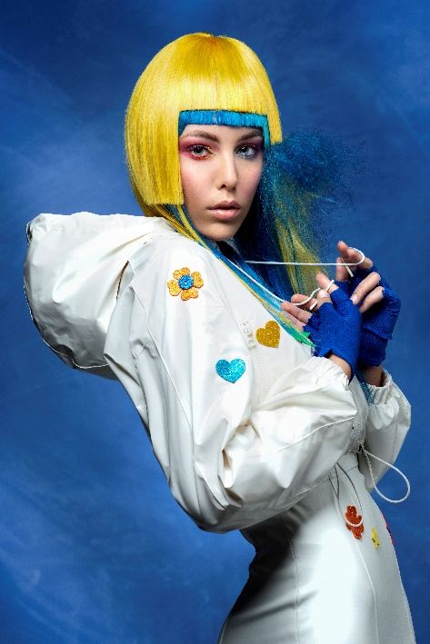

Hair: Xaro Ferri Estilista @xaroferriestilista
Photography: Juanjo Martín @graficament
Retouche: Juanjo Martín @graficament
MUA: Karla Rillo @karlarillo
Styling: Xaro Ferri Estilista @xaroferriestilista

XARO FERRI
ADUHO Collection

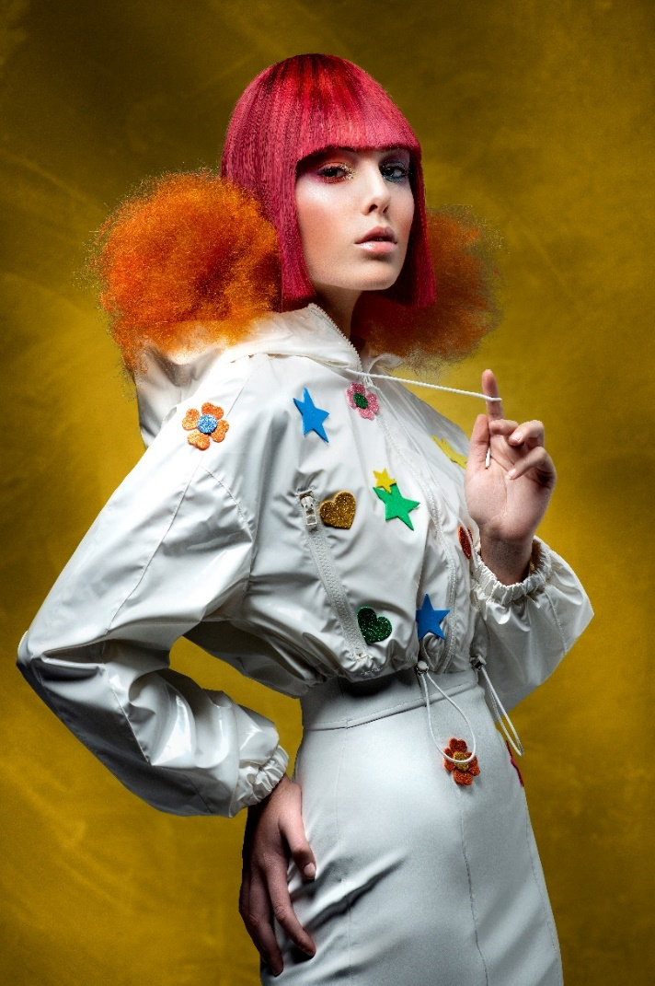

In this collection, color is the protagonist and it expresses all its nuances thanks to the interplay of textures and color combinations. Looks create a landscape full of energy and pop reminiscences. Daring and creativity are the common thread of unexpected haircuts that accompany unusual colors and textures that understand hair as an artistic element.

