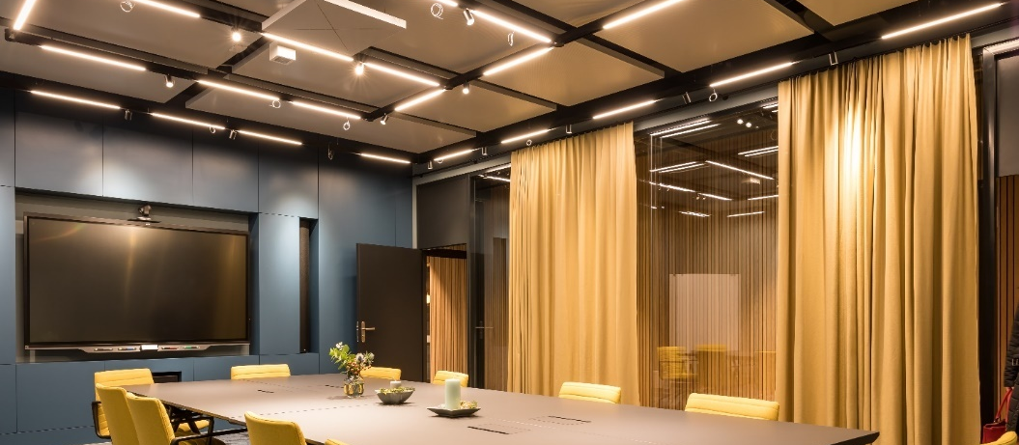

Coworking Lounge Tessinerplatz, Zurich
Inspirational work environment with Sennheiser TeamConnect Ceiling 2 microphone

Marlow/UK, 14 May 2020 – At Tessinerplatz in Zurich, a new coworking space is receiving a very positive response. Designed with a special focus on sustainability, this exceptionally high-quality work environment creates an immediate sense of well-being. It goes without saying that the Coworking Lounge Tessinerplatz is also equipped with state-of-the-art media technology: A Sennheiser TeamConnect Ceiling 2 microphone array with DSP matrixing and patented beamforming technology ensures optimum speech intelligibility during video and audio conferences.

Space for innovation and inspiration
With more than 500 m² of floor space, the Coworking Lounge Tessinerplatz, with its central location in the heart of this vibrant city, offers plenty of space for innovation and inspiration. Sustainability and design were important cornerstones of this showcase project by konzeptS, as Pascal Scheidegger, founder and managing director of the Winterthur-based architecture firm, explains.

The venue offers not only various coworking spaces, but also meeting rooms suitable for larger gatherings and space for events and workshops. A coffee bar that is open to the public (“Coworking, coffee, community”) as well as meeting spaces and recreational areas are also key elements of the services provided. The investor is Swiss Life AG; the Coworking Lounge Tessinerplatz is operated by Home of Coworking GmbH.

Pascal Scheidegger, founder and managing director of konzeptS architect’s office

Mercato with state-of-the-art media technology
The largest room available in the Coworking Lounge Tessinerplatz is called Mercato. It has been created to be a versatile space that can be used for various purposes. It offers 53 m² of floor space and provides state-of-the-art digital working equipment such as large touch screens with smartboard functionality. The conference room is, of course, equipped with top-quality video conferencing technology. In addition to a camera, screen, codec and line array loudspeakers, the equipment also includes a Sennheiser TeamConnect Ceiling 2 microphone array, which is suspended from the ceiling in the middle of the room. This ground-breaking Sennheiser ceiling microphone was supplied, installed and set up by Swiss company Supravision AG.

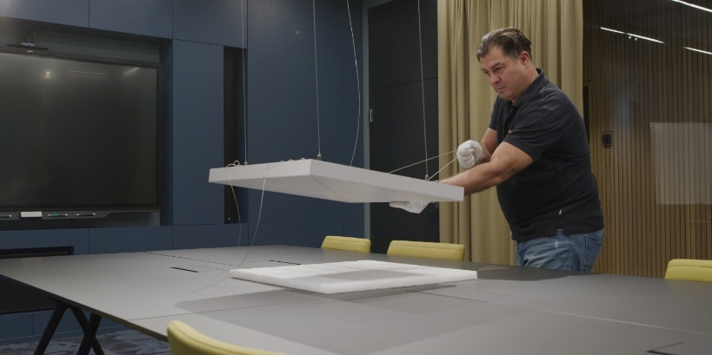 | The Sennheiser ceiling microphone was supplied, installed and set up by Supravision AG

Quality with no unnecessary frills
The acoustics, light and room climate in the multi-functional Mercato conference room are highly impressive, as are the furnishings, which can be freely arranged as required. Quality “with no unnecessary frills” was the top priority of the planners. Equally exquisite is the media equipment, in which the Sennheiser TeamConnect Ceiling 2 plays a key role.

With its 28 pre-polarized electret condenser capsules, the microphone array provides coverage of the entire room, no matter where the meeting participants choose to sit. Its unobtrusive appearance supports the clean and elegant design of the work environment: The speakers’ faces are not obscured by microphones during video conferences and the desks are not cluttered with microphone units and stands. There are also no cables lying around for people to trip over. Interaction with the line array loudspeakers installed at the side of the screen takes place without feedback, and speech intelligibility is always described as excellent by video conference participants at the other end of the video link.

With hygiene having become a key concern these days, TeamConnect Ceiling 2 provides a very sensible solution too: Mounted to the ceiling, it does not require constant cleaning as table microphones would, and the fact that it reliably covers the entire room without the need for any re-adjustment allows for participants to sit at the recommended distance from each other.

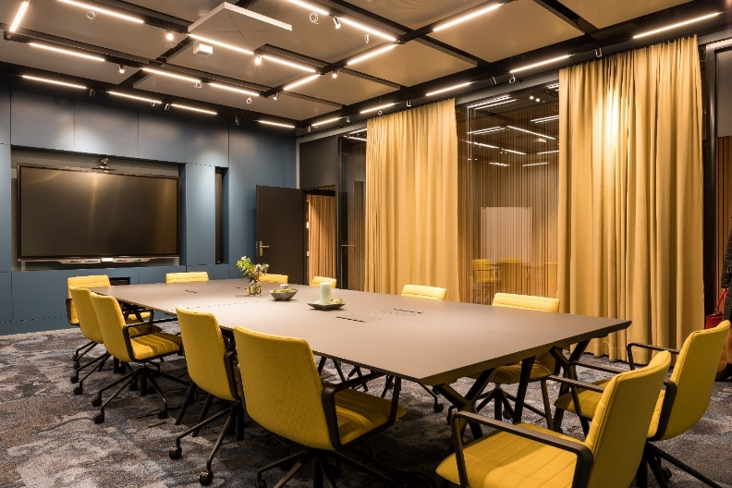 | Sennheiser’s TeamConnect Ceiling 2 fits elegantly into the modern appearance of the Mercato conference room

“The first choice for conferences”
“Selecting the best microphone solution was difficult for us because we really have no idea about audio technology. We simply wanted the audio system to work properly and to provide good quality,” explains Fabio Donnaloia, co-founder in the Coworking Lounge Tessinerplatz. “The Sennheiser ceiling microphone was recommended to us as the benchmark for conference room audio. Speech quality is superb and it fully meets the high demands that we have at Tessinerplatz for our clients at the top management level. The digital technology of Sennheiser’s TeamConnect Ceiling 2 is state of the art. It is easy to use and has an attractive design.”

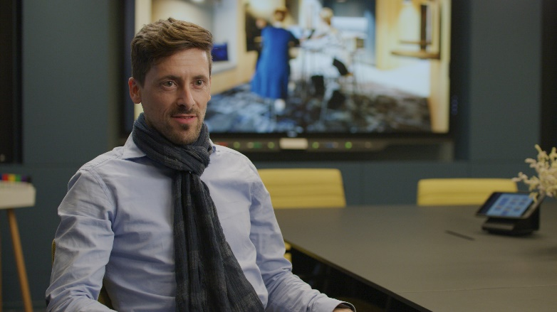 | Fabio Donnaloia, co-founder in the Coworking Lounge Tessinerplatz

Viviane Mathieu, Assistant to Head Real Estate Portfolio Management at Swiss Life Asset Management, who is a regular client at the Coworking Lounge Tessinerplatz, reports on her experiences: “We often hold online meetings in Mercato. As the microphone array covers the entire room, those taking part in the meeting can move around freely. Even when they are working at the digital whiteboard, the audio quality is never impaired. And it makes no difference whether there are two or twenty people in the room – it simply works!”

Viviane Mathieu, Assistant to Head Real Estate Portfolio Management at Swiss Life Asset Management

Co-founder Fabio Donnaloia points out that, in his opinion, a conference room is always well received if it works according to the plug-and-play principle. Donnaloia: “You go into the room and don’t need to waste any time because everything works straight away. In the meantime, we have clients at the Coworking Lounge Tessinerplatz who have become real fans of the ceiling microphone – their initial scepticism quickly gave way to the realisation that the product has a very high quality and is extremely easy to use.”

Viviane Mathieu confirms this observation: “Feedback on the video conference from the participants at the other end of the video link has been very positive throughout. They can always hear us loud and clear, even if two people are speaking at the same time – the audio quality is not impaired in any way.”

Fabio Donnaloia adds: “Business partners on the other end are usually surprised at how well they can understand us – which, by the way, is not always the case in the other direction in every situation…” (he smiles). Donnaloia summarises his experiences with the ceiling microphone in a single sentence: “For us, Sennheiser TeamConnect Ceiling 2 is the first choice for conferences!”

To learn more about this and other practical applications do also check out the Sennheiser Business Blog.
Watch the project video here: https://www.youtube.com/watch?v=ewCH9NdRxNQ

The high-resolution images accompanying this press release can be downloaded at https://sennheiser-brandzone.com/c/181/WqrGP9WB.

About Sennheiser
Founded in 1945, Sennheiser is celebrating its 75th anniversary this year. Shaping the future of audio and creating unique sound experiences for customers – this aim unites Sennheiser employees and partners worldwide. The independent family company, which is managed in the third generation by Dr. Andreas Sennheiser and Daniel Sennheiser, is today one of the world’s leading manufacturers of headphones, loudspeakers, microphones and wireless transmission systems. In 2018, the Sennheiser Group generated sales totalling €710.7 million. www.sennheiser.com

Global Press Contact

Stephanie Schmidt
Stephanie.schmidt@sennheiser.com
+49 (5130) 600 – 1275

Local Press Contacts

Sarah James Maik Robbe
sarahj@gasolinemedia.com maik.robbe@sennheiser.com
+44 (0) 1483 223333 +44 (0) 7393 462484

