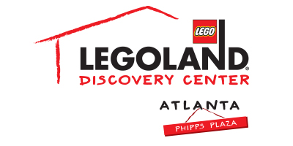
Contact information:
Katie Clark
BRAVE Public Relations
kclark@bravepublicrelations.com

***MEDIA ADVISORY***

LEGOLAND® Discovery Center Atlanta to celebrate
National Ugly Christmas Sweater Day with Adult Night, December 21
Adults fans of LEGO invited to get festively tacky this holiday season

ATLANTA (December 12, 2017) – LEGOLAND® Discovery Center Atlanta will host its annual Ugly Christmas Sweater Adult Night on Thursday, December 21, continuing the National Ugly Christmas Sweater Day celebration, which is celebrated on December 15! Guests will receive $5 off admission if dressed in their tackiest holiday apparel and can enjoy the merry festivities, including a Christmas-themed building competition, learning to build a LEGO present in the Model Builders Academy and more!

WHAT: Ugly Christmas Sweater Adult Night
Guests will have access to the LEGO Factory Tour, MINILAND, Pirate Adventure Island, Kingdom Quest Laser Ride, Merlin’s Apprentice, the 4D Cinema and model building in addition to the café and LEGO shop.

WHEN: Thursday, December 21
7-9 p.m.

WHERE: LEGOLAND Discovery Center Atlanta
Phipps Plaza | Buckhead
3500 Peachtree Road NE
Atlanta, GA 30326

HOW: General admission tickets can be purchased at the door for $19.95 or online in advance for $14.95. Purchase online by visiting atlanta.legolanddiscoverycenter.com.

For more information, visit www.facebook.com/LDCatlanta
or atlanta.legolanddiscoverycenter.com.

###

