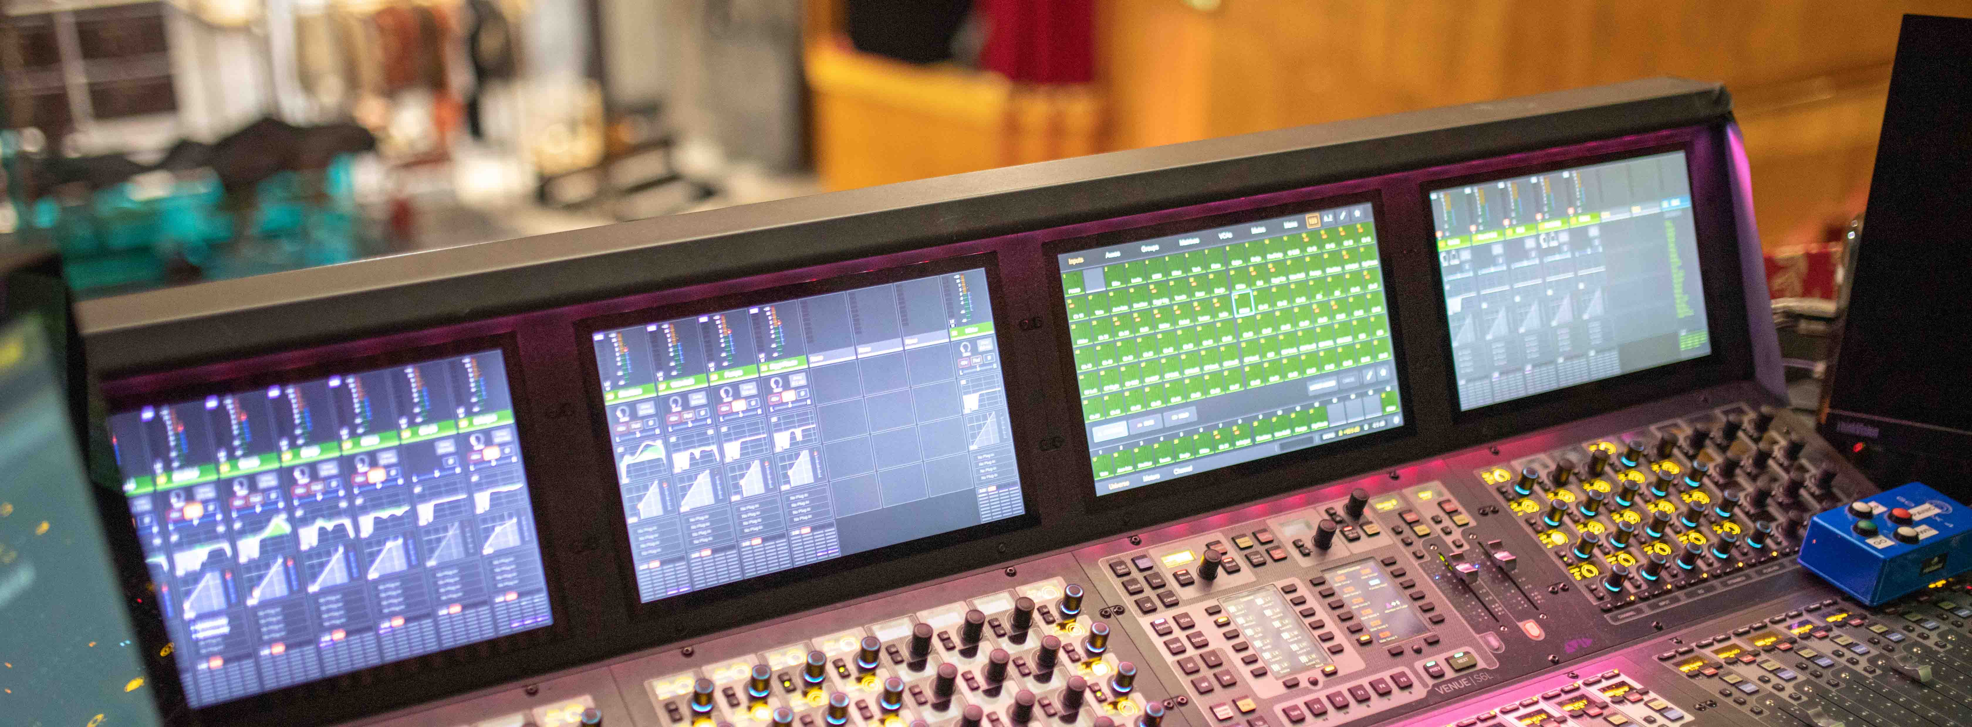

National Theatre of Iceland chooses digital wireless audio from Sennheiser

ÞJÓÐLEIKHÚSIÐ relies on Digital 6000 wireless microphones

Wedemark, 23 June 2020 – ÞJÓÐLEIKHÚSIÐ, the National Theatre of Iceland, has made the leap to digital with Sennheiser. Reykjavik’s premier arts venue regularly attracts large audiences who expect the very highest quality every time the curtain raises. When it was time to update the venue’s audio equipment, Sennheiser’s Digital 6000 wireless microphone system – including the ultra-compact SK 6212 mini-bodypack transmitter – was the ideal choice for Kristinn Gauti Einarsson, Head of Sound at the National Theatre of Iceland.

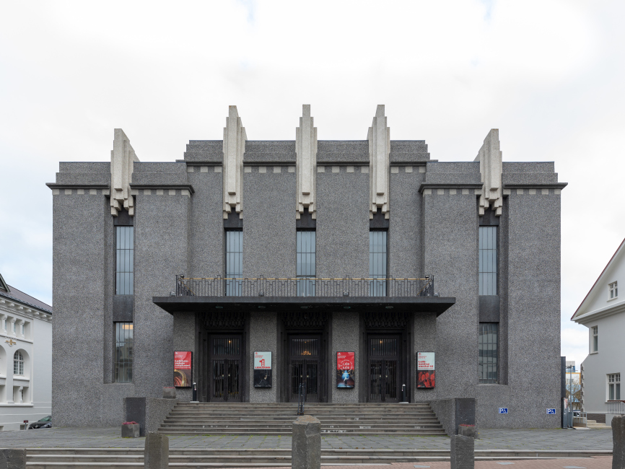 | The National Theatre of Iceland has made the switch to digital with Sennheiser’s Digital 6000 series

With three different shows every day and more than 10 premieres each year across its five stages, the National Theatre of Iceland delivers the fantastic sound design one would expect of a top-class venue – but the theatre is operated with a leaner team and budget than most national theatres.

How is this achieved? Einarsson shares the secret behind their success: he has worked with the same musical composer, set designer and director for six years. “It’s so amazing to start new, great shows with the same team. Our collaboration and coordination get better all the time,” says Einarsson. “We are successful because 90 percent of the job is communication – and good communication makes good shows.” This trust and relationship extend to the equipment as well: “Our theatre has used Sennheiser in the past and their products have been rock-solid.”

With a crew that works effortlessly together, it’s vital for equipment to be just as intuitive – and just as dependable. When making the switch to digital, the National Theatre chose to invest in a future with Sennheiser, acquiring a 32-channel Digital 6000 wireless microphone system with Sennheiser SK 6212 mini-bodypack transmitters.

Kristinn Gauti Einarsson, Head of Sound at the National Theatre of Iceland, next to the Sennheiser Digital 6000 racks. At the top: L 6000 charging units, which can be fitted with the respective inserts for all transmitters in the Digital 6000 series | 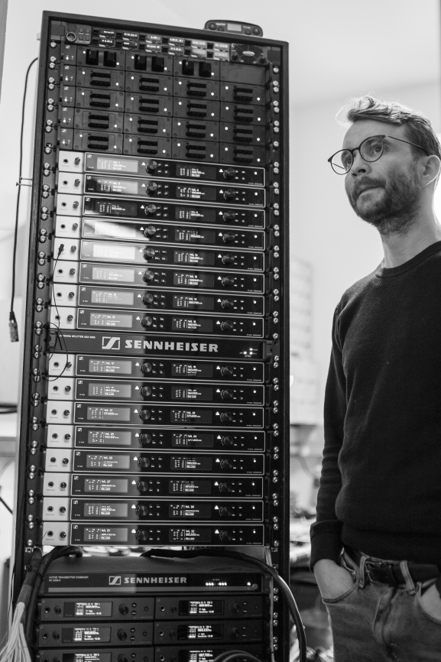

A winning performance
Einarsson praises the combination of performance and simplicity that the Sennheiser system delivers: “We sometimes have three different shows per day, so ease of use has been crucial for us. Precision is also important because it is not a one-time show at a festival.”

The Digital 6000 has rapidly demonstrated its value. Its intermodulation-free RF technology ensures a higher channel count – with reliable transmission even in very narrow frequency spaces. The system delivers audibly better sound quality and a wider dynamic range, thanks to the Sennheiser Digital Audio Codec (SeDAC).

“Good communication makes good shows” – the secret behind the success of the National Theatre of Iceland is the fact that the production team have worked together for so long | 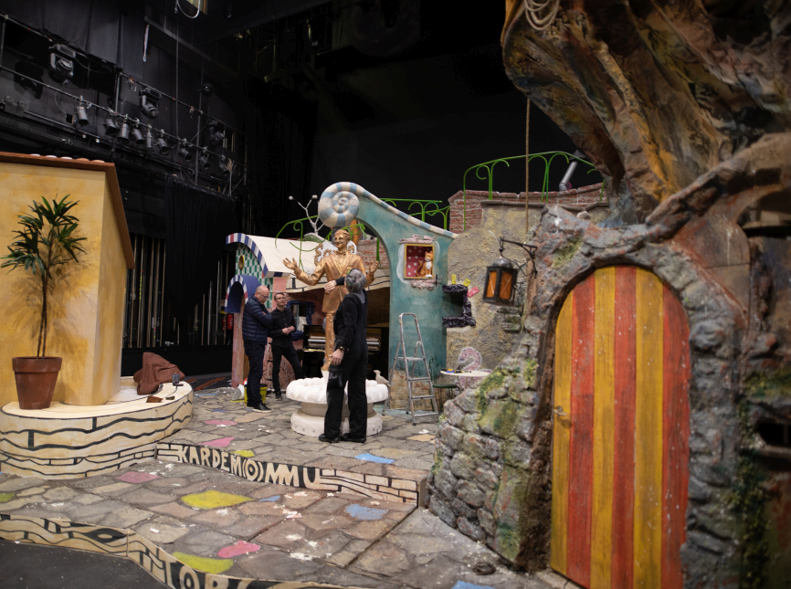

Just as dependable are the SK 6212 transmitters. Created by Sennheiser to be the new reference for dynamic stage performances and production situations that require discrete transmission technology, they have impressed the National Theatre of Iceland for their tough, all-metal build, compact dimensions and long operating time.

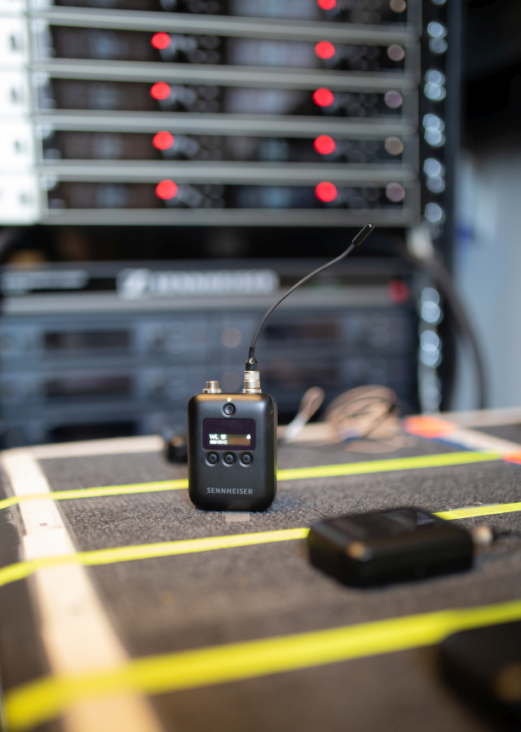 | The SK 6212 mini-bodypack transmitter impresses with compact dimensions and an operating time of 12 hours

“The small SK 6212 transmitters are a very convenient option for theatres,” comments Einarsson. “You can hide them easily and the actors sometimes forget that they are wearing them. We no longer have to worry about batteries because the SK 6212s last the whole day.” The transmitter batteries are recharged in the rack-mount L 6000 charger, which Einarsson finds “amazing”. In addition, the rechargeable battery technology helps the team to improve their environmental footprint.

With Digital 6000, the National Theatre of Iceland is seeking to build another long-lasting professional relationship. Kristinn Gauti Einarsson. “Our Sennheiser EM 1046 from the nineties still works perfectly even though it is nearly as old as me. Our experience of the Digital 6000 has confirmed that Sennheiser is just as reliable today!”

The images accompanying this press release plus additional photos can be downloaded at https://sennheiser-brandzone.com/c/181/BepaPFeu.

About Sennheiser
Founded in 1945, Sennheiser is celebrating its 75th anniversary this year. Shaping the future of audio and creating unique sound experiences for customers – this aim unites Sennheiser employees and partners worldwide. The independent family company, which is managed in the third generation by Dr. Andreas Sennheiser and Daniel Sennheiser, is today one of the world’s leading manufacturers of headphones, loudspeakers, microphones and wireless transmission systems. In 2018, the Sennheiser Group generated turnover totalling €710.7 million. www.sennheiser.com

Global Press Contact

Stephanie Schmidt
Stephanie.schmidt@sennheiser.com
+49 (5130) 600 – 1275

