Xytech Introduces New Mobile UI, REST APIs for MediaPulse at IBC 2018

The new UI will enhance the user experience of the company’s leading facility management software

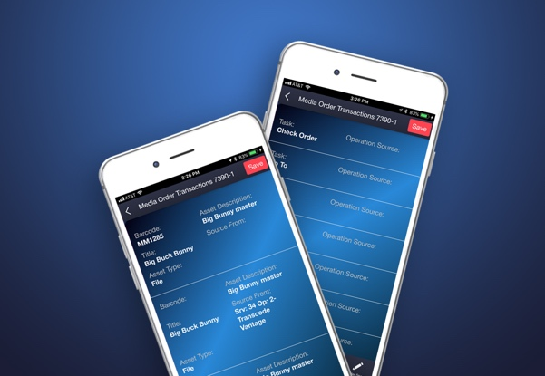
Amsterdam, 12 September 2018 — Xytech [IBC 2018, stand #6.C22], the leader in facility management software for the broadcast, studio, media services and video transmission industries, is introducing a new, completely configurable mobile interface for MediaPulse. This new UI increases flexibility and scalability by extending MediaPulse to all our customers’ team members. MediaPulse Mobile supports all devices with a responsive design.

The new UI for MediaPulse is ideal for the entire team. Operations staff, producers, facility managers, field crews and freelancers can now use MediaPulse in a screen designed and configured specifically for their needs. The new UI increases efficiency and consistency for the entire organization by delivering exactly what a user needs, when they need it. This streamlines workflows, speeds communication and reduces costly mistakes.

"Our new MediaPulse Mobile UI is designed to provide a personalized interface for all team members," explains Greg Dolan of Xytech. "The new UI allows our clients to implement their workflows throughout the entire staff base. This is the beginning of a crucial strategy for Xytech as we expand our technology from the hands of operational and financial users to all users in the enterprise. Having an easy adopted UI configured specifically for each end user is the vital next step.”

Xytech Launches New REST API
At IBC 2018, Xytech also announces the latest release of the MediaPulse Development Platform. The platform provides simple, fast and flexible integrations with all systems through API library now supporting REST calls. Triggered messaging, parameter-based alerts and automated report delivery are all included with the IBC 2018 release.

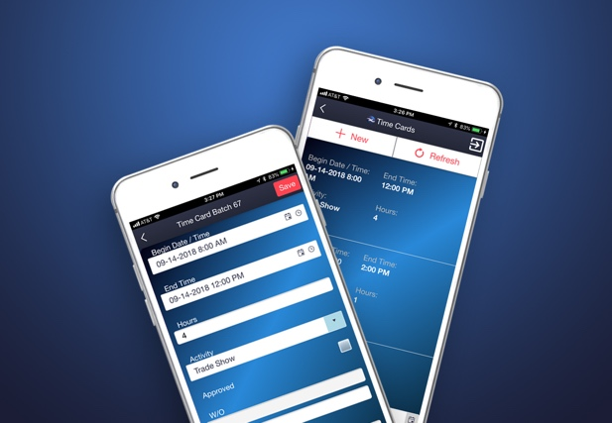
“MediaPulse is always moving forward,” says Dolan. “Our mission is to put the best technology in our users’ hands to meet not just today’s challenges, but tomorrows as well. The broadcast industry and technology are moving super quickly. These two initiatives further prove our commitment to constant innovation. This is the key to good partnership. IBC is a great place to separate the doers from the talkers and I can’t wait to show off our hard work.”

Xytech will be exhibiting at the upcoming IBC 2018 in Amsterdam, from September 14-18, 2018. Located in Hall 6 Booth C22, Xytech will demonstrate the 2018 release of its leading facilities management software MediaPulse, along with its latest subscription-based software Dash. Those interested in scheduling an appointment may contact Alexandra Kuipers at akuipers@xytechsystems.com, + 1 (818) 698-4958.

About Xytech Systems: For 30 years, the world’s premiere media companies have depended on Xytech to run their businesses. MediaPulse is the only end-to-end solution for the complete content lifecycle. MediaPulse provides scheduling, automation, asset management, billing and cost recovery for broadcasters, media services companies and transmission facilities in a scalable platform-independent solution.

For more information, visit xytechsystems.com

Media Contacts:

Katie Kailus
Public Relations
Hummingbird Media
+1 (630) 319-5226
katie@hummingbirdmedia.com

Jeff Touzeau
Public Relations
Hummingbird Media
+1 (914) 602 2913
jeff@hummingbirdmedia.com

