Percussionist Kuniko Kato Employs RME Fireface UFX Interface During ‘Drumming 2021’ Tokyo Performances
A full arsenal of RME gear helps Kato achieve the most accurate and high-quality sound possible

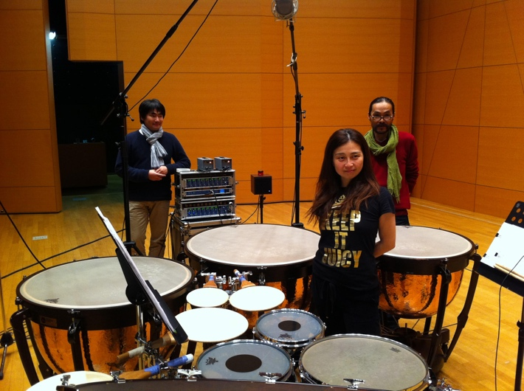
TOKYO, November 16, 2021 — Percussionist Kuniko Kato has been wowing audiences for years with her world-renown virtuosity on the marimba and other percussion instruments. After a 12-month hiatus from international touring due to the Covid-19 pandemic, Kato returned to the stage to premier her latest version of drumming by composer Steve Reich on Oct. 14th and 15th during her “Drumming 2021” concert series at the Art Center of Tokyo in Senju, Tokyo. Since it was a complex gig with huge video files fully synchronized to music, Kato brought a full suite of RME, including an RME Fireface UFX 24-bit/192kHz audio interface to ensure she had the lowest possible latency and the clearest audio quality for the performances.
“The most important aspect of a piece of gear for me is always the quality of the sound it offers,” Kato said. “Whether I’m playing live or recording in the studio, the Fireface UFX offers superior sound with true clarity.”
Kato added the UFX’s lack of troubleshooting is also a key feature when looking for an interface to perform live with.
“I carry it around everywhere and use it for everything during concerts, from simple live amplification to highly complex setups that require its 24-bit/192kHz audio playback,” Kato explained. “The UFX is always very solid.”
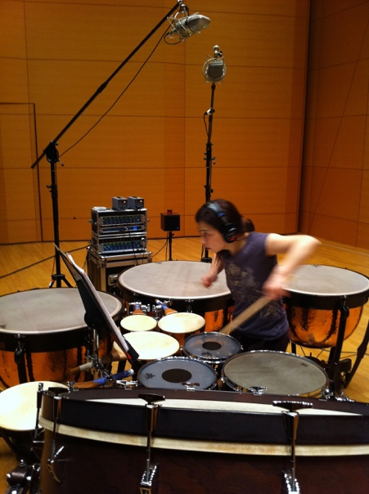
A Well-Rounded Arsenal
In addition to the Fireface UFX, Kato also relies on RME’s UCX USB interface, the Babyface Pro interface and the DMC 842, an 8-channel AES42 interface and digital microphone controller while recording in the studio.
“I’ve been using a digital microphone as my main mic since my 2015 album ‘IX – Iannis Xenakis,’” Kato explained. “Since we deliver 24-bit/192kHz audio to my label LINN, the DMC-842 is essential. It always gives me totally flawless and the most faithful representation of the sound possible.”
Due to the difficulty of recording percussive instruments, Kato’s workflow also includes an RME HDSP digital audio card.
“I use the HDSP consistently, because of the sound quality,” Kato said. “Recording percussion isn’t easy, and I am very serious about wanting the most precise sound. I want the listener to get the most accurate representation of what I’m playing and hearing, so I’ve been a longtime user of the HDSP audio card.”
Live Sound, As It Should Be
Since becoming an RME enthusiast, Kato said she also notices a difference in quality of sound when connecting to a venue’s sound system.
“In the past, I sometimes use the house sound system at the venue or concert hall, and I feel there’s a stark difference between the sound I hear and the sound I’m playing. I always thought that’s just how it was,” Kato explained. “But, after I started using RME, I realized what I was hearing was not accurate. Since then, I carry almost soley RME interfaces wherever I travel around the world.”
For more on RME, visit rme-usa.com

About Synthax, Incorporated
Synthax Inc. is the exclusive USA distributor for RME digital audio solutions, Digigram broadcast audio systems, Appsys digital audio tools, Ferrofish advanced audio applications, myMix personal monitoring systems and ALVA cableware. We supply a nationwide network of dealers with these products for professional audio, broadcast, music industry, commercial audio, theater, military and government applications. For additional information, visit the company online at http://www.synthax.com.

Media Contacts:
Katie Kailus
Public Relations
Hummingbird Media
+1 (630) 319-5226
katie@hummingbirdmedia.com

Jeff Touzeau
Public Relations
Hummingbird Media
+1 (914) 602 2913
jeff@hummingbirdmedia.com

