Under embargo until 00:00 PM (CET), May 2nd, 2023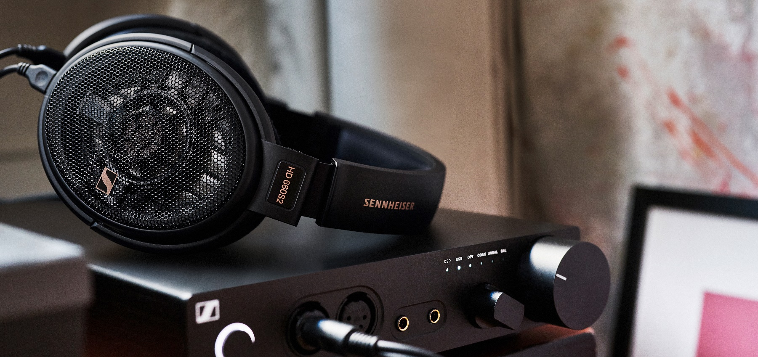
HIGH END 2023
The Sennheiser brand is showing its audiophile portfolio and Custom Comfort Tips at the HIGH END 2023

Wedemark, May 2, 2023 – The Sennheiser brand will be presenting its broad audiophile portfolio at the HIGH END 2023 at the MOC Munich from May 18 to 21, 2023. One focus is the new Custom Comfort Tips pilot project, in which customers from Germany can have individual ear tips made for the Sennheiser IE series. Exclusively at HIGH END, journalists and creators have the opportunity, after prior registration, to have their ear canals scanned and receive their individual custom comfort tips after the trade fair. The focus is also on the newcomers HD 660S2, IE 200 and the Conversation Clear Plus, and the portfolio is rounded off by the legendary HE 1. Interested media representatives are asked to book an appointment at the Sennheiser booth in advance via this link.

Custom Comfort Tips: a whole new experience for the perfect sound perception
The sound reproduction of a wired earphone is significantly influenced by the fit and position of the ear tips used. The pilot project by Sennheiser Consumer and GEERS for Custom Comfort Tips offers the optimal solution for a perfect fit and perfect sound. With individual ear tips, two unique versions are produced by molding the ear canals with a scanner or silicone mass. They sit perfectly in the corresponding ear, are exceptionally comfortable and can be attached to any of the audiophile Sennheiser IE 200, IE 300, IE 600 or IE 900 earphones.

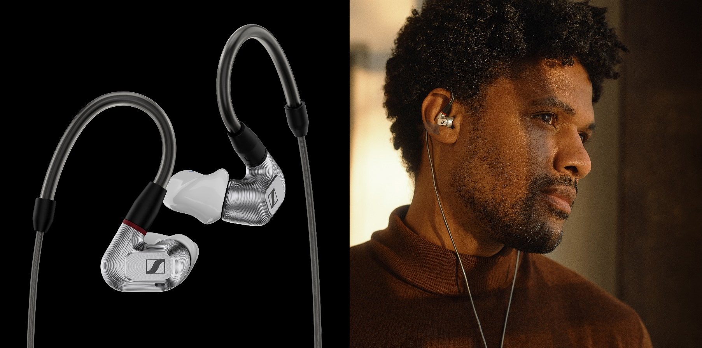

At HIGH END, journalists and creators have the exclusive opportunity to have their ear canals scanned directly at the Sennheiser booth on Thursday and Friday and to have the Custom Comfort Tips sent home to test after the trade fair. A scan is only possible with a previous appointment booking via this link.

HD 660S2, IE 200 and HE 1: Crystal clear sound and emotional audio experiences
With the revised HD 660S2, the Sennheiser brand is expanding the spectrum of the legendary HD 600 family, which has long been the benchmark for audiophile headphones of the highest quality. The headphones combine outstanding precision with a warm, relaxed sound image - and have been shaped with feedback from the hi-fi community. With its powerful sub-bass range, the HD 660S2 offers an emotional listening experience of the greatest intensity and, thanks to its improved acoustics, manages to fully unfold the dynamic effect of the music.

The Sennheiser IE series is also continuing its success story with the new IE 200: the powerful new addition to the audiophile headphone segment builds on the legacy of its sister models in many areas. It not only provides pure listening pleasure for die-hard audiophiles, but also for everyone who is curious about a sound world full of details. Because with its exceptional depth, crystal-clear sounds and a range of intuitive features, the IE 200 offers a comprehensive overall package that is otherwise only reserved for products in a higher price range.

The audiophile portfolio is rounded off by the legendary HE 1: like no other hearing system, the HE 1 impresses with the highest reproduction precision and creates an extraordinary spatiality when listening. With an ultra-wide frequency range from 8Hz to 100kHz and a distortion factor of just 0.01 percent at a sound pressure level of 100dB, the HE 1 combines technical finesse that is unique in this form.

Conversation Clear Plus: ideal for clear conversations in noisy environments
In noisy environments, such as at a busy restaurant or street, many people find it difficult to hear conversations clearly. The new Sennheiser Conversation Clear Plus features advanced speech intelligibility technology that ensures conversations are always the center of attention – no matter the environment.

Experience these and more Sennheiser products at HIGH END in Hall 1, Booth D02/E07. Please make an appointment in advance for the Custom Comfort Tips or for a conversation with our product experts.

www.sennheiser-hearing.com

About the Sennheiser brand
We live and breathe audio. We are driven by the passion to create audio solutions that make a difference. Building the future of audio and bringing remarkable sound experiences to our customers – this is what the Sennheiser brand has represented for more than 75 years. While professional audio solutions such as microphones, meeting solutions, streaming technologies and monitoring systems are part of the business of Sennheiser electronic GmbH & Co. KG, the business with consumer devices such as headphones, soundbars and speech-enhanced hearables is operated by Sonova Holding AG under the license of Sennheiser.
www.sennheiser.com
http://www.sennheiser-hearing.com/

Press contact
Sonova Consumer Hearing GmbH
Paul Hughes
Head of PR and Influencers
Sennheiser Headphones & Soundbars
T +49 (0) 162 2921 861
paul.hughes@sonova.com

