Next Generation Monitoring:
Neumann Releases the KH 120 II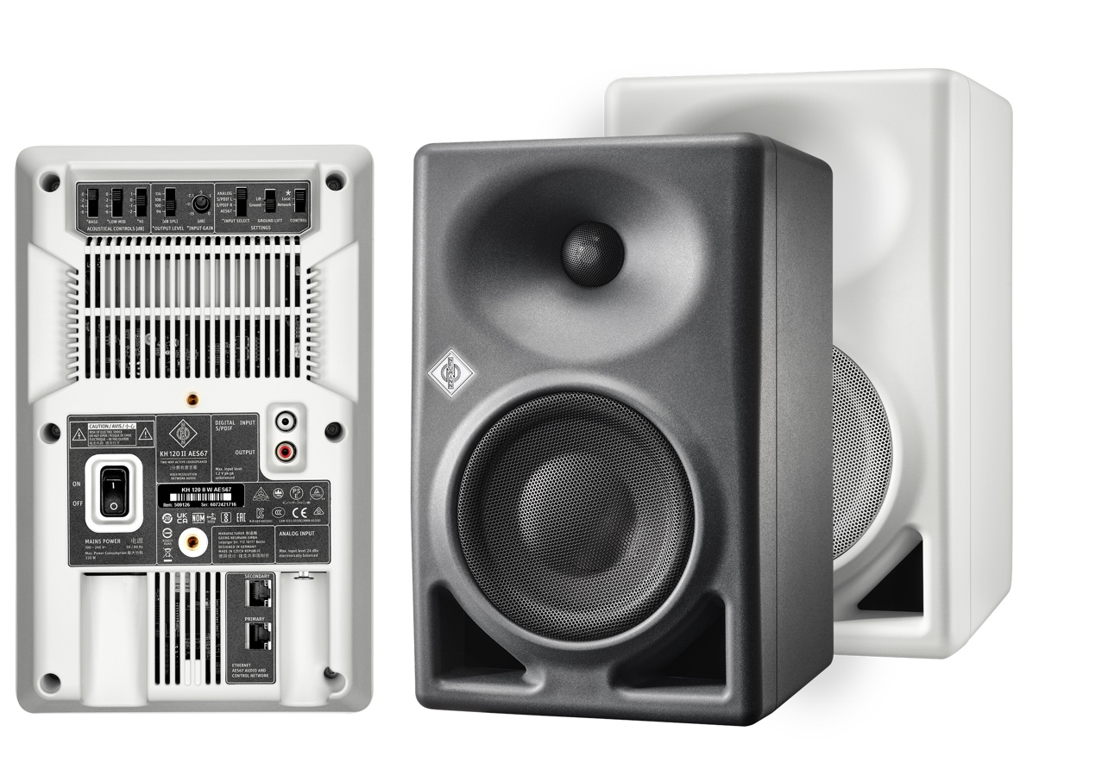
Berlin, Germany, 10 April 2023 – Neumann, one of the leading brands in pro audio, has announced the release of the KH 120 II studio monitor. Building upon the success of its predecessor, the KH 120 II offers improvements in all acoustic parameters for deeper bass, higher SPL capability, and increased resolution. In addition, its internal DSP engine allows for phase linear crossovers and room correction via Neumann’s MA 1 Automatic Alignment.

When Neumann released the KH 120 in 2010, it was the beginning of an ongoing success story. Neumann monitoring has since become the reference of choice in countless studios around the globe. The KH 120 II follows the same philosophy as its predecessor and takes it to the next level: highest linearity, lowest distortion, no coloration, and perfect adaptability to any acoustic environment.

“It is part of the Neumann ethos to never be satisfied with what has been achieved so far,” says Portfolio Manager Stephan Mauer, “The KH 120 garnered hundreds of 5-star reviews, yet we knew that we could make it even better. For the KH 120 II we’ve developed a novel woofer design that reduces distortion audibly and allows for much higher SPLs. In addition to an exceptionally flat frequency response from 44 Hz to 21 kHz (±3 dB), the KH 120 II also offers a linearized phase response. Which translates to clear mids with astonishing transparency as well as extreme accuracy in the time domain, i.e. precise impulse reproduction and finely resolved reverbs.”

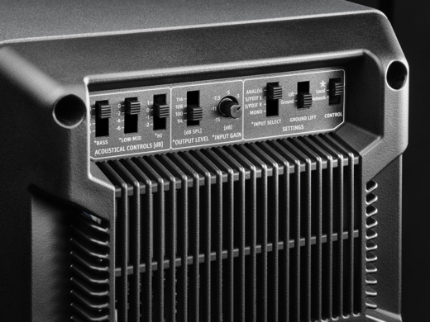
This is made possible by DSP-controlled electronics whose sophisticated crossovers avoid the phase distortion caused by analog filters. The internal DSP also realizes new standards in tonal consistency. The KH 120-II is made to extremely low tolerances of no more than ±0.5 dB. Stereo imaging, therefore, is razor-sharp. Digital electronics also allow for automatic room alignment using Neumann's MA 1 hardware/software solution (sold separately).

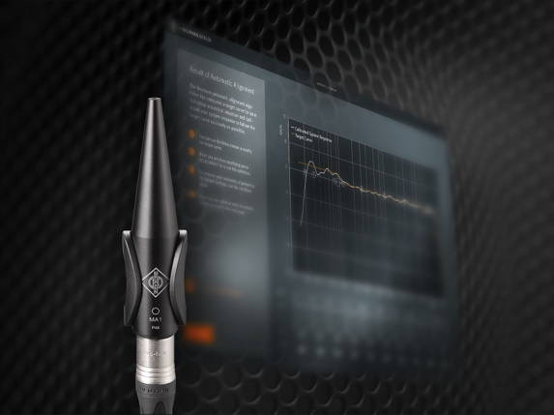
“Even the best studio monitor is dependent on its acoustic environment”, explains Neumann’s CEO Ralf Oehl. “So, being able to use the KH 120 II with Neumann’s Automatic Monitor Alignment MA 1 is an enormous advantage in terms of real-world performance. Finally, you can work with reliable reference-class monitoring even in less-than-ideal environments such as small studios or makeshift control rooms for mobile recording. But of course, the KH 120 II is also an excellent solution for professional studios, editing suites, and even immersive setups.”

The KH 120 II is also an update in sustainability. Neumann engineers took great care to develop a patent pending amplifier technology which combines superior audio performance with the energy efficiency of Class D. Although the amplifiers of the KH 120 II deliver up to 145 W to the 5.25” woofer and 100 W to the 1” tweeter, they only consume 17 W at idle. Auto-standby reduces power consumption to 0.3 W when the KH 120 II has not been used for a while, but can be deactivated.

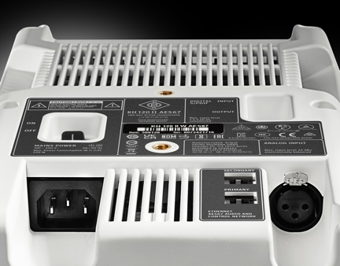
The KH 120 II offers analog and digital inputs (S/PDIF). It will also be available in an AES67 variant with redundant AES67 audio network ports that are fully compliant with broadcast standards such as ST 2110, ST 2022-7 redundancy, and RAVENNA. At the same time, the KH 120 II AES67 is compatible with DANTE®-generated AES67 network streams.

The KH 120 II and KH 120 II AES67 will be available from 17 April 2023.
List prices: KH 120 II € 899/$ 999; KH 120 II AES67 € 1195/$ 1250.
More information at https://www.neumann.com/en-en/products/monitors/kh-120-ii

Features:
Linear frequency and phase response
DSP engine for outstanding performance and automatic room alignment via MA 1
Deep low end down to 44 Hz and high SPL capability in a small format
Analog and S/PDIF connectivity, optionally with AES67

About Neumann
Georg Neumann GmbH, known as “Neumann.Berlin”, is one of the world’s leading manufacturers of studio-grade audio equipment and the creator of recording microphone legends such as the U 47, M 49, U 67 and U 87. Founded in 1928, the company has been recognized with numerous international awards for its technological innovations. Since 2010, Neumann.Berlin has expanded its expertise in electro-acoustic transducer design to also include the studio monitor market, mainly targeting TV and radio broadcasting, recording, and audio production. The first Neumann studio headphones were introduced in 2019, and since 2022, the company has put an increased focus on reference solutions for live audio. Georg Neumann GmbH has been part of the Sennheiser Group since 1991, and is represented worldwide by the Sennheiser network of subsidiaries and long-standing trading partners.

Press Contact Neumann:
Andreas Sablotny
andreas.sablotny@neumann.com
T +49 (030) 417724-19

