Photo by Bence Balla-Schottner at Unsplash

AMBEO 2-Channel Spatial Audio now for live production
Unlocking even more immersive experiences for all viewers

Wedemark, 14 April 2023 – Exciting news for all sports broadcasters: Sennheiser brings the power of AMBEO 2-Channel Spatial Audio to live broadcast applications. The technology that has transformed the streaming experience for viewers with stereo devices is now set to make its real-time debut. At the NAB show, Sennheiser Pro Labs will demonstrate a prototype of the AMBEO 2-Channel Spatial Audio live renderer – ready for immediate field testing with broadcast partners at booth No. C5217.

While content is increasingly being produced and enjoyed in immersive formats, many viewers still only have stereo listening systems at home. Leading streaming providers are already addressing this challenge, offering their members a cinematic listening experience using AMBEO 2-Channel Spatial Audio rendering. The technology unlocks investments into surround and immersive content for all viewers by translating immersive mixes into an enhanced 2-channel experience that works on any stereo device. Since its introduction last year, AMBEO 2-Channel Spatial Audio has enabled more people than ever to enjoy the benefits of immersive sound. However, this ground-breaking immersive processing was unavailable for live events – until today.

Crossing from the streaming industry into the broadcast world
Renato Pellegrini, Head of Pro Labs, Sennheiser: “Today’s large, televised sporting events are increasingly produced in immersive formats. However, both distribution pipelines and viewer access to immersive speaker systems have limited its reach into homes – leading to a duplication of efforts between stereo and immersive mixes. Now, using our renderer, broadcasters can instead focus on immersive formats and know they can reliably translate those mixes into a far better stereo experience than could be previously achieved.”

Pellegrini continues, “Live broadcasting presents special challenges, and productions must operate with tight precision and coordination. The sound mix must be ready within a few video frames, tools must fit within specific workflows, and gear must be dependable day-in, day-out. When we set out to build the live renderer, this environment was front of mind.”

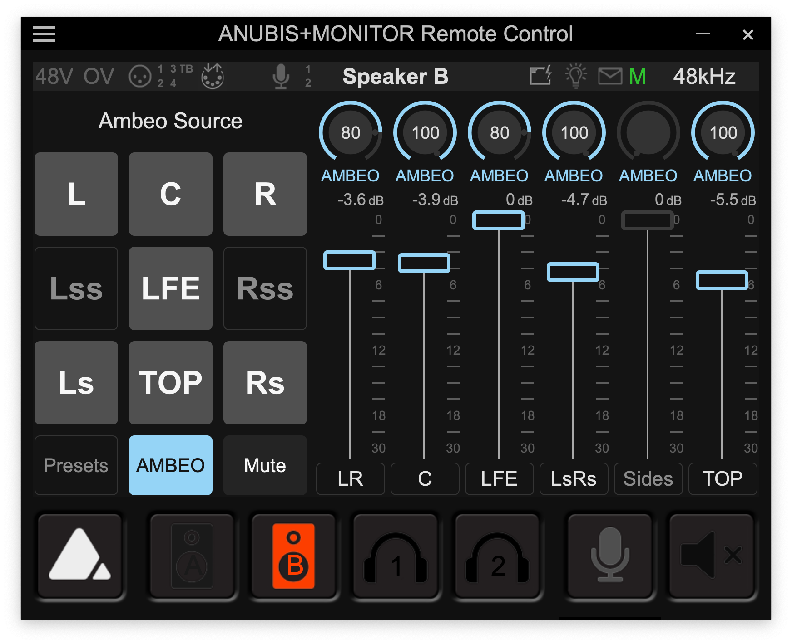 | The AMBEO 2-Channel Spatial Audio live renderer unlocks investments into surround and immersive content for all viewers. Pictured is the prototype of the renderer interface for finetuning the spatially enhanced two-channel mix, controlled via the standard Anubis remote control software

Ready for the field
The first implementation of the AMBEO 2-Channel Spatial Audio live renderer is running on Merging Technologies’ powerful AES67 devices, used in many broadcast environments. At the NAB show, Sennheiser will show a prototype plugin for the Anubis interface that extends the device’s already powerful Monitor Mission to include AMBEO 2-Channel Spatial Audio processing.

The live renderer transforms, in real time, standard multichannel surround and immersive formats into two channels of audio that can be delivered anywhere stereo is delivered today. Patented controls, adapted for use in a broadcast environment, allow for finetuning of spatialization settings to maintain mix integrity and dialog intelligibility.

Stop by at C5217 for a demonstration of the live renderer or contact prolabs@sennheiser.com to schedule a field test.

(Ends)

About the Sennheiser brand
We live and breathe audio. We are driven by the passion to create audio solutions that make a difference. Building the future of audio and bringing remarkable sound experiences to our customers – this is what the Sennheiser brand has represented for more than 75 years. While professional audio solutions such as microphones, meeting solutions, streaming technologies and monitoring systems are part of the business of Sennheiser electronic GmbH & Co. KG, the business with consumer devices such as headphones, soundbars and speech-enhanced hearables is operated by Sonova Holding AG under the license of Sennheiser.

www.sennheiser.com
www.sennheiser-hearing.com

Global Pro Audio Press Contact
Stephanie Schmidt
stephanie.schmidt@sennheiser.com
+49 (5130) 600 – 1275

