

Biuro prasowe better. gaming agency
bettergamingagency.prowly.com

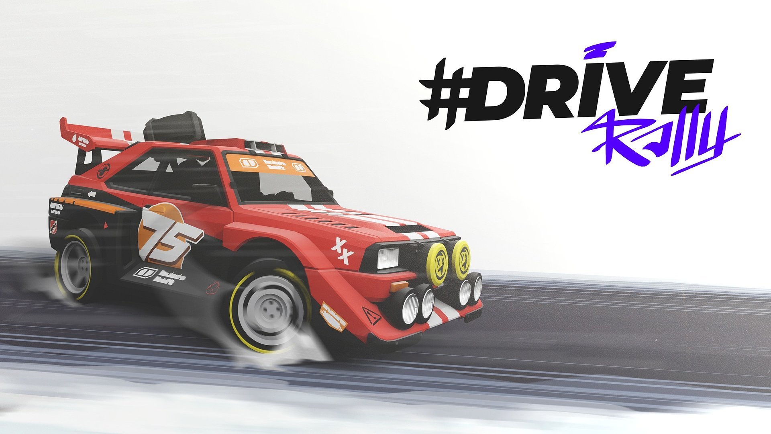

90s classic rally vibes in a modern style. #DRIVE Rally is revving up!

The global community of 20 million #DRIVE players will soon have the opportunity to challenge their driving skills behind the wheels of powerful vehicles. The golden era of rallies returns in #DRIVE Rally, and Pixel Perfect Dude studio has tuned up their new production with the spirit of the '90s. Veterans who recall those days, as well as younger generations, can expect a solid dose of high-octane adrenaline. #DRIVE Rally is gearing up for launch in 2024 on Steam, GOG and theEpic Games Store.

In #Drive Rally, players will recognise the stylish, minimalist world they fell in love with in #DRIVE. Everything, including cars, maps, and tracks, has been created from scratch, bringing new opportunities and challenges all the way. Thanks to the supportive community of players, #DRIVE Rally has become an even more complex project, enriched with features created based on the feedback of those who have always wished to hit the roads with personally customized machines from the '90s.

#DRIVE Rally – trailer

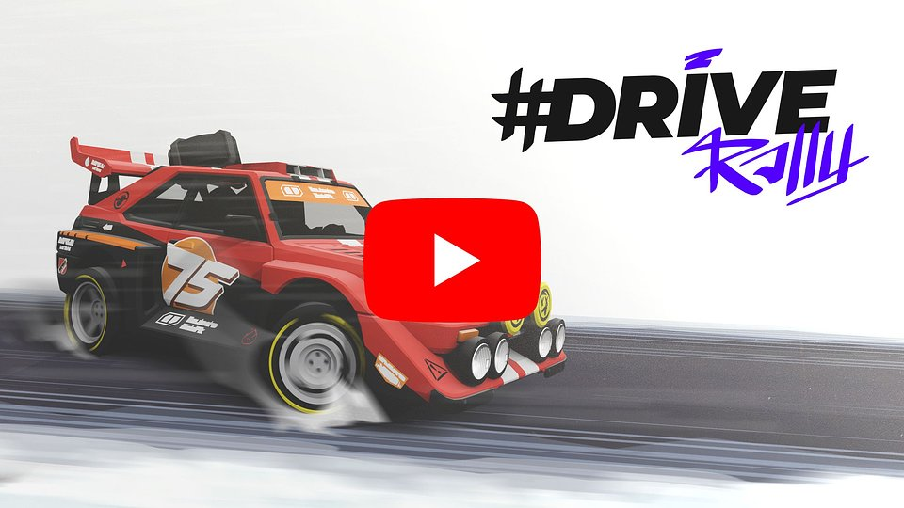
https://www.youtube.com/watch?v=Pracg9fAmzg

The gameplay model is intuitive for beginners and, at the same time, challenging for those who want to squeeze every millisecond out of each turn. When rivals are breathing down your neck, every moment is as precious as gold. Success will come with a co-driver who witnesses both great victories and tough losses. It's a partnership that thrives on performance and emotions! Celebrate together, but be ready to face criticism in failures.

While creating #DRIVE Rally, we had our fans in mind – those who have spent countless hours competing in #DRIVE. We hope that with this new game, they'll discover even more joy and, thanks to the sentimental journey back to the '90s, experience a delightful wave of nostalgia. Get ready for an adventure that's loaded with legendary machines, references to rally history, and a bunch of nostalgic details from the past. We would love to see players enjoying our game as much as we did while designing the turns, jumps, and challenges

- Dariusz Pietrala, Game Director at Pixel Perfect Dude.

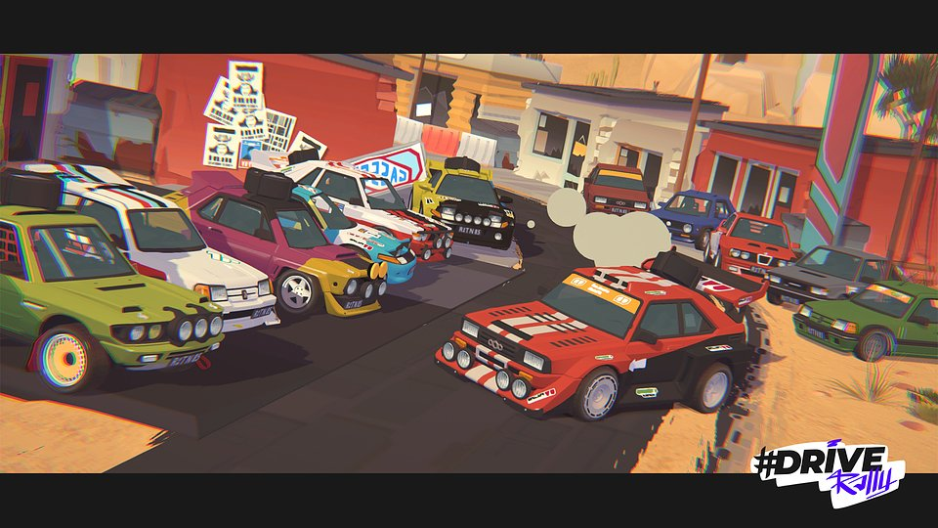

#DRIVE Rally – key features:

● Easy to learn, hard to master – a simple and intuitive driving model that even beginners will handle with ease. However, challenging trials await those who know well the sound of gravel under their tires. This system is designed to showcase the fun of racing games.

● Don't cut! – the co-driver can be the most loyal fan or the sternest judge. Enjoy victories together, but be prepared for criticism after losses.

● Nostalgic vehicles – take the wheel of legendary rally cars such as Das Holzwagen, The Doggo, The Bobond, and many more. #DRIVE Rally is now taking players on a nostalgic journey to the '90s, introducing new additions, including Das Sandsturm and Celestia, awaiting in the pits.

● Triumph with style – build your cars from the base to perfectly match your driving style, allowing you to compete on your own terms. Personalize the body, paint, and designs, while the boldest players can look forward to custom decorations.

● Postcards from rallies – from the sunny landscapes of Dry Crumbs, through the whispering woods of Holzberg, to the chilly wilderness of Revontuli. Compete in diverse settings unlike any you have experienced in racing games. Get creative and capture your most epic moments in #DRIVE Rally with the special photo mode.

● Join a community of rally fans – ready to dive deeper into this world? Join a dedicated Discord server, where every member can be your co-driver.

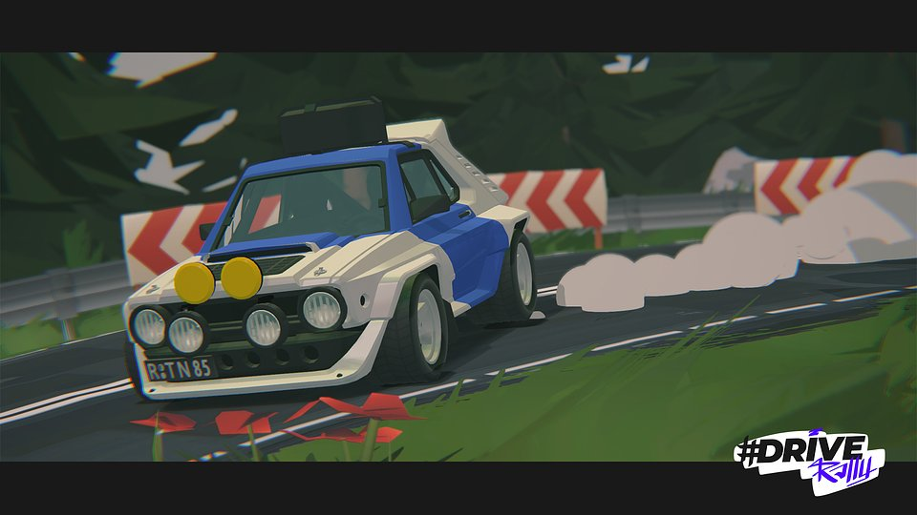

#DRIVE Rally's store page is already available on Steam, GOG, and theEpic Games Store. We encourage all rally fans to add the game to your wishlist and join the Discord server. Pixel Perfect Dude is also working on versions dedicated for PlayStation, Xbox, and Nintendo Switch, which will be released in the future.

The presskit is available here.

About Pixel Perfect Dude:​Pixel Perfect Dude is a small yet successful independent studio from Poland. The team has created and supported titles such as #DRIVE and Ski Jump. The studio's games boast 25 million players, numerous nominations, and awards, including the title of "Game of the Year." Pixel Perfect Dude always strives to deliver high-quality titles for all platforms. More details about the studio's activities can be found at pixelperfectdude.com



Jakub Smolak
PR Specialist at better. gaming agency
jakub.smolak@bettergaming.pro
Twitter

