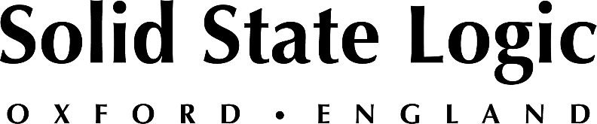

Solid State Logic Enhances Production Pack Bundled with SSL 2 And 2+ Audio Interfaces with Even More Industry Standard Software, and Extended SSL Complete Subscription

SSL Production Pack expands with software from Antares, Output and extended 3-month SSL Complete subscription for both new and existing SSL 2 and SSL 2+ customers

Oxford, England, November 23, 2022 — Once again, Solid State Logic expands its renowned SSL Production Pack offering, which is included with every SSL 2 / SSL 2+ audio interface. The SSL Production Pack delivers an extended range of creative possibilities and production tools for budding musicians, content creators and seasoned engineers.

Additions to the SSL Production Pack include 3-month trials of industry standard correctional and creative tool Antares Autotune ‘Unlimited’ as well as the inspiring and highly acclaimed, Output ‘Arcade’. Finally, also included is a 3-month SSL Complete subscription, providing full access to Solid State Logic's entire suite of class-leading plug-ins, including the new 4K B Channel Strip.

The new software additions make the SSL Production Pack even more compelling, adding to an impressive existing roster of offerings from Applied Acoustic Systems, Ableton, Celemony, Loop Cloud, IK Multimedia, Native Instruments. Also included in the bundle are perpetual license of SSL’s mix favourites Vocalstrip 2 and Drumstrip Plug-ins.

Both new and existing SSL 2/2+ customers can access the enhanced SSL Production Pack through their registered 2/2+ accounts. SSL user accounts portal can be accessed here: https://store.solidstatelogic.com/my-account

SSL 2/2+: Empowering your personal studio
Designed to be at the heart of a project or personal recording set up, the SSL 2 personal studio is perfect for individual singers, songwriters, or media producers, while the SSL 2+ collaborative studio provides expanded I/O for musicians working and recording together.

The 2-In/2-Out SSL 2 packs in two SSL designed analogue mic preamps together with pristine 24-bit/192kHz conversion to capture and hear every detail, a single high-grade headphone output, easy-to-use monitor mix control for critical low-latency monitoring tasks, and balanced monitor outputs with an impressive dynamic range. In addition, the ‘Legacy 4K’ mode – inspired by the studio legendary hit-making sound of the SL 4000 series consoles - gives you the ability to add extra analogue SSL console character and sparkle to your input sources.

Meantime, the SSL 2+ feature set builds in a production hub for those wanting to collaborate, with an additional headphone output with independent monitor mix, MIDI I/O, and additional unbalanced outputs for DJ Mixers.

Solid State Logic is the world’s leading manufacturer of analogue and digital audio consoles and provider of creative tools for music, broadcast, live and post production professionals. For more information about our award-winning products, please visit: www.solidstatelogic.com.

###
For further information contact:
Jeff Touzeau
+1 (914) 602-2913
jeff@hummingbirdmedia.com

Ross Gilbert
+44 (0) 1865 842300
rossg@solidstatelogic.com

