Ralf Oehl appointed CEO of Georg Neumann GmbH

Wedemark, February 3, 2020 – Ralf Oehl has been appointed as CEO of studio specialist Georg Neumann GmbH. In his new position, Ralf will continue to build the business and brand, further developing the overall strategic direction of Georg Neumann GmbH, a Sennheiser Group company. He will report to Peter Claussen, COO of the Sennheiser Group.

Ralf Oehl has been appointed as CEO of studio specialist Georg Neumann GmbH | 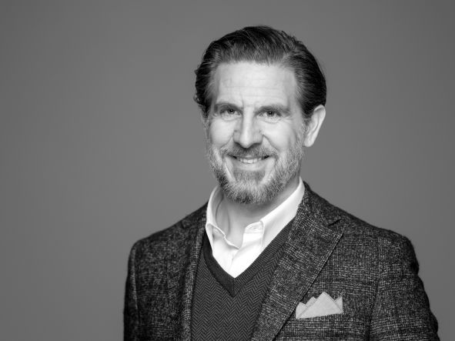

“It is a great honour to be joining Neumann.Berlin,” said Ralf Oehl. “Taking the helm of a company with such tremendous history, impact and reputation in the professional audio world is a once-in-a-lifetime opportunity. While carefully preserving its highly appreciated values and unmatched commitment to quality, we will be striving hard to further expand our portfolio and make our offering available to even more audio professionals all around the world. I am looking forward to working with the team at Neumann as we take this iconic company to new heights.”

“I am delighted to welcome Ralf Oehl to our company,” commented Peter Claussen. “Thanks to his achievements and breadth and depth of experience, Ralf is the ideal choice to take this exceptional brand forward, while cherishing the legacy of excellence that makes Neumann so unique. In particular, his expertise in capturing new markets will be key in taking Neumann into new areas of opportunity.”

Ralf Oehl joins Georg Neumann GmbH after founding his own company, Concinno, which focused on strategic and M&A advisory services to high-end manufactures. With his expertise in areas such as disruptive industrial technologies, innovative new business models and innovation-driving organizations, Ralf has also become a valuable contributor to multiple prestigious institutions including Fraunhofer Ventures and the World Economic Forum.

His previous work records include executive roles at high-tech engineering group M+W and a Managing Partner position at Droege Group, a leading German strategy consultancy.

A brand built on excellence
Building on a nine-decade history of excellence, Neumann.Berlin is today regarded as the standard-setting, world-leading manufacturer of studio microphones: its products are used by more than 80% of the professional recording studios globally. In 2010, Neumann expanded its expertise in electro-acoustic transducer design to also include studio monitors, and in 2019 the portfolio was extended into studio headphones with the successful launch of the acclaimed NDH 20.

About Sennheiser and Neumann
Shaping the future of audio and creating unique sound experiences for customers – this aim unites Sennheiser employees and partners worldwide. Founded in 1945, Sennheiser is one of the world’s leading manufacturers of headphones, loudspeakers, microphones and wireless transmission systems. Since 2013, Sennheiser has been managed by Daniel Sennheiser and Dr. Andreas Sennheiser, the third generation of the family to run the company. As part of the Sennheiser Group, Georg Neumann GmbH, known as “Neumann.Berlin”, is the world’s leading manufacturer of studio microphones. Founded in 1928, the company has been recognized with numerous international awards for its technological innovations. Since 2010, Neumann.Berlin has expanded its expertise in electro-acoustic transducer design to also include the studio monitor market, and has recently added studio monitoring headphones to its portfolio. In 2018, the Sennheiser Group generated turnover totaling €710.7 million.
www.sennheiser.com | www.neumann.com

Global Press Contacts

Andreas Sablotny Mareike Oer
andreas.sablotny@neumann.com mareike.oer@sennheiser.com
T +49 (30) 417 724 – 19 T +49 (5130) 600 - 1719

