For immediate distribution

Powersoft Appoints Dave Raneses as Western Regional Sales Manager
Raneses focuses on not only adding new verticals to Powersoft’s growing footprint, but also on helping integrators get the most out of their equipment
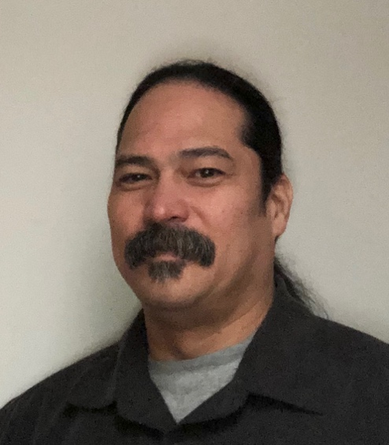
Seattle — January 30, 2019 – Powersoft, leading manufacturer of professional power amplifiers, has announced the appointment of Dave Raneses to the position of Western Regional Sales Manager. Raneses will help to continue to expand Powersoft’s footprint in the Western US by working with reps and consultants in Alaska, Montana, Idaho, Oregon, Washington, California, Nevada, Arizona, New Mexico, Wyoming, Colorado, Utah, Oklahoma and Louisiana. He will be based in Seattle.

As a veteran of the pro-audio industry, Raneses started his career at Symetrix where he worked in support semantics before transitioning to EAW where he worked for 10 years in a number of positions, including product development, product management and brand development. After his tenure at EAW, he served as a rep for 6 years where he excelled in selling Powersoft products.

“I am thrilled to join Powersoft,” Raneses said. “The company’s position as a leader in the market coupled with its dedication to advancing audio technology make it an exciting time to be joining the team. I’ve been on both sides of the table, so I have developed an acute ability to understand what the reps and consultants are looking for and find them the best solution available.”

“We are extremely excited to have Dave join the Powersoft team,” said Luca Giorgi, Powersoft’s Sales and Business Development Director and General Manager, North America. “His background in the industry coupled with his experience as both a rep and a manufacturer will be extremely valuable to us as we continue to grow the Powersoft brand.”

The Integrator’s Best Friend
As an avid user of Powersoft products himself since 2006, Raneses is excited to not only grow the company’s dealer base, but also to find new verticals within his territory as well.

“Powersoft is much more than a manufacturer of amplifiers,” Raneses said. “The core of what we do is create new and useful technologies for our customers. While we are currently successful in what we do — and will continue to be — we still believe there is room for growth. The ingenuity of our customers and how they apply our technologies insures that, however these new applications may not always fall into what has been defined as traditional verticals. It’s going to be fun.”

Helping integrators and end-users get the most out of their gear through Powersoft’s technology is another focus for Raneses in his new role.

“We at Powersoft are uniquely positioned to drastically increase how easy it is for integrators to implement our solutions and make those solutions a lot easier to execute,” he said. “Technology is great because it makes everything so much simpler — and there’s no brand on the market that features the same level of technology as Powersoft.”

###

For further information, contact:

Jeff Touzeau (media contact)  Hummingbird Media  Tel : +1 (914) 602 2913  Email: jeff@hummingbirdmedia.com | Francesco Fanicchi  Powersoft (Florence, Italy)  Tel: +39 339 6381206  Email: francesco.fanicchi@powersoft.it

Or visit www.powersoft-audio.com
About Powersoft:
Powersoft is the world leader in lightweight, high power, single rack space, energy efficient amplifiers for the professional audio market. Founded in Italy in 1995, headquartered in Florence, Italy, with offices in New Jersey, Powersoft couples the experience and precision of its production department with exceptional components to deliver products with perfect audio response and high-performance reliability. Its state-of-the-art amplifiers can be found in an array of markets, ranging from stadiums, sporting arenas, theme parks, performance venues and airports to convention centers, churches, and clubs, and are used by the world's leading tour sound companies. For more information, visit the Powersoft website at www.powersoft-audio.com.

