Sennheiser Education Solutions
For a better learning experience: premium audio solutions for bright minds

Wedemark/Amsterdam, 5 February 2019 – Sennheiser Education Solutions is the audio specialist’s portfolio for the education sector. For Sennheiser, this is not new territory: Numerous universities and colleges have already been equipped with Sennheiser products. But in the age of digital transformation, the education system is also subject to constant change, and students, colleges and universities must constantly adapt to this change. Focused on these users’ evolving needs, Sennheiser Education Solutions presents a portfolio that is perfectly customized for educational institutions – making the digital workflows of IT managers as simple and productive as possible.

Sennheiser Education Solutions presents a portfolio that is perfectly customized for educational institutions

Sennheiser’s solutions for education all share the same essential quality: They are user-friendly and can easily be operated by professors, students and IT staff alike. The products can be effortlessly integrated into existing infrastructures and work reliably, while providing users with maximum flexibility. This ensures an uncomplicated learning atmosphere in which ideas can be easily shared – even in large groups – providing students with optimal support in their personal development.

SpeechLine Digital Wireless - perfectly balanced sound in the lecture hall
The SpeechLine Digital Wireless microphone series offers reliable and highly flexible solutions that are specially customized for speech applications. Depending on the speaker's preference, different microphone types can be selected: If the professor wishes to move freely in the auditorium during the lecture, he or she can choose between a handheld transmitter or a bodypack transmitter with either a clip-on microphone or a headset microphone. In a podium discussion, for example, (wireless) table stands can be used in combination with gooseneck microphones for the panel participants, while handheld transmitters can be used for questions and reactions from the audience.

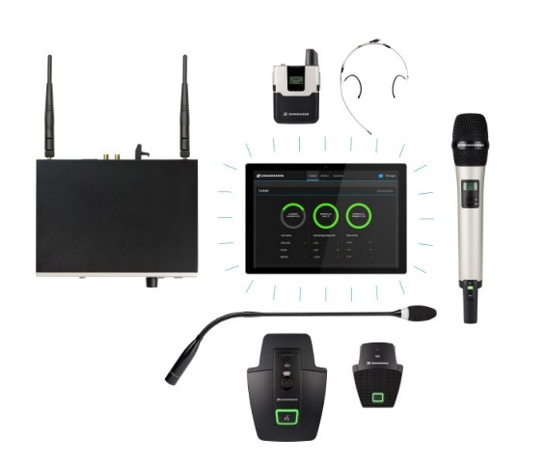 | A reliable wireless microphone system for students, professors and IT staff: SpeechLine Digital Wireless offers flexible solutions for work and lecture activities

With the SpeechLine Digital Wireless range, it does not matter if the microphones are installed in a single room or used campus-wide: The system can be extended at any time and fulfils all the requirements of everyday lecture activities. It uses the future-proof and license-free 1.9GHz frequency range via two different modes: The Automatic Mode ensures easy installation and a reliable, maximum range for up to 20 concurrent microphone links. In multi-room mode, a significantly larger number of links is possible by modifying the transmission power – a campus-wide installation with more than 2000 links overall is possible.

A handheld transmitter – or a bodypack transmitter with a clip-on or a headset microphone – allows the professor to move freely

Sennheiser Control Cockpit – All microphones at a glance
By using Sennheiser Control Cockpit software, IT managers at universities can make their digital workflows as simple and productive as possible. They have control over all campus-wide set-ups as well as an overview of all devices on the network, including their location and status.

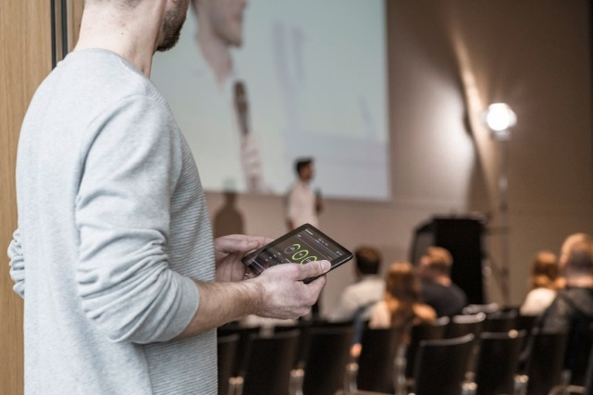 | The Sennheiser Control Cockpit software allows remote control and maintenance of all integrated devices

Settings or firmware updates for microphones can be made remotely – as can troubleshooting, with error messages helping to identify problems and often allow for these to be rectified remotely too. Saving IT staff considerable time in maintenance, educational institutions can use the software to improve their digital processes and minimize future investments. The Sennheiser Control Cockpit software is entirely compatible with the SpeechLine Digital Wireless microphone series, as well as evolution wireless G3, evolution wireless G4 and Digital 6000 radio microphone systems.

Sennheiser MobileConnect – Lectures and seminars without barriers
MobileConnect is Sennheiser’s wi-fi-based solution for hearing without barriers. The system is optimized for use in educational institutions, providing all students’ needs using the latest and user-friendly audio technology. Operation is incredibly simple: The MobileConnect app for either iOS or Android is downloaded onto the mobile device. The “Personal Hearing Assistant” then allows the user to adapt the sound to their individual hearing needs via an intuitive touchscreen interface.

Stream audio content live via wi-fi: Sennheiser Mobile Connect provides hearing support directly via your smartphone | 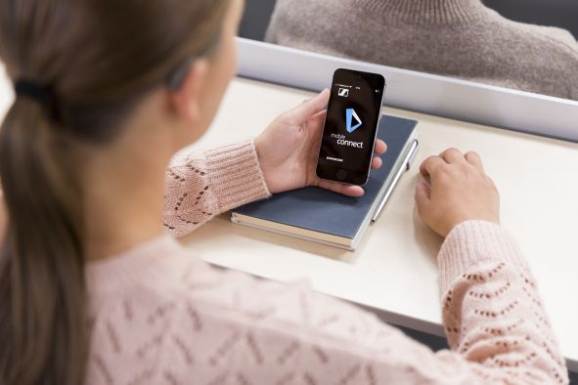

The lectures are broadcast in real time and high quality to mobile devices and smartphones via wi-fi. Thanks to the solution’s “Bring Your Own Device” approach, students don’t require any additional hardware and simply can use their own smartphone. The latency is extremely low due to real-time audio streaming, while Unicast technology allows the transmission of audio content to all smartphones worldwide. This ensures that students with hearing impairments can participate in normal lectures without facing any barriers.

To learn more, please visit www.sennheiser.com/education or visit Sennheiser at ISE, Hall 2, Stand B-50.

About Sennheiser
Shaping the future of audio and creating unique sound experiences for customers – this aim unites Sennheiser employees and partners worldwide. Founded in 1945, Sennheiser is one of the world’s leading manufacturers of headphones, microphones and wireless transmission systems. With 21 sales subsidiaries and long-established trading partners, the company is active in more than 50 countries and operates its own production facilities in Germany, Ireland, Romania and the USA. Since 2013, Sennheiser has been managed by Daniel Sennheiser and Dr. Andreas Sennheiser, the third generation of the family to run the company. In 2017, the Sennheiser Group generated turnover totaling €667.7 million. www.sennheiser.com

Local press contact Global press contact

Victoria Chernih Stephanie Schmidt
victoria.chernih@sennheiser.com stephanie.schmidt@sennheiser.com
+44 7881 091687 +49 0(5130) 600 – 1275

