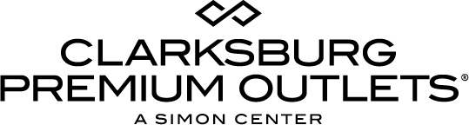

For more information:
Becca Meyer
BRAVE Public Relations
404-233-3993
bmeyer@bravepublicrelations.com

**MEDIA ADVISORY**

Clarksburg Premium Outlets to celebrate Lunar New Year, March 4

Welcome the Year of the Dog with family friendly cultural activities including a dragon dance, crafts, martial arts, musical performances and more!

CLARKSBURG, Md. (February 8, 2018) – Clarksburg Premium Outlets invites families of all cultures to revel in the magic of the Lunar New Year with a variety of authentic celebratory activities! On Sunday, March 4 from 1-4 p.m., shoppers can experience an afternoon of multi-cultural activities and entertainment on both Low Street and High Street as well the new VIP Lounge located on High Street by kate spade new york.

Clarksburg Premium Outlets will welcome the Chinese Alumni Associations of Greater Washington and over a dozen other multi-cultural organizations, for a variety of authentic Lunar New Year activities. Shoppers will experience traditional dragon and lion dances; martial arts; multicultural music and dancing; and customary culinary samples from Asian Chao Restaurant, Kung Fu Tea and chocolate sampling from Lindt Chocolate. Little ones can also create origami and other Lunar New Year-themed crafts. Finally, guests will be able to participate in a red envelope giveaway to win retailer gift cards, items and more, while supplies last. As an added bonus, red envelope giveaway participants will receive a free Savings Passports (pending availability) with additional discounts at over 40 brands.

Clarksburg Premium Outlets features sought-after outlet brands, including Armani, Old Navy Factory Store and Under Armour, at every day savings up to 65 percent off. Special Lunar New Year discounts will also be available at specific retailers.

WHAT: Clarksburg Premium Outlets’ Lunar New Year Celebration
Dragon and Lion dances, live entertainment, food sampling, giveaways and more!

WHEN: Sunday, March 4
1-4 p.m.

WHERE: Clarksburg Premium Outlets
(Center Court areas on Low Street and High Street as well as the new VIP Lounge located on High Street near kate spade new york)
22705 Clarksburg Rd
Clarksburg, Md. 20871

HOW: The event is FREE and open to the public

For more information on this event, please visit premiumoutlets.com/clarksburg, or connect with Clarksburg Premium Outlets on Facebook, Twitter and Instagram.
###

