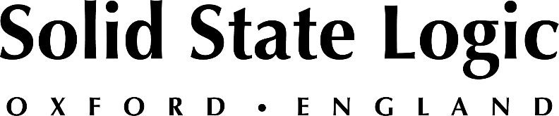

2022 NAMM Show: Solid State Logic to Showcase ORIGIN, SSL Live L550 Plus and Range of Hybrid Production Tools including THE BUS+ and BiG SiX

SSL looks forward to returning to NAMM, presenting its latest solutions
across studio, post-production, content creation, live sound and more.

Anaheim, CA, May 19, 2022 — Solid State Logic [Booth 18205] looks forward to presenting its latest solutions for music and audio professionals at the 2022 NAMM Show, scheduled to take place at the Anaheim Convention Center between June 3 and 5. SSL will be presenting product demos on several recent products, including its ORIGIN, a 32-channel, fully analogue in-line console, SSL Live L550 Plus console with new V5.1 software, and UC1, UF8, BiG SiX and THE BUS+ making their NAMM debuts.

"We look forward to connecting with our colleagues, partners and customers at the 2022 NAMM Show," commented Nigel Beaumont, Managing Director, Solid State Logic. "Throughout the history of SSL, music has always been a primary driver of our product design, and we have always appreciated the passion and interest that resonates among attendees and exhibitors at NAMM."

In addition to showcasing its ORIGIN analogue console for studio applications and the recently launched THE BUS+ rackmount compressor, the company will also demonstrate its SSL Live L550 plus console, running the latest V5.1 software. The SSL Live 550 Plus is a best-in-class solutions for live sound applications, featuring advanced AoIP capabilities, integrated control solutions for L-ISA and SpaceMapGO as well as new processing favourites Blitzer, Sorcerer and much more. Guest presentations will be happening over the course of NAMM, check Solid State Logic’s social channels for more information.

SSL also looks forward to highlighting its growing range of hybrid production tools, including the UF8 and UC1 control surfaces, BiG SiX SuperAnalogueTM mixer, as well as its SSL 2 and SSL 2+ USB audio interfaces — which now include an enhanced SSL Production Pack featuring a selection of must-have virtual instruments, plug-ins, samples and DAW from some of the industry’s key brands.

SSL is pleased to be attending the NAMM Show in Anaheim again and looks forward to meeting with attendees. To book an appointment or request a free guest pass, please visit https://www.solidstatelogic.com/events/namm-show-2022.

Solid State Logic is the world’s leading manufacturer of analogue and digital audio consoles and provider of creative tools for music, broadcast, live and post production professionals. For more information about our award-winning products, please visit: www.solidstatelogic.com.

###
For further information contact:
Jeff Touzeau
+1 (914) 602-2913
jeff@hummingbirdmedia.com

Ross Gilbert
+44 (0) 1865 842300
rossg@solidstatelogic.com

