For Immediate Release

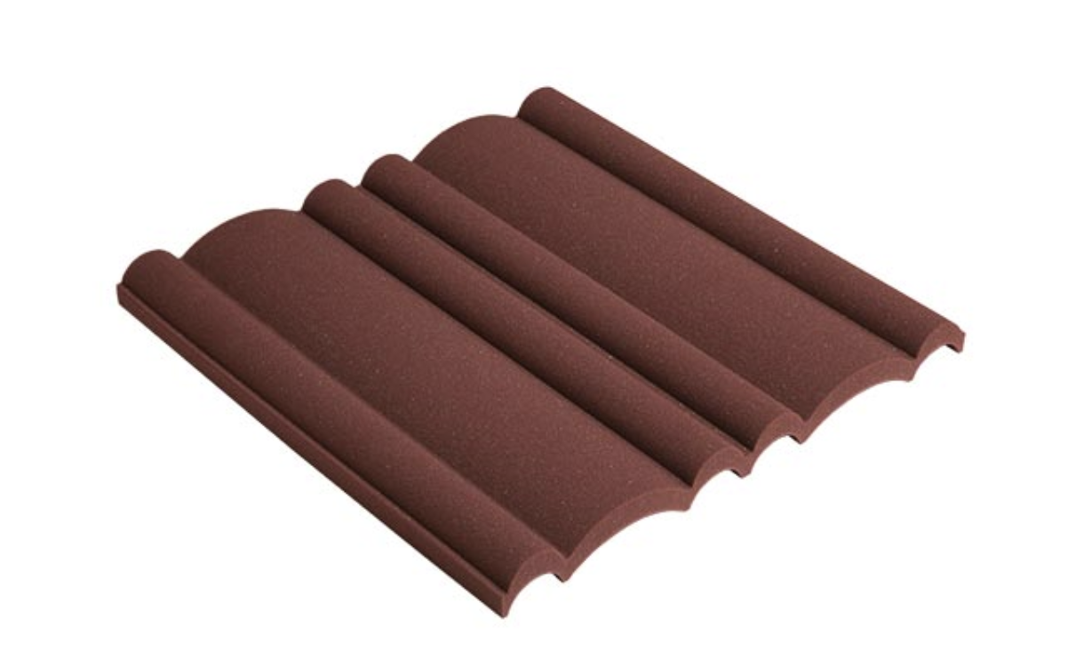
At Long Last: EZ Acoustics Brings Innovative and Affordable Acoustic Treatment Solutions to U.S. Market, Starting with ProFoam
Signature Series ProFoam, designed by legendary acoustics product developer Peter D’Antonio, offers more absorption for less money
Miami, Florida, October 8, 2019 — After a decade of providing more than 40 countries with high quality and affordable acoustic panels, diffusors, foam and furniture, EZ Acoustics is foraying into the United States’ acoustic treatment market as a meeting of three powerful audio engineering and entrepreneurial minds. European acoustic engineer and EZ Acoustics’ founder Marc Viadiu has teamed up with recording engineer PK Pandey, who founded both Guitar Center Pro and A/V systems design/build company AVN SYS, for the company’s greater expansion into the U.S., the world’s largest acoustic treatment market. And leading the charge are two innovative and affordable acoustic foam products co-created and designed by Dr. Peter D’Antonio, the legendary acoustic researcher who established RPG Diffusor Systems in 1983 (now RPG Acoustical Systems).

D’Antonio designed the two products in the EZ Acoustics Signature Series: the ProFoam wall panels and matching ProCorner foam units, which score a Noise Reduction Coefficient (NRC) of 1, promising total absorption across the audio spectrum. Both the ProFoam and ProCorner reflect EZ Acoustics’ driving philosophy of doing more with less—both less material and less cost for the customer. They’re designed with a Variable Depth Air Cavity (VDAC), which spaces most of the foam away from the mounting surface. That results in better acoustic performance at a more economical price. The ProFoam panels are also uniquely stackable. They’re sold in different thicknesses, and the customer can achieve a higher absorption range by simply stacking additional panels onto each other.
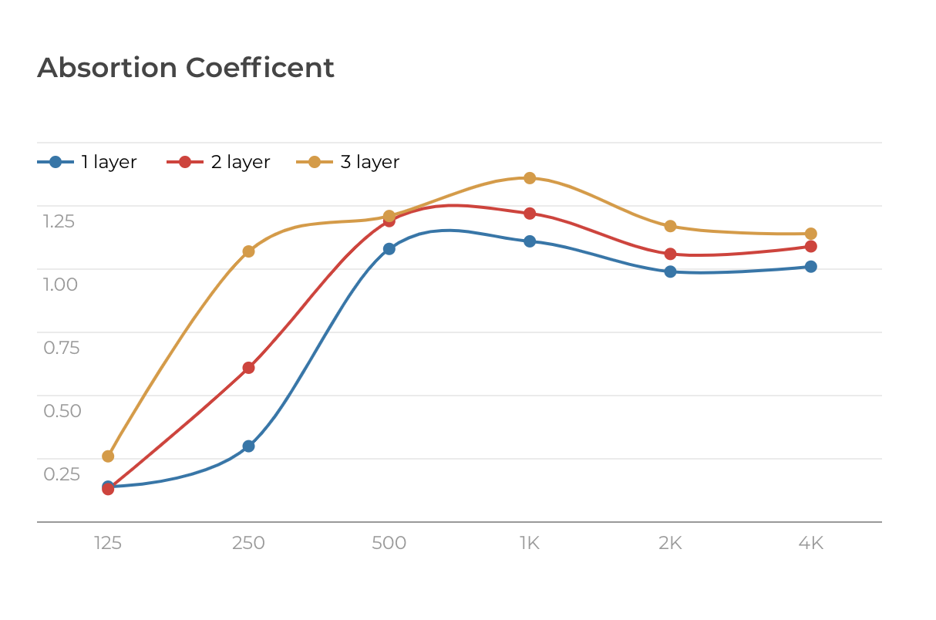
“We are proud to celebrate our 10-year anniversary in 2020 by serving the U.S. commercial and project studio owners,” commented Marc Viadiu. “Acoustic performance and room treatment make all the difference in achieving optimal recordings, mixes and masters. Our products — including the ProFoam and ProCorner — put stellar acoustic performance within reach for thousands of studio owners, who no longer have to compromise.”

The Signature Series brings high-end performance to home studios and project studios at an accessible price. It’s a full-circle return for EZ Acoustics, which began in Barcelona, Spain by producing budget-minded acoustic materials in Europe. When large installation designers such as Moneo Brock in Madrid and Walters-Storyk Design Group (WSDG) approached Viadiu for pro-audio solutions, EZ Acoustics began making high-end and custom acoustic treatment products, as well. About two years ago, with Pandey at the helm of U.S. operations, EZ Acoustics broke into the United States with a number of large projects.

“We can address a wide range of markets simultaneously,” Viadiu says. “With the ProFoam and ProCorner, we’re bringing the same kind of innovation to the home studio that we brought to big-budget, high-end installations.”

Now ready for country-wide retail availability in the U.S., EZ Acoustics continues with the strategy of maintaining a streamlined product line that emphasizes the quality of performance and visual style over the quantity of options. That allows them to keep prices low by producing a larger volume of a smaller number of high-performance products. EZ Acoustics’ creations will ship soon from its warehouse in Miami, Florida.

“The idea is to have the same success here in the U.S. as we have had in Europe and Asia,” Viadiu says, “so that everyone can have great sound in their studios as an affordable rate—that means more acoustics for less money”

The EZ Acoustics Signature Series ProFoam and ProCorner are available now. The ProFoam wall panels come in a box of ten panels for $269 USD, and the ProCorners come in a box of four units for $229 USD.

Some of EZ Acoustics’ flagship projects from around the world include:
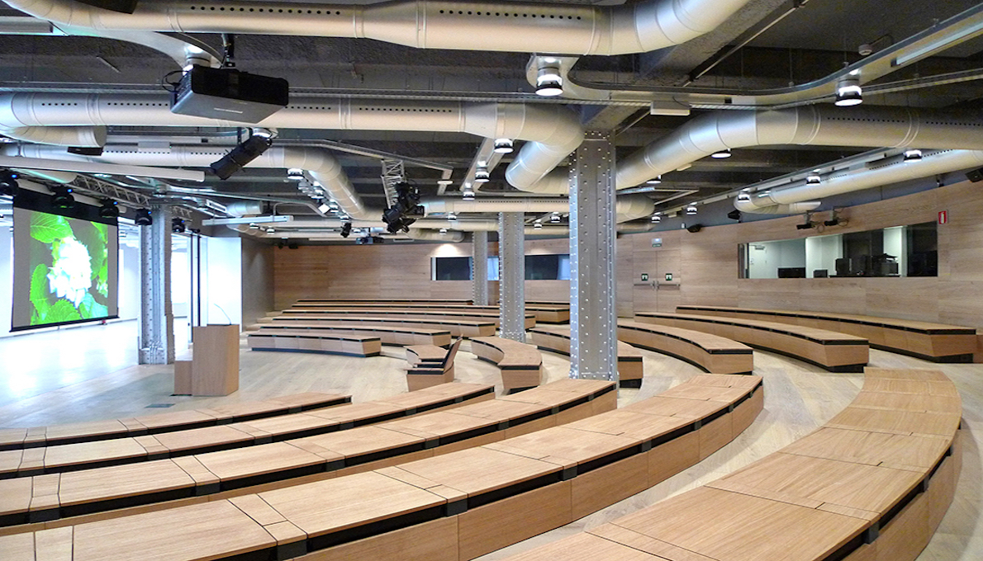
- Telefonica Foundation — Madrid, Spain.
HP — Barcelona, Spain.
- UKGR — The Hague, The Netherlands.
- SAE — Barcelona, Spain.
- Qatar Television — Doha, Qatar.
- Katara Studios — Doha, Qatar.
Radio Masira — Haifa, Israel.
- Universidad Icesi — Cali, Colombia
- Oxido Studios — Mexico City, Mexico.
- TEC Monterrey — Mexico City, Mexico.
- Drexel University — Philadelphia, Pennsylvania.
- Berklee College of Music — Boston, Massachusetts.

Please visit ezacoustics.com for more information.
About EZ Acoustics
“More acoustics for less money” is the essential EZ Acoustics philosophy that traces back to its 2010 founding by Marc Viadiu. Almost a decade later, EZ Acoustics remains true to that founding principle while adapting to meet it customers’ changing needs. EZ Acoustics starts by valuing clients and seeing prospects as people, rather than things. The company passionately commits to teamwork, collaboration, building personal bonds and trust, integrity and delivering superior, precision products. From its offices in Miami, Florida and Barcelona, Spain, EZ Acoustics encompasses manufacturing, distribution and brand management with the mission of providing high-performing products, premium quality and customizability, all at affordable prices. With operations in more than 40 countries, EZ Acoustics proudly serves the acoustic market as one of the world’s largest suppliers.

US and Canada
Jeff Touzeau
Hummingbird Media, Inc.
jeff@hummingbirdmedia.com
+1 (914) 602-2913
Markkus Rovito
Hummingbird Media, Inc.
markkus@hummingbirdmedia.com
+1 (575) 208-4782

