For immediate distribution

An Engineer’s Shrewd Ear: SonoTone Sets the New Standard for Premium Guitar Strings

Having spent years developing the ideal guitar strings for himself, founder P.K. Pandey makes his boutique line of premium strings available to all

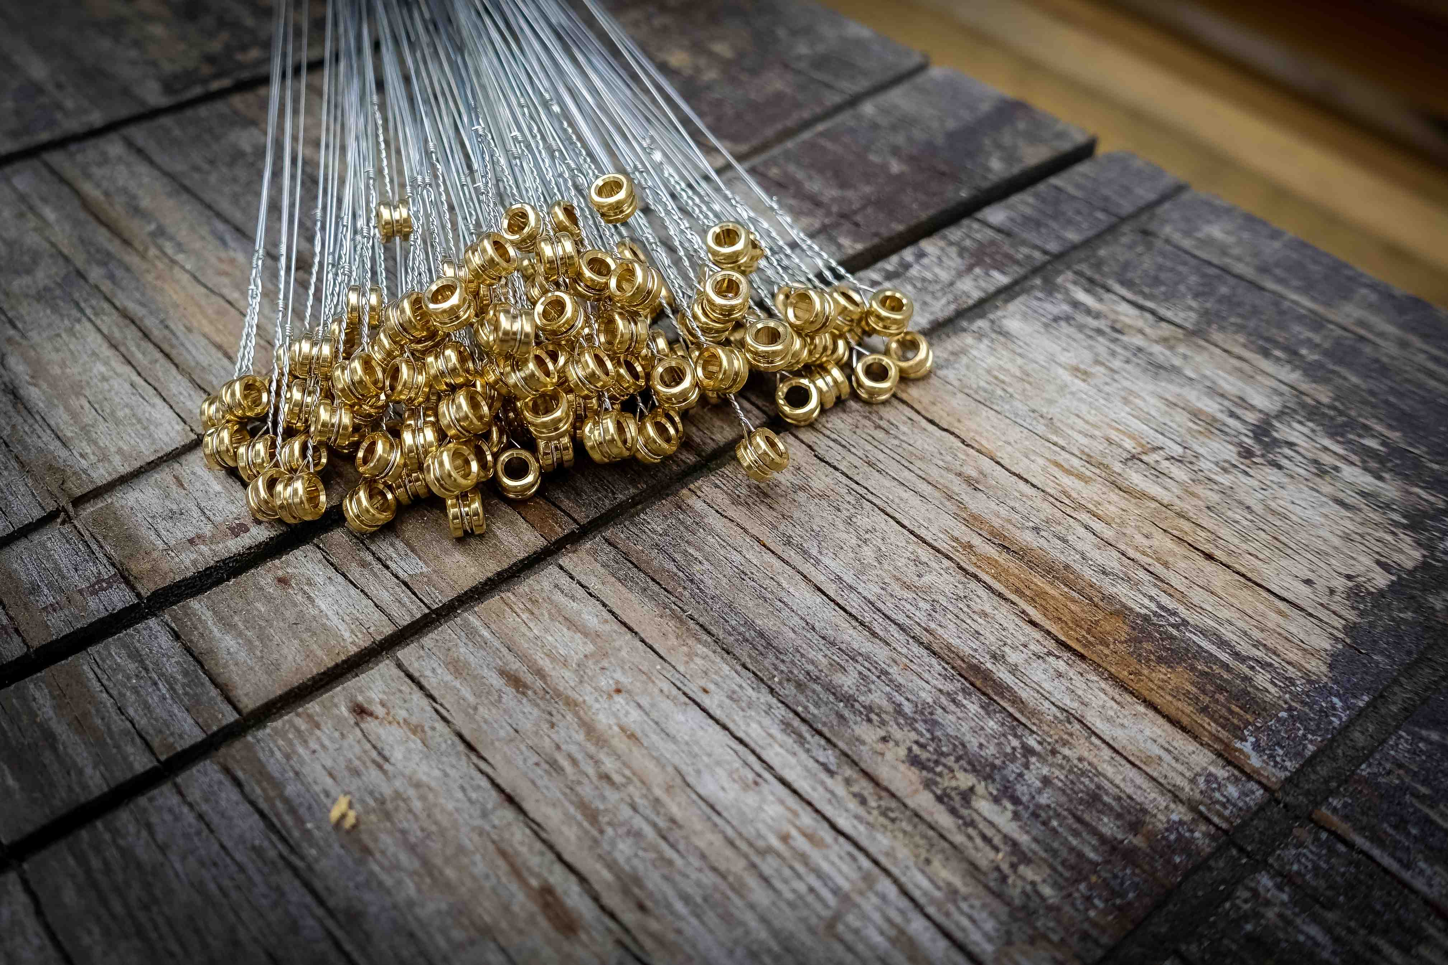
Allston, Massachusetts, August xx, 2019 — SonoTone founder P.K. Pandey built a professional career with his discerning ear, achieving pristine, balanced tone across the full spectrum of sound as a professional recording studio engineer and A/V systems design/build engineer by trade. So, in addition to founding AVN SYS, he has continued his decades-long pursuit of attaining the highest quality sound possible in any recording situation by going straight to the source of his instrument's sound: the guitar strings.
An engineer's shrewd ear
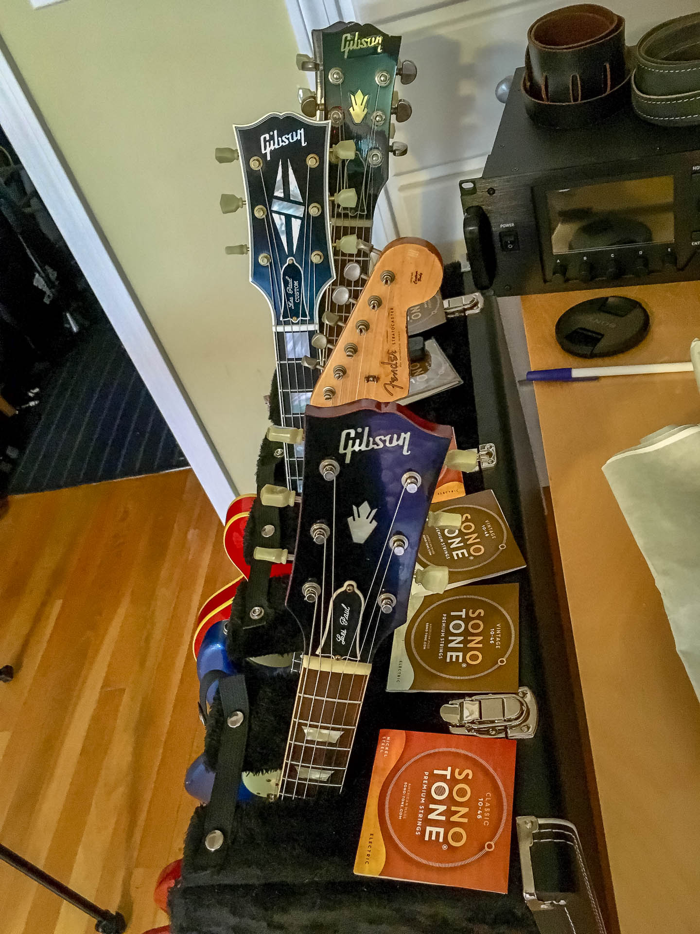
Starting in 2014, Pandey invested his own time, funds and professional expertise to begin researching manufacturing techniques for developing guitar strings that would perform better and last longer than any other strings that were then currently available on the market — a market in which only a few major players produced virtually all the guitar strings in the U.S.

He spent years experimenting with different combinations of cores, wrap wires and amalgams, and trying out different techniques for optimizing the behavior and longevity of the strings, seeking to recreate the raw feel and unadulterated tone of the vintage strings he remembered from when he started playing guitar at age 13. With this in mind, he intuitively eschewed adding any additional materials to the strings, including coatings, because the sound he hoped to recreate was from a time before string coatings were used. By 2017, after three years of painstaking trial and error, he at last landed on a judicious blend of materials: a top-secret formula with a DuPont nylon-style supply chain in which no one but the creator knows the complete recipe.
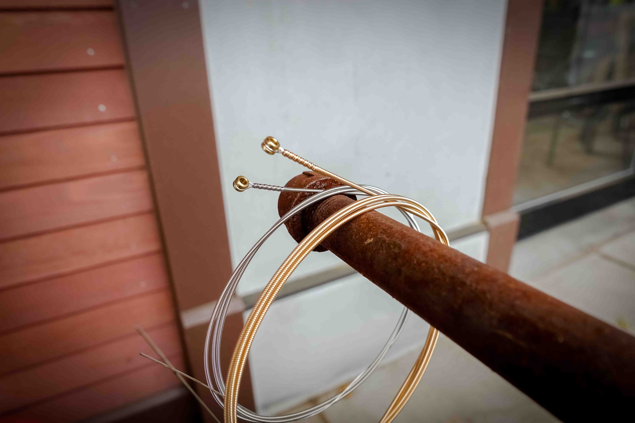
Investing in human capital
With his proprietary manufacturing process in place, Pandey built relationships with local materials suppliers and manufacturers in the U.S. — all of whom hand-process, quality test and package the strings domestically — ensuring that he would now have strings that meet the standards of a professional sound engineer's ear for the rest of his life.

But, when a close friend — who happened to be a world-renowned professional guitar player — came to Pandey in need, complaining that the strings he was using at the time consistently lacked the vintage tone and feel that he, too, had been missing for years, Pandey helped him out by sending over a few of his custom-made string sets, then began sharing with a select few others who asked. Once guitarists like Joe Perry and Jeff Beck started ordering bulk sets of Pandey's strings, however, he recognized that there were, indeed, other guitarists out there who would gladly pay a premium price to drastically increase the tonal response and sustain of their instruments.

The only boutique line of premium guitar strings available
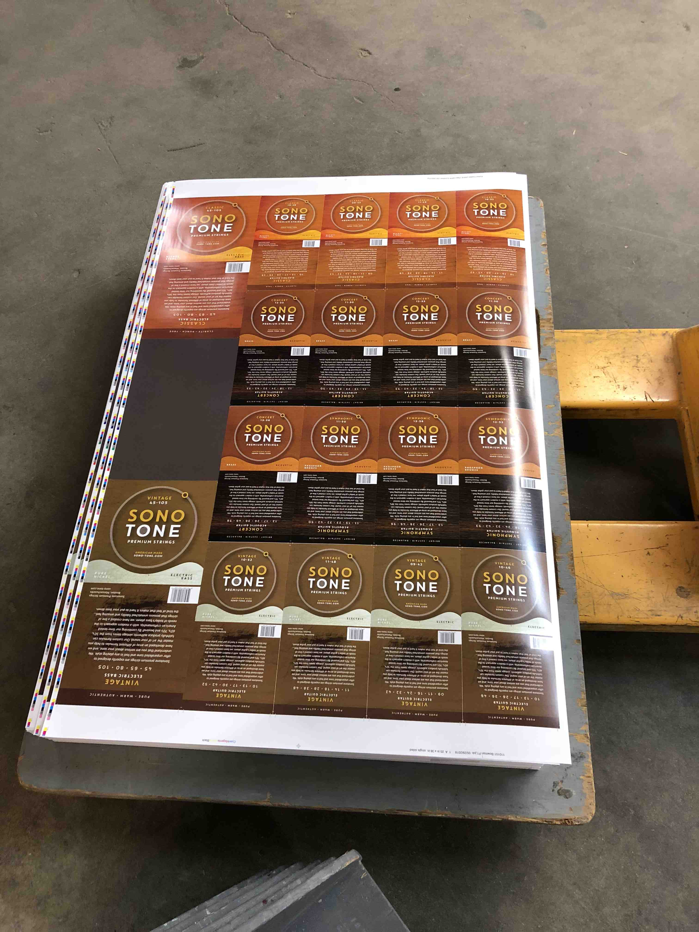
While Pandey had begun his guitar string-making experiments for himself in order to have enough strings to last a lifetime, he had no desire to scale-up his operation and start selling his strings across the country, or in international markets. But, finally convinced that there was a need for strings manufactured in the U.S., by hand, with the highest quality materials available, he decided to make as many sets as he feasibly could per year without having to change his formula, or hire more people, and started selling SonoTone premium guitar strings.
Maxing out at around 200,000 sets per year — the general equivalent of what large-scale guitar string manufacturers can make in a week — Pandey decided that, in order to keep that cost of his strings as low as possible for end-users, he would need to sell them to guitarists who wanted to try SonoTone directly from the Web at http://www.sono-tone.com. SonoTone soon also became one of the early adopters of Fulfillment by Amazon, so that guitarists anywhere in the U.S., or in select European countries, can now purchase boutique, vintage-quality strings at the lowest possible price within a couple days of placing their order.
Adding a further element of his own personal touch to SonoTone strings, Pandey fields all inquiries regarding strings he sells himself, answering all questions and responding to comments from guitarists who purchase SonoTone strings, whom he considers his clients. With over 25 years of experience selling recording equipment and engineering impeccable tone for studios and musicians alike, Pandey maintains this level of active engagement with SonoTone users because, he says, "At this point in the game, for me, there's no other way but to be involved with every single sale."
Please visit to www.sono-tone.com for more information.

About SonoTone
SonoTone is a small batch high-quality string manufacturer based in Massachusetts. In a world of commoditized, all-purpose guitar strings sold to the mass market, SonoTone strings are authentic, comfortable and expressive and sold directly to the customer. For more about SonoTone, please visit our website at www.sono-tone.com

Media contacts:
Jeff Touzeau
Public Relations
Hummingbird Media
+1 (914) 602 2913
jeff@hummingbirdmedia.com

David Ball
Public Relations
Hummingbird Media
+1 (630) 885-1795
david@hummingbirdmedia.com

