
bettergamingagency.prowly.com

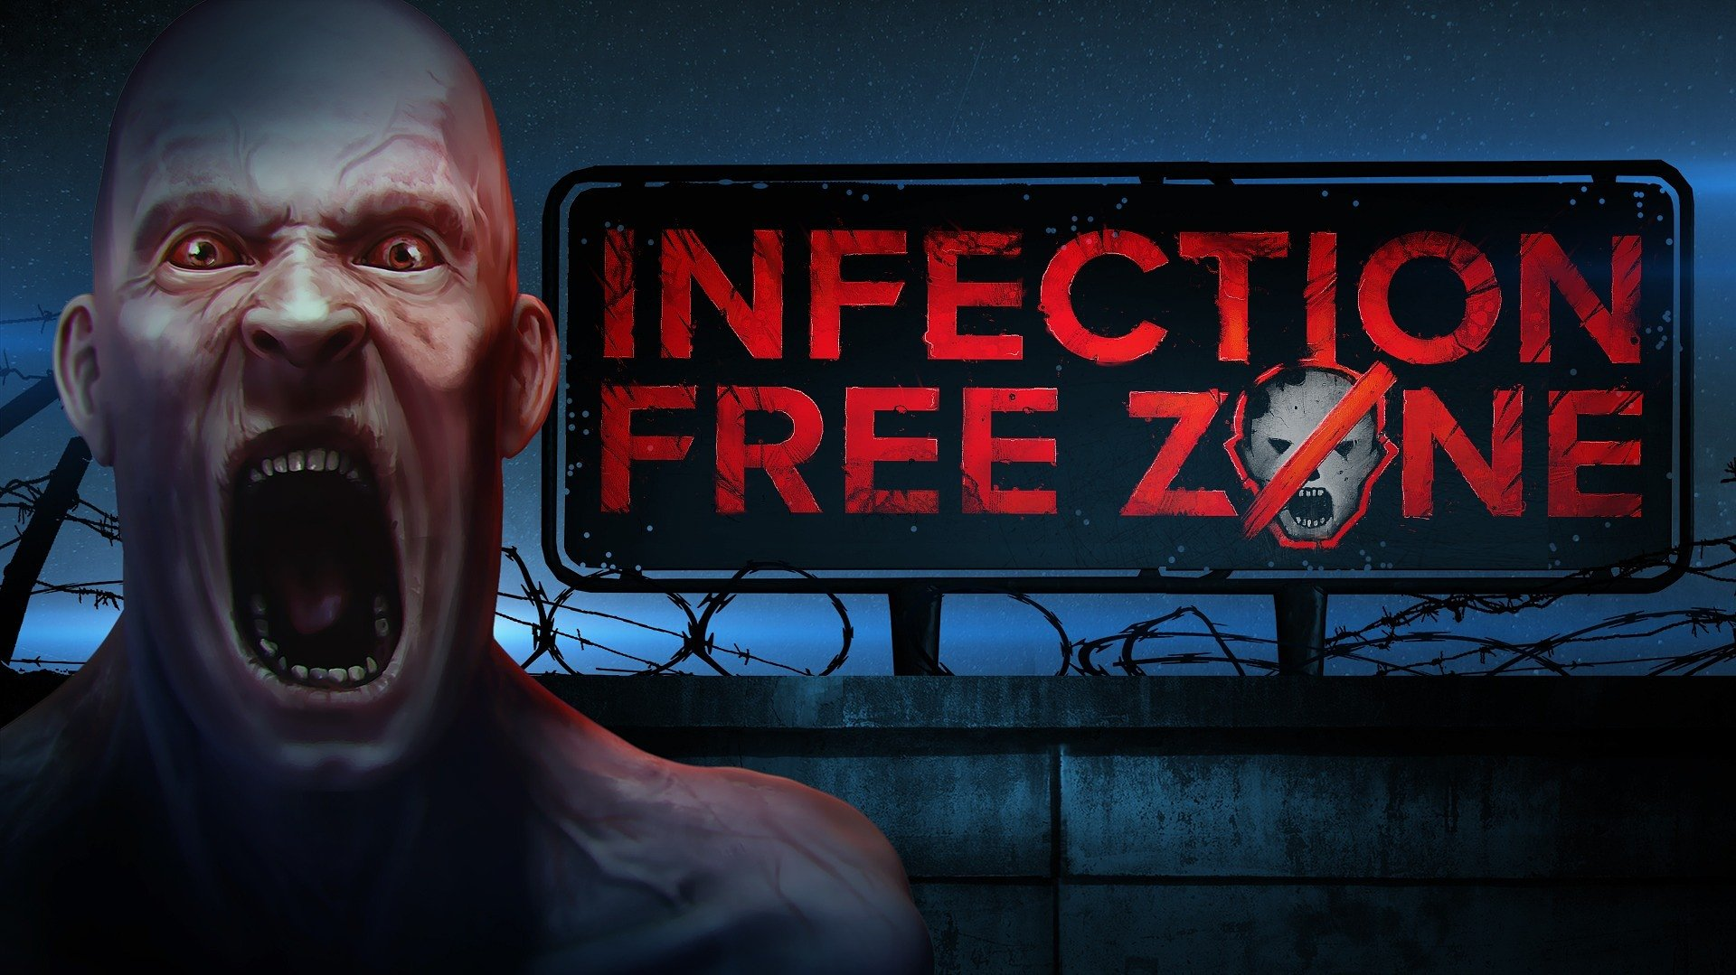

The press release and all related information are under embargo until February 22nd, 14:00 CET
The infected will try to take over your city on April 11th. Infection Free Zone is coming to Steam

When Earth faces a global catastrophe, the only hope for survival will lie in united humanity. Over 400,000 people who played the Infection Free Zone demo and prologue have proven they are ready to fight the terrifying virus. The creators at Jutsu Games and the publishing team at Games Operators confirm that soon the conflict between the survivors and infected will escalate to the next level. Infection Free Zone is coming to Early Access on Steam on April 11th.

No one really knows what the source of the virus is, but its speed of spreading across the entire planet is terrifying. Infected people lose control of themselves, while falling into unstoppable madness. Aggression constantly drives them towards the last survivors. The player's task, being one of humanity's last hopes, is to create the titular Infection Free Zone. As the leader of a group fighting for everything, they will have to build and lead a base that will lay the foundation for a new civilization.

Infection Free Zone – trailer

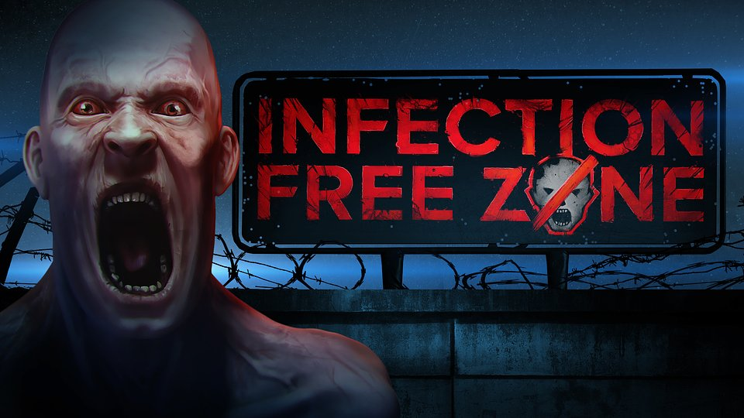
https://youtu.be/TJLWOW_T0go

The location of the Infection Free Zone depends entirely on players. They will be able to choose any city in the world, all thanks to OpenStreetMap’s real-world data. This feature allows them to select a location and turn it into a fighting arena. The final battle between humanity and the infected hordes may happen anywhere in the world – whether it's New York, Miami, Paris, Beijing, Tokyo, or even that small, lovely town in the south of Italy you visited ten years ago – everything is up to players. The system replicates the city's topography in the game, including its roads and buildings. Knowing the terrain can be incredibly useful when planning actions and strategies.

Infection Free Zone is a post-apocalyptic strategy game that can be described as a city rebuilder, directly tied to the necessity of building upon the remaining ruins, from what's left. Humanity was completely unprepared for this sudden and brutal attack, and the remaining survivors lack all resources. Adapting to the new reality will force commanders to make firm and precise decisions, such as constructing shelters and factories in abandoned buildings, building farms, or establishing defenses with walls, gates, and towers. Gathering resources from what's left will significantly increase the chances of survival, but it must be remembered that the infected are not the only threat.

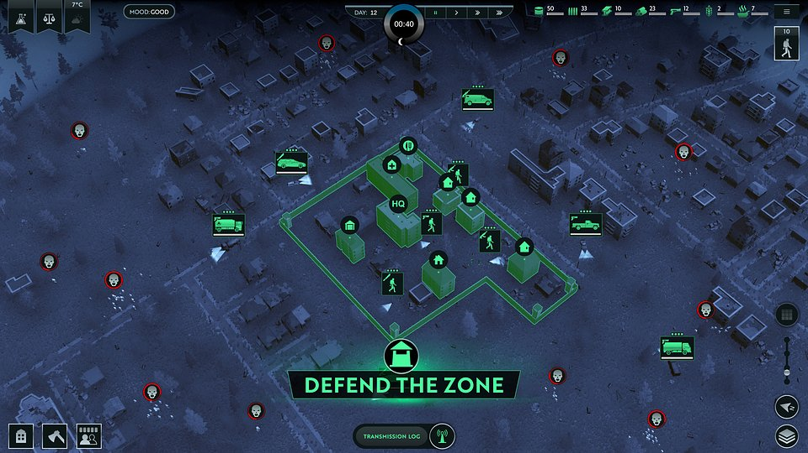

Infection Free Zone – key features:

☣️ Humanity's last bastion – create an Infection Free Zone in any city worldwide. All thanks to a special system based on OpenStreetMap data. Try to adapt existing buildings to new needs by placing factories and shelters, establishing farms, and setting up defensive fortifications.

☣️ Everything can come in handy – use your knowledge of the city's topography to choose the best positions for defending your base. Recall the locations of shops and pharmacies, and consider where you can find weapons. Abandoned buildings may be full of valuable resources, but beware of the infected lurking within them.

☣️ Brace yourself against the incoming waves – the determination of the infected will make it hard to catch a breath. Defend against hordes of enemies attacking at night and fight them with every possible means. Melee or long-range weapons, vehicles, and terrain traps - do everything to survive as long as possible.

☣️ Hope dies last – don't give up, your base will lay the foundation for a new civilization. Fight the virus and focus on rebuilding more cities, increasing the chances of survival.

☣️ Homo homini lupus est – even in the most critical moment, you can't trust others. There are people waiting for your mistakes, ready to raid your enclave. However, remember that for many your base is the only hope, so consider letting other survivors join your team.

☣️ Step by step – Early Access is a perfect opportunity to contribute to the development and influence the final look of the game as a voice of the community. Add the game to your wishlist and join those fighting for the future of civilization.

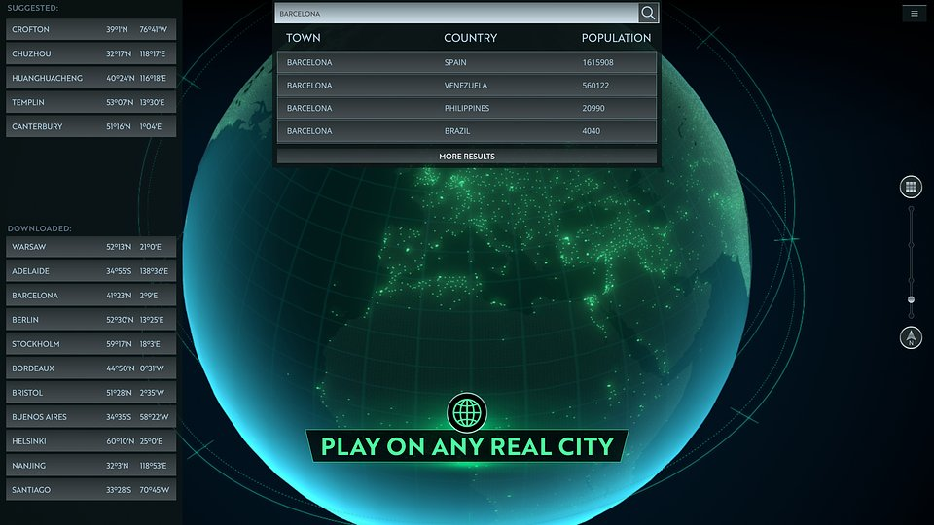

From April 11th, Infection Free Zone will be available in Early Access on Steam. All players interested in this unique strategic survival can now add the game to their wishlist. We also encourage joining the community gathered on Discord and following the publisher’s Facebook and Twitter profiles.

A full press kit available here.

About Jutsu Games:Jutsu is a Chinese word for technique, method, spell, skill, or trick. Fittingly, the team’s main focus is to create innovative gameplay experiences. Jutsu Games are best known for their hit games 112 Operator, 911 Operator, and Rustler.http://jutsugames.com/About Games Operators:Games Operators is a publishing company that invests in, releases, and promotes video games. The company helps develop innovative and unique video games like 911 Operator, Radio Commander, 112 Operator, Infection Free Zone, and Transport INC. by getting involved in projects at various levels of progress – from the conceptual phase to nearly-finished products. For more information visit: www.gameops.pl



Jakub Smolak
PR Specialist at better. gaming agency
jakub.smolak@bettergaming.pro
Twitter

