Wireless Multichannel Audio Systems (WMAS)
A technology revolution for large wireless set-ups

At the NAB show, Joe Ciaudelli, Sennheiser’s Director of Spectrum & Innovation, will speak about the exciting WMAS technology. Four sessions will be held on Tuesday, April 18th in demo room N114LMR at 10:00 a.m., 11:30 a.m., 2:30 p.m., and 4 p.m.

 | Joe Ciaudelli, Sennheiser’s Director of Spectrum & Innovation, will speak about the opportunities that the WMAS technology brings to large wireless microphone and monitoring set-ups

Wireless Multichannel Audio Systems will revolutionize large wireless microphone and monitoring configurations. Compared to today’s conventional link-based approach, where each audio channel transmits on a dedicated, unique narrowband radio frequency (RF) carrier, WMAS multiplexes audio channels onto a single wideband RF carrier. This allows more audio channels to be packed within a small block of RF spectrum, such as a vacant TV channel.

It also allows more spectrum reuse because the required separation distance is shorter between a WMAS and another user operating on the same RF channel. This is particularly beneficial for multi-studio production facilities, mega-sporting events such as the Olympics, theme parks, school campuses, or densely packed theater districts such as Broadway, the West End or Las Vegas.

The engineer can fine tune the required fidelity, operating range, and latency of each audio channel individually. For example, providing the lead singer higher levels of these characteristics compared to a backstage communications channel. WMAS also offers dynamic spectrum resource allocation where the engineer assigns the majority of the spectral resources to the set of microphones and in-ear monitors that are currently on stage or on-camera until that performance is complete, and then seamlessly switch to the next set of mics that is ready to go live.

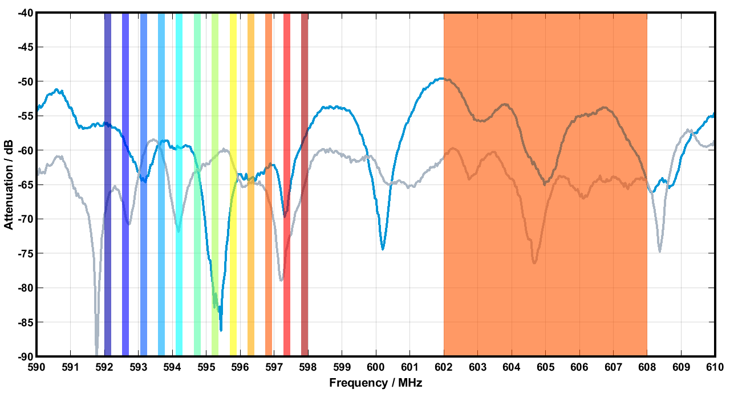 | Operating principle of Wireless Multi-Channel Audio Systems. Instead of individual 200 kHz bandwidths as in narrowband transmission (left-hand side), the technology uses time slots in a 6 or 8 MHz wide window (right-hand side). More information at sennheiser.com/wmas

(Ends)

The images accompanying this media release can be downloaded here.

About the Sennheiser brand
We live and breathe audio. We are driven by the passion to create audio solutions that make a difference. Building the future of audio and bringing remarkable sound experiences to our customers – this is what the Sennheiser brand has represented for more than 75 years. While professional audio solutions such as microphones, meeting solutions, streaming technologies and monitoring systems are part of the business of Sennheiser electronic GmbH & Co. KG, the business with consumer devices such as headphones, soundbars and speech-enhanced hearables is operated by Sonova Holding AG under the license of Sennheiser.

www.sennheiser.com
www.sennheiser-hearing.com

Global Pro Audio Press Contact
Stephanie Schmidt
stephanie.schmidt@sennheiser.com
+49 (5130) 600 – 1275

