MEDIA ALERT: Xytech Talks Future of the Industry Post-Pandemic with Testronic Labs President on Latest Episode of ‘After Dark’ Podcast
‘Xytech After Dark’ is available on iTunes, Spotify & all podcast platforms

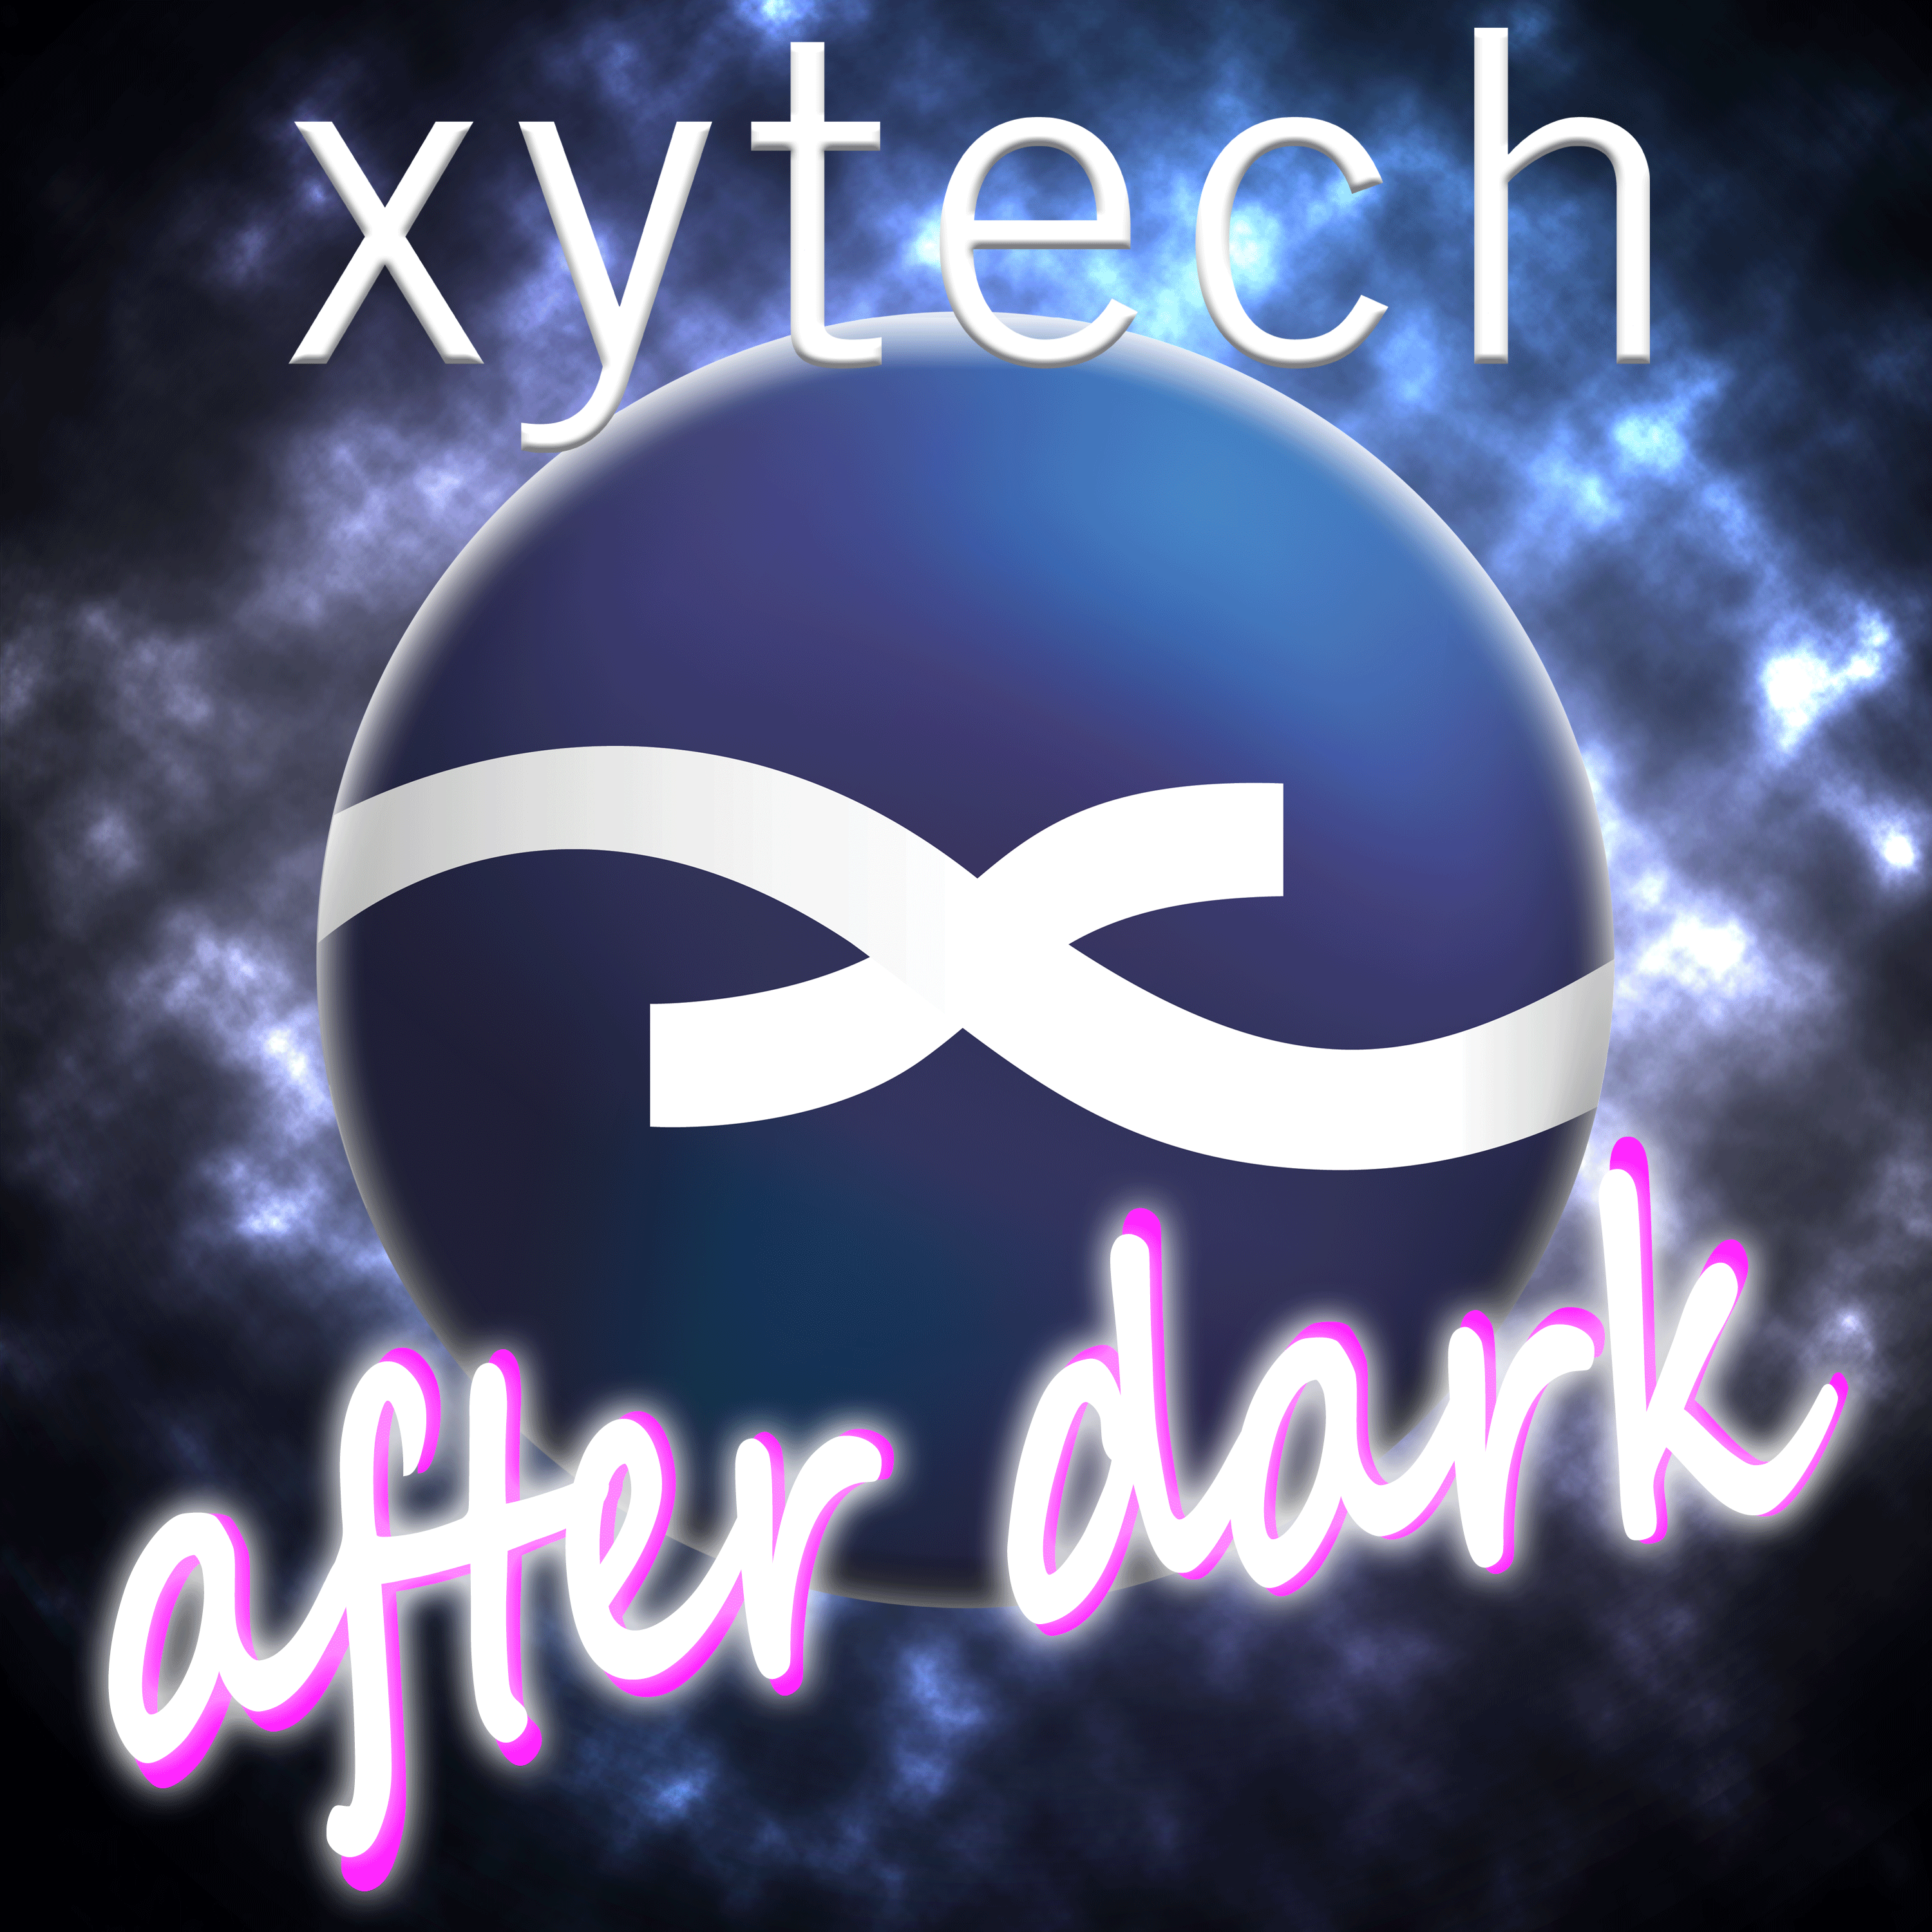
LOS ANGELES, CA, February 5, 2021 — Xytech, leader in facility management software for media and broadcast, launched its ‘Xytech After Dark’ podcast in early 2020, focusing on trends in the media and broadcasting industries and touching on how these industries have been impacted by the Covid-19 pandemic. Available on iTunes, Spotify and all podcasting platforms, Xytech’s latest episode, “Talking QC & the Content ‘Goldrush’ with Testronic’s Jason Gish,” features a candid conversation between the Testronic Labs president and Xytech’s Senior Account Manager Gregg Sandheinrich. The two discuss the challenges and innovations of QC during the pandemic, the content “explosion” of streaming platforms and the future of the industry post-pandemic.

“Our clients have been postponing so much of their production, and the shows that have come back have been coming back really slowly due to Covid protocols,” Gish says during the podcast. “It’s going to be an avalanche of content once production is back to full capacity.”

Past episodes of ‘Xytech After Dark’ have covered trending industry topics, including post-production in the ‘new normal,’ the ‘streaming wars’ and its impact on the industry, and lessons learned due to the pandemic.

“The goal for the podcast is to take a not-too-serious look at the world of media and entertainment through the lens of software solutions,” said Sandheinrich during the podcast’s initial launch. “We are looking forward to sharing what we see on the front lines with our listeners and evoke thoughtful conversations about our industry.”

To listen to ‘Xytech After Dark’ or to subscribe, visit: https://podcasts.apple.com/us/podcast/xytech-after-dark/id1502477089

About Xytech
For more than 30 years, the world’s premiere media companies have depended on Xytech to run their businesses. MediaPulse is the only end-to-end solution for the complete content lifecycle. MediaPulse provides scheduling, automation, asset management, billing and cost recovery for broadcasters, media services companies and transmission facilities in a scalable platform-independent solution. For more information, visit xytechsystems.com.

Media Contacts:

Katie Kailus
Public Relations
Hummingbird Media
+1 (630) 319-5226
katie@hummingbirdmedia.com

Jeff Touzeau
Public Relations
Hummingbird Media
+1 (914) 602 2913
jeff@hummingbirdmedia.com

