For immediate distribution

Doug Strahm Promotes Inclusivity in Music Video for Latest Single, “Freedom Rings”
“Freedom Rings” takes viewers on a musical journey through the struggle for equal rights in the U.S.
April 16, 2019, Fort Wayne, IN – Fort Wayne-based singer/songwriter Doug Strahm has debuted a new music video for his song “Freedom Rings” ahead of the release of his latest album Souvenirs. The video, directed by renowned music video director Nigel Dick, traces the history of the struggle for equal rights in the U.S., from the nation’s Founding Fathers through to the present day, with iconic images of the nation’s past and present alongside Strahm’s powerful lyrics and soulful vocal performance. “Freedom Rings” is one of 17 songs that Strahm recorded with Sweetwater Studios Senior Producer/Engineer Mark Hornsby and Producer Dave Martin for inclusion on Souvenirs, which is set to be released on May 3, 2019.
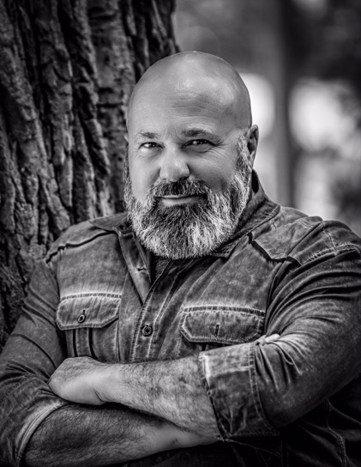
A lifelong resident of Fort Wayne, Indiana, Strahm was one of Sweetwater’s first customers, even recording his own songs on the eight-track recorder in Sweetwater Founder and CEO Chuck Surack’s basement during the company’s early years. As time passed Strahm continued making music on the side while raising a family and running his own local Italian restaurant, Strahmboli’s, until he began working at Sweetwater in 1999. Starting out as the Client Amazement Specialist, Strahm later managed the service department and the warehouse, and he now serves as Vice President of Facilities, in charge of all facilities on the Sweetwater campus, in addition to his role overseeing Sweetwater’s Downbeat Diner.
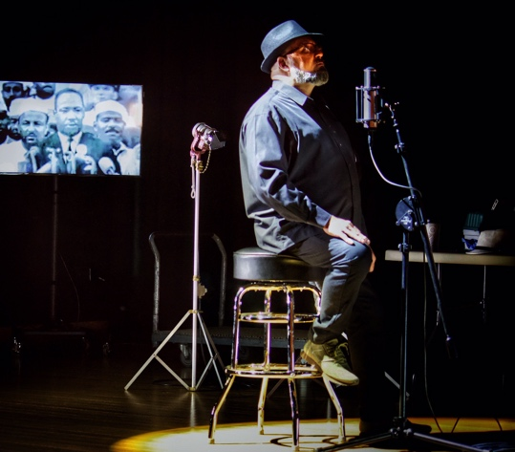
Photo Credit Petro G Photography
Strahm has also become a passionate advocate for diversity and inclusivity through his music in both the local Fort Wayne community and beyond. With music videos for singles from his 2013 album Everything Has Changed now garnering over a million views on YouTube, the new album embraces the same core values that have appealed to Strahm’s growing following of listeners and viewers. “I really wanted to look for the promise and the hope that freedom does ring when you go into battle,” Strahm explains. “From the birth of the country, when the Pilgrims fled religious persecution, to the Suffragists and the Civil Rights Movement and now the LGBT movement — it’s the same struggle: the struggle for equality. And I want to draw parallels for anybody that fought for that struggle.”
Photo Credit David Lengel

As a longtime friend and colleague at Sweewater, Hornsby has watched Strahm’s musical success grow in recent years. “Doug was always pitching songs and going to Nashville when he was younger,” Hornsby explains. “But since he came back to it in the past ten years with YouTube and social media, he’s gotten hundreds of thousands of plays. It’s really resonated worldwide.”

To watch the video for “Freedom Rings,” please visit https://www.youtube.com/watch?v=j43GW6JHBEg
To learn more about Doug Strahm’s latest album, Souvenirs, please visit http://www.dougstrahm.com/
About Sweetwater Studios
Sweetwater Studios is a wholly owned subsidiary of Sweetwater Sound, Inc., the largest online music instrument retailer in the country. With three world-class studios designed by Russ Berger and access to a greater diversity of musical equipment and professional audio gear than any other recording studio in the world, Sweetwater Studios is able to accommodate just about any recording, mixing or mastering project, no matter how simple or complex. With renowned staff producer Mark Hornsby at the helm, who has worked on many Grammy-award winning albums, Sweetwater Studios also has an exceptional staff of producers, engineers, session musicians and studio technicians. For more information on Sweetwater Studios, please visit http://www.sweetwaterstudios.com.

Media contacts
Steve Bailey
Public Relations
Hummingbird Media
+1 (508) 596 9321
steve@hummingbirdmedia.com

Jeff Touzeau
Public Relations
Hummingbird Media
+1 (914) 602 2913
jeff@hummingbirdmedia.com

