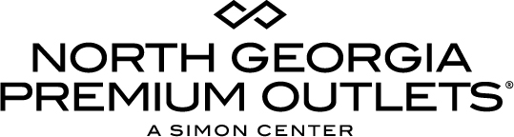

For More Information:

Claire McKenzie
BRAVE Public Relations
404.233.3993
cmckenzie@bravepublicrelations.com

North Georgia Premium Outlets to host Holiday Job Fair October 14
Retailers hiring both seasonal and permanent positions at popular value retail
shopping destination

Dawsonville, GA (October XX, 2017) – North Georgia Premium Outlets, Dawsonville’s premier shopping destination for savings up to 65 percent off, will hold a holiday job fair on Saturday, October 14 from 10 a.m. – 2 p.m. Retailers are looking to hire enthusiastic employees with exceptional customer service experience.

Over 25 stores are looking to staff positions, including adidas, Bass Factory Outlet, Bose, Cole Haan, Hugo Boss, Levis, LOFT, lululemon, Luxury Beauty, Nike, Oakley, PacSun, The Pickled Peach, Saks Fifth Avenue OFF 5th, Soma and Zales.

Candidates are encouraged to visit www.simon.com/careers for a full list of participating stores. Participating retailers will be accepting applications and conducting interviews directly in front of their stores.

WHO/WHAT: Holiday Job Fair at North Georgia Premium Outlets

WHEN: Saturday, October 14
10 a.m. - 2 p.m.

WHERE: North Georgia Premium Outlets
800 U.S. Highway 400 S.
Dawsonville, GA 30534

MORE INFO: This event is open to the public! For more information, visit premiumoutlets.com/northgeorgia on Facebook and Twitter.

###

