For more information, please contact Marta de Paco
On +34 670 780 664 or email press@comunicahair.com

Important:
These images are only available for editorial content.
Credits must be included.
Notification of their publication is expected.
CAROL BRUGUERA
ICONIC Collection
Streets are the new runways
and you, the new fashion icon

Carol Bruguera presents ‘Iconic’, a fall collection with contrasting but gentle and wearable hair colours.
Half & half dyeing is a good way to extreme your daily look a bit and become a fashion icon

Do you hear them? Have they dazzled you? The camera flashes look at you. At the colour contrasts of your new look. Since the streets are also full of style. Walking on the cobblestones, loads of fashion icons parade.

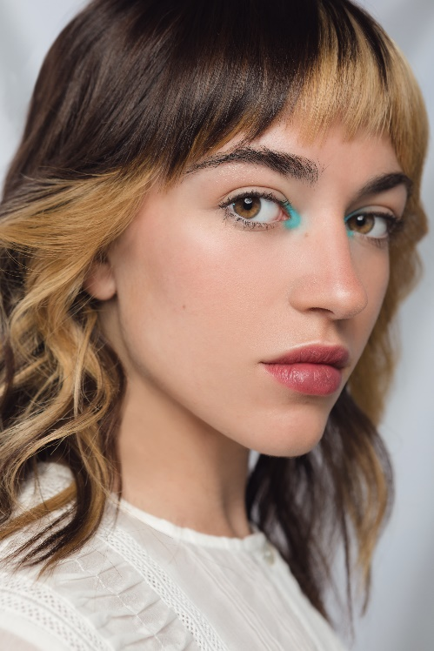
In this way arrives “Iconic”, the new fall collection by Carol Bruguera, which raises the streets to the status of runways. And it is done with a modern touch but maintaining the day to day naturalness. Addressed to the general public, “Iconic” proposes great color contrasts and differentiated areas, but it is easy to wear and not garish at all.

Captured by the outstanding photographer Xenia Lau, the looks of this new collection highlight the uniqueness of each person without falling into sharp or too geometric cuts, but rather accompanying the features in an organic and gentle way. Perfect for a style as bold as a fashion icon, but wearable.

"Iconic" follows the current trend of discoloration by areas. But it proposes a very respectful discoloration for the hair and a delimitation by large and gentle layers. This is achieved by accompanying the half & half technique with variations of tones in the different areas.

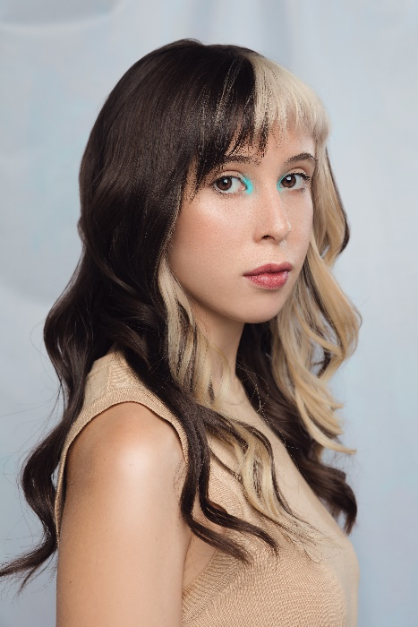
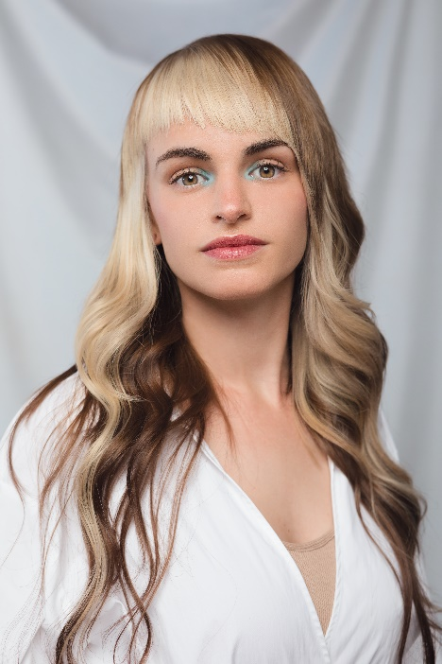
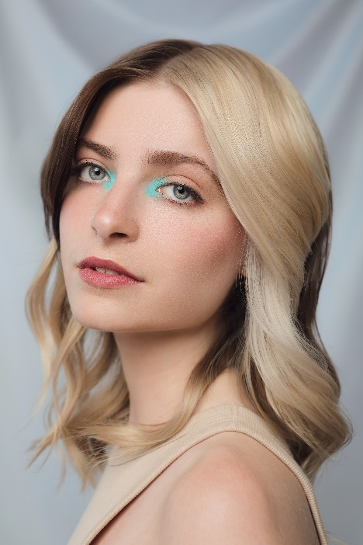
The challenge, technically speaking, has been to achieve a discoloration that would keep intact the touch and the internal quality of the hair. This requires a careful technique and knowledge of the product and protectors, as well as time.

Six decades making hairdressing an art

“Iconic”’s gentle contrasts arrive after the summer collection “Shine”, released in July, and the 20 collections that Carol Bruguera has launched since 2008, whether they are avant-garde or more wearable.

As one of the leading hairdressing chains, Carol Bruguera has shown its originality and artistic skills on numerous occasions. The brand has taken hairdressing to the limit with its hair shows and hairstyle collections, as well as innovating in digital media and winning relevant prizes, like the HairBrained Video Awards and the AIPP Award. The last ones are considered the "Oscars" of hairdressing.

CREDITS:

Hairdressing Director: Mia Carol
Instagram: @carolbruguera @mia_carolbruguera

Hairdressing Manager: Susana Moreno and Emma Sagristà

Hairdressers
Núria Codina, Africa Cuenca, Marina De Aguilar, Sandra León and Alberto Moreno
Hairdressing Assistants
Angi López, Bet Sanchez and Angels Santos
Make Up
Jessica Alcalá

Photography
Xenia Lau

Production Assistant
Lidia Febrer

Lighting
Carlos Rodríguez

Lighting Assistant
Josu Gómez

Audiovisual Production
Natx Creacions Audiovisuals

Design & Strategy
Dadà&Co

Fashion Stylist
Sandra Requena del Rio

Fashion Stylist Assistant
Judith Val Gómez

Models
Paula Bassas, Nora Bernal, Abril Galobardes, Anna Vila

Special thanks to
La Fàbrica (Sant Miquel de Balenyà)

