Rediscover & Reconnect with the iFi ZEN Phono 3 on Record Store Day 2024
Southport, England— April 15, 2024—With Record Store Day 2024 fast approaching, vinyl lovers everywhere will be looking to indulge in the nostalgia and authenticity of their favorite artists. In light of this, iFi, a pioneer in high-fidelity audio components, introduces the Zen Phono 3 - a sophisticated yet accessible DAC that promises to redefine your listening experience.
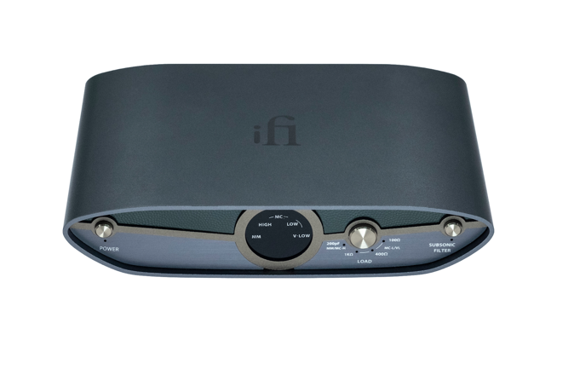

Among the excitement of exclusive releases and limited-edition vinyl treasures, the ZEN Phono 3 offers a gateway to the rich, warm sound that vinyl enthusiasts admire. With its enhanced features and intelligent warp filter, the ZEN Phono 3 allows you to dive deeper into your record collection, uncovering hidden nuances and rediscovering beloved classics with unparalleled clarity.

Intelligent Subsonic Filter for Warped Record
Traditional subsonic filters often compromise music by filtering out both the rumble from warped records and essential bass frequencies. However, the ZEN Phono 3's intelligent subsonic filter sets a new standard of excellence, selectively removing imperfections while preserving the integrity of the music, ensuring every note is heard as the artist intended.
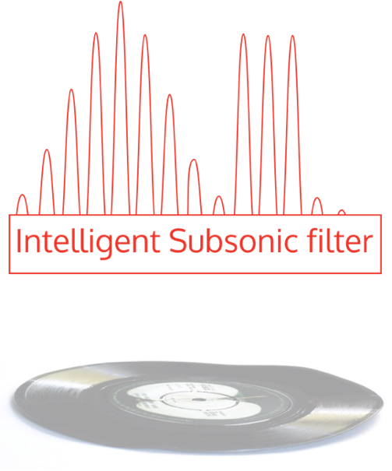
Its precise RIAA equalization circuit maintains a consistent frequency response, preserving the original sonic characteristics of your vinyl records with remarkable accuracy. With an exceptionally low Equivalent Input Noise of -151dBV, surpassing even Stereophile's Class A+ models, it offers an unprecedented level of clarity and detail.

The inclusion of balanced and RCA line outputs ensures versatile connectivity options, while the high-precision power supply controller and adjustable gain range and load impedance further optimize performance and compatibility, delivering pristine audio reproduction tailored to your preferences.

This Record Store Day, immerse yourself in the rich tapestry of vinyl sound and rediscover the joy of spinning records with iFi’s ZEN Phono 3.

Key features of the iFi ZEN Phono 3 include:
- Intelligent subsonic filter that removes LP warp without removing low end
- Precise RIAA EQ with +/- 0.15dB tolerance from 20Hz-20kHz
- -151dBV measured Equivalent Input Noise. 20dBV quieter than some Stereophile Class A+
- 4.4mm balanced and RCA line outputs
- High precision, (1.2MHz) high-current power supply controller
- 36-72dB gain range and load impedance adjustment button to support a range of cartridges
- Two loading options for MM and MC-High (100 & 200pF capacitance) and three options for MC-Low and MC-V Low (100, 400 & 1kOhm)
Pricing & Availability
The iFi ZEN Phono 3 is available to purchase from ifi-audio.com and selected retailers for $249.00.
About iFi
iFi is the sister-brand of Abbingdon Music Research (AMR) and is headquartered in Southport, UK. The two brands respectively design and manufacture portable, desktop and lifestyle audio products and high-end hi-fi components. Combined in-house hardware and software development teams and a ‘music first’ approach enable iFi and AMR to create advanced audio products that deliver new levels of design, functionality and performance at their respective price points. Since iFi’s formation in 2012, its products have earned many awards around the world, helping it to become one of the fastest-growing brands in its field. For more information, please visit— https://ifi-audio.com/

Media Contacts
Shelby Coppola
Hummingbird Media
+1 (203) 598-8167
shelby@hummingbirdmedia.com

Jeff Touzeau
Hummingbird Media
+1 (914) 602-2913
jeff@hummingbirdmedia.com

