Sennheiser and AVer propell University of Greenwich into the future of learning
Modern and diverse university partners with AV industry leaders to transform teaching methods and embrace digital-era educational needs

Wedemark, February 27, 2024 - With a rich history spanning over 125 years, the University of Greenwich has consistently maintained its position as one of the world's top universities, as recognised by the QS World University Ranking since 2021. Offering a diverse array of over 200 courses across its Greenwich, Avery Hill, and Medway campuses in London and Kent, the institution attracts high-calibre students from the UK and abroad. Embracing the global trend of digital transformation in higher education, the university has forged strategic partnerships with Sennheiser, a global audio manufacturer, and AVer, a video collaboration solutions provider. Together, they aimed to elevate the hybrid learning experience and bridge the gap between in-person and remote education.

In the wake of the unprecedented challenges posed by the global pandemic, the university found itself at a crossroads. The shift to remote teaching via Microsoft Teams proved successful, but presented challenges in engaging students effectively, leading to fatigue and decreased concentration levels during longer sessions.

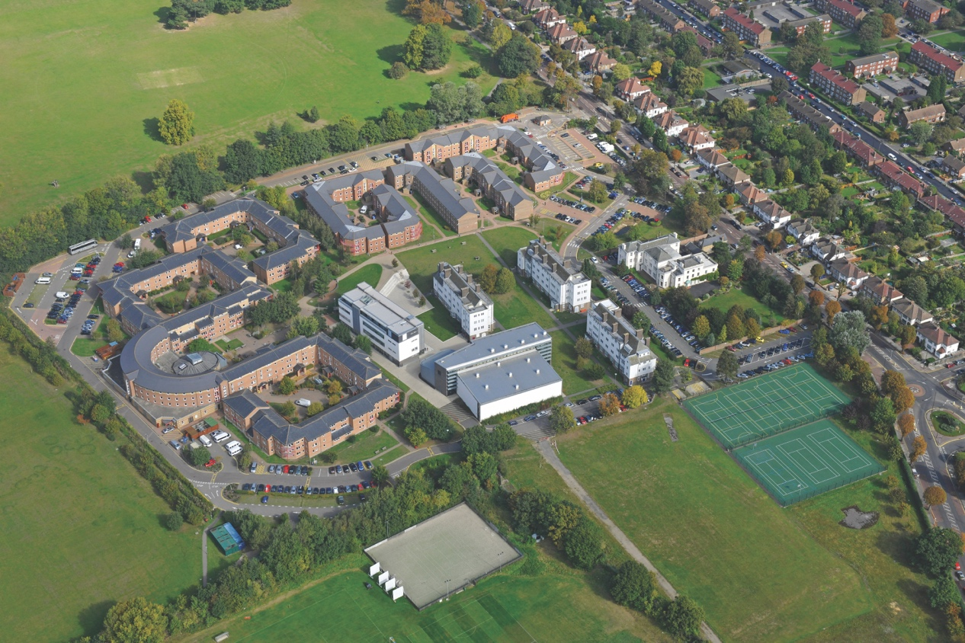 | University of Greenwich Avery Hill campus view from above

To address this, Mark Affection, Head of Digital AV Solutions at the University of Greenwich, and his team spearheaded the initiative to create a cutting-edge ‘HyFlex’ solution. This innovation aimed to provide a seamless and inclusive learning environment for both on-campus and remote participants, ensuring that no student was left behind due to physical constraints. The HyFlex solution also had to comply with building regulations, given that the university's Greenwich campus is situated within the Old Royal Naval College, an integral part of a UNESCO World Heritage Site. Moreover, the historic Queen Anne Building on the Greenwich campus is a listed building, necessitating dialogue with Historic England before any modifications could proceed.

“The HyFlex configuration required a lecture podium, computers, visualisers, and a whiteboard - typical classroom elements,” Affection explains. “Additionally, a crucial requirement identified during lockdown was the requirement for a second monitor for the lecturer, facilitating presentation display on one side and participant viewing on the other.” Affection notes that the second screen needed to be replicated on a large display monitor on the wall facing the podium to ensure the remote students are visually present to both the rest of the remote audience and the speaker. “We hoped that this would help foster a sense of inclusivity,” he adds.

Building on that sense of inclusivity, the team investigated what benefits Auto Tracking Cameras could bring, with AVer’s camera solution being chosen for its remarkable AI functionality in detecting, recognising and switching video automatically between different speakers and different zones.

A key requirement for the cameras was the ability to integrate with other hardware. Affection and his colleague Ben Sleeman, Senior Digital AV Technician, had identified that a fixed microphone on the lecturer’s podium wasn’t adequate for group discussion, as the sound levels were mixed. A handheld microphone would be too cumbersome to pass round the audience, so the team looked to install centrally placed, ceiling mounted acoustic panel microphones.

TeamConnect Ceiling 2 (TCC 2) microphone emerged as the most effective option to elevate the hybrid learning experience and bridge the gap between in-person and remote education | 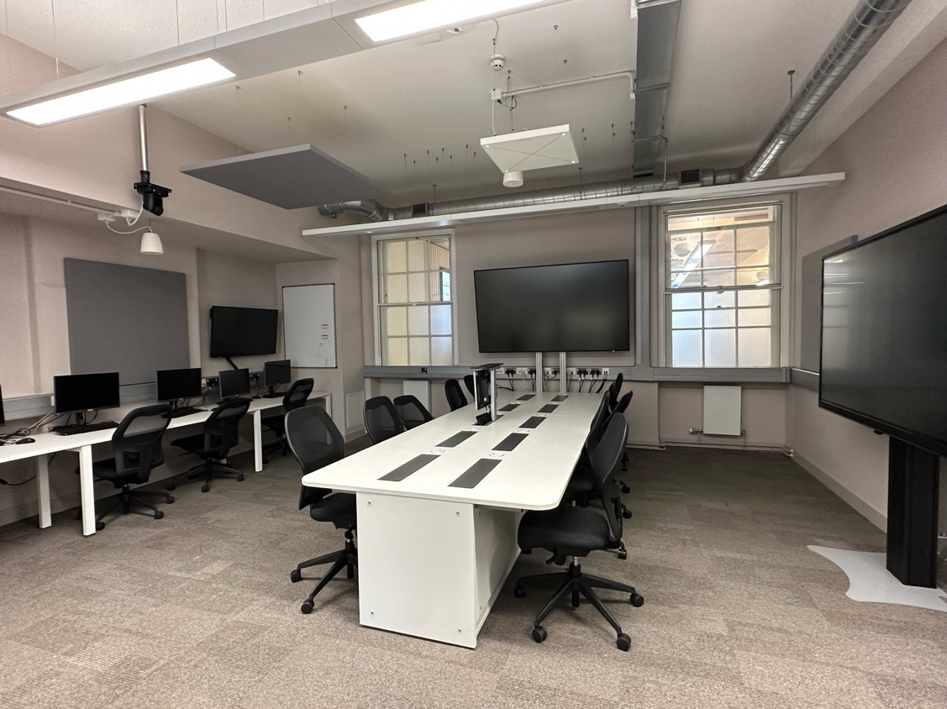

After extensive evaluation, Sennheiser was chosen due to their “well-regarded and trusted pedigree”, with Affection emphasising the need for high-quality, reliable, and adaptable technology. “Sennheiser's established reputation was a driving factor in our decision-making process,” he says.

Sennheiser’s TeamConnect Ceiling 2 (TCC 2) microphone emerged as the most effective option. The microphone also has the option to be integrated with the AVer cameras using the PTZ Link software bridge, allowing both the camera and microphone to intelligently detect and follow the active speaker.

“Given our extensive use of Sennheiser audio solutions, like the Evolution Series and SpeechLine, we were confident in the superior quality technology offered by their products for our classrooms and lecture halls,” says Affection. “Upon testing the TCC2 solution with Sennheiser’s Inesh Patel [Business Development Manager – Business Communication], and Joe Mahoney [Customer Development & Application Engineer], who visited our facilities to set up the microphones in a classroom environment, we were thrilled with its performance. It captured voices from various positions, while allowing prioritisation. And that’s when we realised the potential of this technology and thought ‘this could really work for us!’.”

Following the successful classroom testing, the team extended the evaluation to a lecture theatre, testing the TCC 2 microphone with TrueVoicelift technology. Once again, the test yielded tremendous success. “We were astonished by the performance,” exclaims Mark. “This reinforced our confidence in the product's suitability, both for teaching in classrooms and voice reinforcement in lecture theatres.”

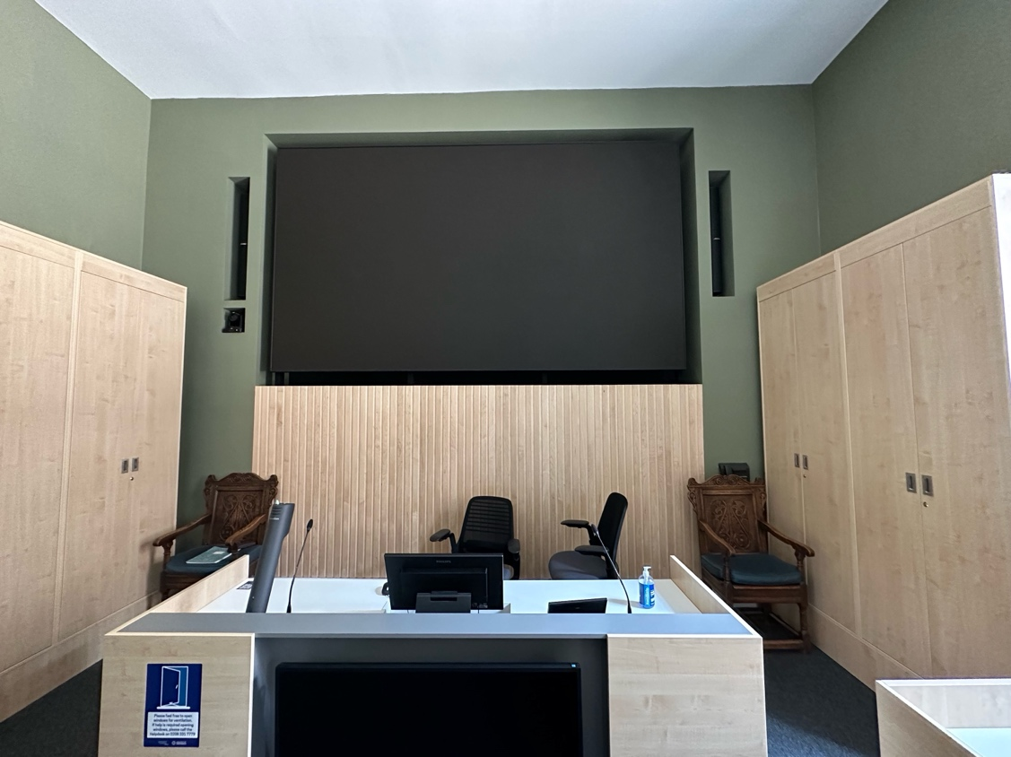 | Given the extensive use of Sennheiser audio solutions by the University of Greenwich, like the Evolution Series and SpeechLine, the team were confident in the superior quality technology offered by Sennheiser products for their classrooms and lecture halls

While the TCC 2 was initially deployed in 24 classrooms, four larger lecture theatres, and IT labs across the campuses, the team later equipped four additional smaller classrooms with the new TeamConnect Ceiling Medium ceiling microphone. The university is also currently piloting Sennheiser’s WiFi enabled MobileConnect, an innovative, scalable, app-based accessibility solution, with the aim of incorporating it into the university’s assistive hearing technology facility-wide.

After the initial installation in 2021, where the university collaborated with AV consultants Hewshott and integrator Strive AV, subsequent work ensued the following year, involving the same acoustics consulting service and integrator GVAV. Finally, 2023 marked the collaboration between the university and DramaByDesign AV consultants, alongside GVAV. In response, both university teaching staff and students quickly adapted to this novel experience. From an instructional standpoint, the AV solution unlocked new possibilities, especially in scientific and technical courses, enabling even more sophisticated deployments. Remote participants noted a more engaging experience, resulting in increased attendance and heightened student satisfaction.

The AV configuration achieved its objective of ensuring course continuity and improving the learning experience for all stakeholders. This was especially valuable for international students, some of whom still could not travel to the UK, but could participate in the learning discussions remotely.

Deployed in 24 classrooms, four larger lecture theatres, and IT labs across the campuses, the team later equipped four additional smaller classrooms with the new Sennheiser’s TeamConnect Ceiling Medium ceiling microphone | 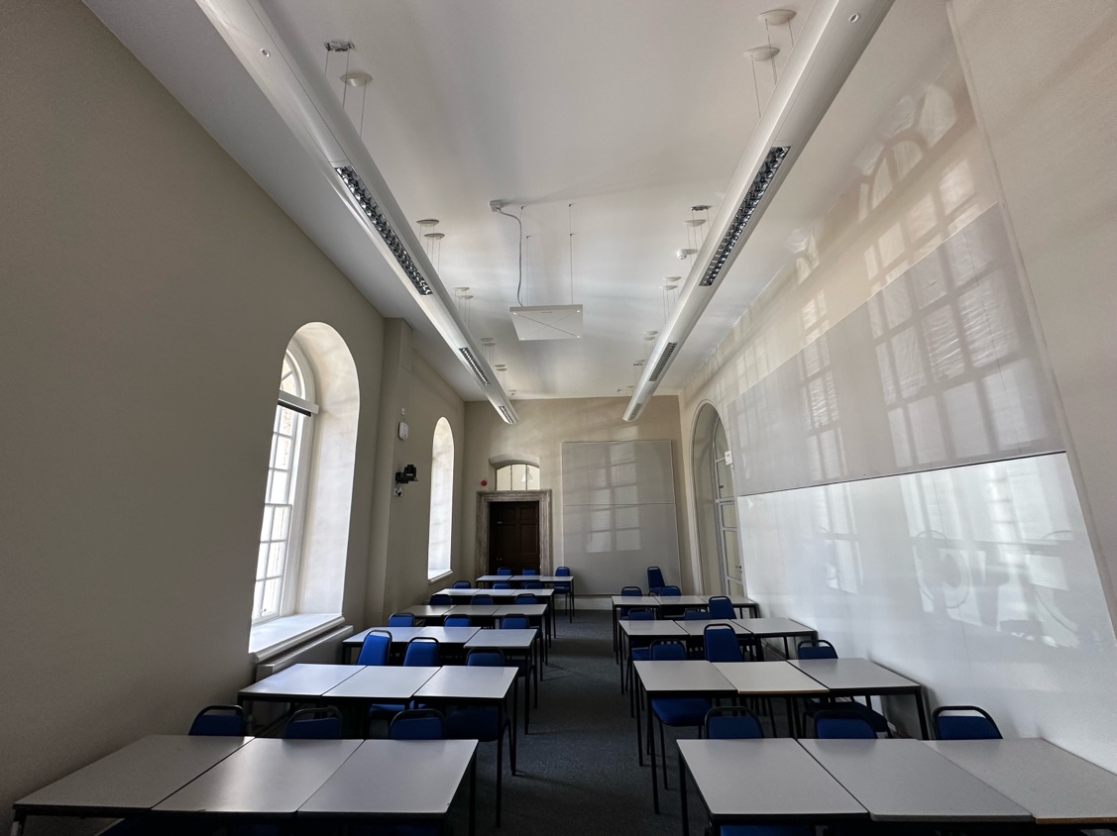

Moreover, the technology aligns with the university’s target of achieving zero carbon emissions by 2030. Affection observed a reduction in staff travel between campuses since the implementation, with online meetings becoming the norm. “The natural audio experience and auto-tracking don’t hinder or stifle conversation,” he notes.

“Out of a dreadful situation like COVID-19, positive and intriguing developments have emerged in how people engage with these technologies, which I don’t see us reverting from,” remarks Mark. “Necessity forced this change, and people have embraced and become accustomed to these technologies.”

Looking ahead, Mark says, “Feedback from non-remote rooms indicates that the HyFlex configuration is the new normal. ‘We want the cameras; we want the microphones and dual screens’, they say. Our aim is to continue working in this manner.”

“Our collaboration with the University of Greenwich has highlighted the significance of teamwork and shared expertise in shaping the learning environment,” concludes Patel. “Sennheiser's TeamConnect Ceiling microphones have been instrumental, ensuring a seamless educational experience by intelligently integrating with AVer cameras. Our joint efforts underscore the importance of innovative solutions in advancing education, and we're excited about its continuing impact on the future of learning.”

About the Sennheiser Group

Building the future of audio and creating unique sound experiences for our customers - this is the aspiration that unites the employees of the Sennheiser Group worldwide. The independent family-owned company Sennheiser was founded in 1945. Today, it is managed in the third generation by Dr. Andreas Sennheiser and Daniel Sennheiser and is one of the leading manufacturers in the field of professional audio technology.

sennheiser.com | neumann.com | dear-reality.com | merging.com

About AVer Information Inc.
Founded in 2008, AVer is an award-winning provider of education technology and video collaboration camera solutions that improve productivity and enrich learning. From accelerating learning in the classroom to increasing competitive advantage for businesses, AVer solutions leverage the power of technology to help people connect with one another to achieve great things. AVer's product portfolio includes professional-grade artificial intelligence-enabled auto-tracking cameras, Zoom and Microsoft Teams Certified enterprise-grade USB cameras, document cameras, and mobile device charging solutions. AVer strives to provide industry-leading service and support that exceeds customer expectations. AVer is deeply committed to the community and the environment, and it employs stringent green processes. Learn more at aver.com.

Local Press Contact
Sennheiser electronic GmbH & Co. KG
Maik Robbe
Communications Manager EMEA
T +49 (0) 5130 / 600 1028
Maik.Robbe@sennheiser.com

