**Neumann Expands Its KH Line With Five New Subwoofers**

Precise Bass Reproduction for Stereo, Surround, and Immersive Monitoring Systems

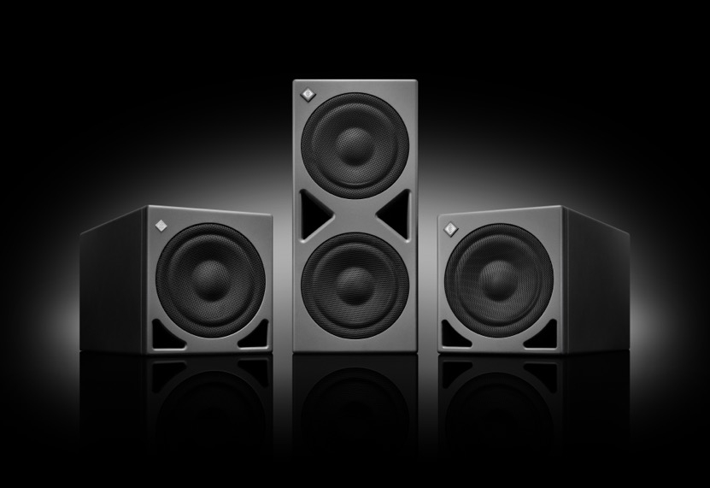

**Berlin, September 11, 2025 – German pro audio specialist Neumann is proud to announce the launch of five new DSP-powered subwoofers in its acclaimed KH series: KH 805 II, KH 810 II and KH 870 II, as well as their Audio-over-IP (AoIP) counterparts KH 810 II AES67 and KH 870 II AES67. With high SPL capabilities, these subwoofers deliver unmatched precision, power, and flexibility for stereo, surround, and immersive audio workflows.**

“With immersive audio becoming the new standard across music, post-production, and broadcast, reliable monitoring is more important than ever,” said Yasmine Riechers, CEO of Neumann. “Our new KH subwoofers offer scalable solutions for every studio size and format – from stereo to surround and immersive – while integrating seamlessly with both analog and DSP-equipped KH monitors.”

Ein Bild, das Elektronik, Lautsprecher, Subwoofer, Audiogeräte enthält.
**More Power & Multichannel Bass Management**

The **KH 805 II** builds on the success of the KH 750 DSP, offering approximately double the output for greater headroom and low-end authority. It’s the ideal choice for stereo setups using Neumann’s KH 120 II, KH 150 or KH 310 monitors.

Ein Bild, das Elektronik, Lautsprecher, Subwoofer, Audiogeräte enthält.

The **KH 810 II** adds multichannel bass management for systems up to 7.1.4, making it perfect for immersive audio production. It shares the same acoustic design as the KH 805 II and supports bass management for up to eleven studio monitors.

Ein Bild, das Elektronik, Lautsprecher, Subwoofer, Audiogeräte enthält.

At the top of the range, the **KH 870 II** doubles the output of the KH 810 II while offering identical multichannel capabilities. Tailored for large rooms and high-demand applications, it pairs effortlessly with large-format monitors like the KH 420.

**Two AES67 Versions for AoIP Workflows**

The **KH 810 II AES67** and **KH 870 II AES67** integrate seamlessly into modern broadcast and networked audio environments. Supporting 12 AES67 input channels and full compliance with ST 2110, ST 2022-7 redundancy, RAVENNA®, NMOS, and DANTE®-generated streams, these models offer future-proof flexibility and full system integration.

**DSP Power and MA 1 Integration**

All new KH subwoofers feature Neumann’s advanced DSP engine, enabling seamless system alignment via MA 1 Automatic Monitor Alignment (sold separately). This allows users to optimize their entire monitoring setup – including analog KH speakers – for room acoustics and phase coherence.

With low-frequency extension down to 16 Hz, these subwoofers provide the clarity and control needed for critical mixing and mastering decisions.

**A Complete Subwoofer Family**

With the addition of these new models, Neumann now offers a complete range of DSP-controlled subwoofers – from the compact KH 750 DSP to the powerful KH 870 II – covering all monitoring needs from stereo to immersive audio across music production, editing, post-production, scoring, mixing, and mastering. All models reach the hearing threshold of 16 Hz and, together with Neumann studio monitors, enable reference sound across the entire frequency spectrum.

“Our new subwoofers offer significant advancements over their predecessors, with dramatically reduced distortion and port noise”, said Stephan Mauer, Head of Product. “It’s worth noting that they can be combined with both analog and DSP-controlled KH Line studio monitors, making them the perfect tool for upgrading an existing stereo system and/or expanding it for immersive monitoring. They also offer the option of precise room alignment via MA 1 of the entire system. In other words: no more low-end guesswork.”

For more information, visit: [www.neumann.com](http://www.neumann.com)

**About Neumann**

Georg Neumann GmbH, known as “Neumann.Berlin”, is one of the world’s leading manufacturers of studio-grade audio equipment and the creator of recording microphone legends such as the U 47, M 49, U 67, and U 87. Founded in 1928, the company has been recognized with numerous international awards for its technological innovations. Since 2010, Neumann.Berlin has expanded its expertise in electro-acoustic transducer design to also include the studio monitor market, building upon the legacy of the legendary loudspeaker innovator Klein + Hummel. The first Neumann studio headphones were introduced in 2019, and since 2022, the company has increased its focus on reference solutions for live audio. With the introduction of the first audio interface MT 48, and its revolutionary converter technology, Neumann now offers all the necessary technologies needed to capture and deliver sound at the highest level. Georg Neumann GmbH has been part of the Sennheiser Group since 1991 and is represented worldwide by the Sennheiser network of subsidiaries and long-standing trading partners. [www.neumann](http://www.neumann.com/).

Stay up to date and follow us on: [FACEBOOK](https://www.facebook.com/neumann/) I [INSTAGRAM](https://www.instagram.com/neumann.berlin/) I [YOUTUBE](https://www.youtube.com/user/GeorgNeumannGmbH)

**Press Contact Neumann:**

Dr. Andreas Hau Raphael Tschernuth

andreas.hau@neumann.com raphael.tschernuth@neumann.com

T +49 (0)30 417724-15 T +49 (0)30 417724-67