5 – Recording Mojo Stories
By Ivo Burum

First and foremost, story rules, and a story focus should always dictate the relevant technology and approach — mojo, or hybrid. Having said this, once the story has been developed (see previous article), there are several key focus areas that can be addressed when shooting mojo stories.

Equipment Focus

The smartphone is a Swiss Army knife on steroids — in media terms, it’s a creative suite in a pocket. The mojo kit will vary depending on the job and the region. In the Middle East and North Africa, you probably wouldn’t have large kits because they’re too obvious. Rana Sabbagh, a former editor of the Jordan Times and Reuters correspondent, says working small enables press to “work and move in oppressive situations where citizens and policemen can obstruct the work of journalists and where large cameras paint them as targets.” Working small can mean you have more access and are less of a target.

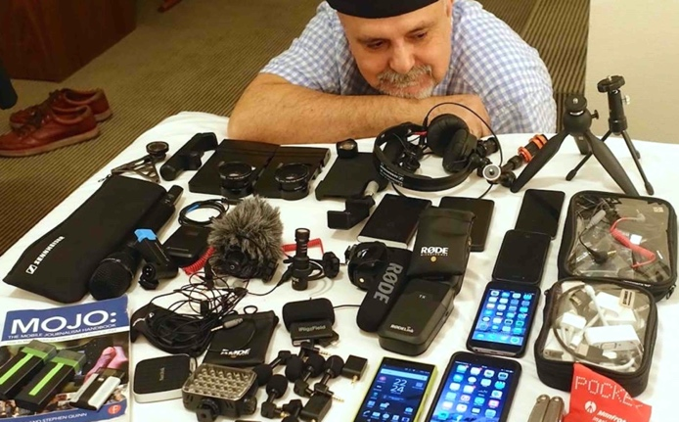 | Figure 1  The author with a variety of mojo equipment  (Photo courtesy of Ivo Burum)
Using a smart device properly is not always easy, and it takes some practice to effectively use powerful apps. The type of app is often determined by the level of story you need to tell. So, experiment with apps and make your own informed decision based on the job at hand (see Tools article).

Coverage Focus
Video stories need pictures. There are basically two types of coverage — the type that you set up and actuality, which doesn’t need to be set up. Either way, you are looking to shoot well-composed shots and sequences that tell a story. My experience as a producer and cameraman working on international current affairs shoots in difficult regions suggests that a tripod can slow things down and quickly paint you as a target. Use tripods for long interviews, long wide pans and a long-lens close-up, otherwise practice working hand-held, close to the subject, on a wide lens.

Ivo’s tip: When working hand-held press your elbows into your sides and hold the smartphone with two hands. This triangle creates added stability, in much the same way that a smartphone cradle, like a Beastgrip, does. (Yes, it feels like a Dalek, but only at first.)

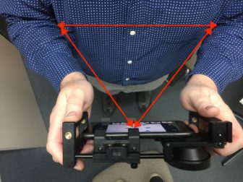 | Figure 2  Stabilising a hand-held shot  (Photo credit: Ivo Burum)

Irrespective of the type of coverage, it’s important to consider these questions:
- Will the story have a dramatic opener with close-ups, a telling wide shot, dynamic B-roll actuality, narration, an interview grab?
- What B roll is required to introduce interviewees, cover edits and narration, and compress and expand sequences to accentuate story points?
- What interviews and actuality are required to provide currency?
- How will you close the story and what vision, and audio is required?

Following are a couple of templates for thinking about coverage.

Check your framing. Generally, use a Medium Close Up (MCU) for interviews and change to a Medium Shot (MS) if your interviewee moves around a bit. Here are some basic shot sizes.

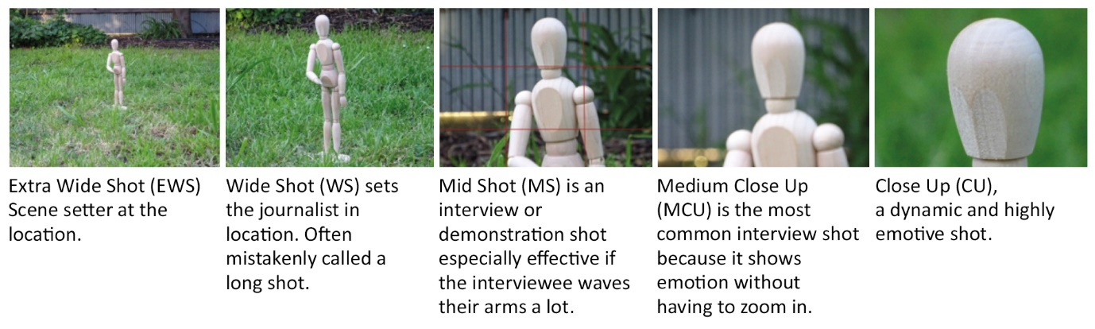
Figure 3. Standard frame sizes (by Ivo Burum)

The classic five-shot rule. This template could be used to cover simple activity and a localized event — how shots are juxtaposed with narration and other elements, and how they are edited gives the piece its pace and gravitas.

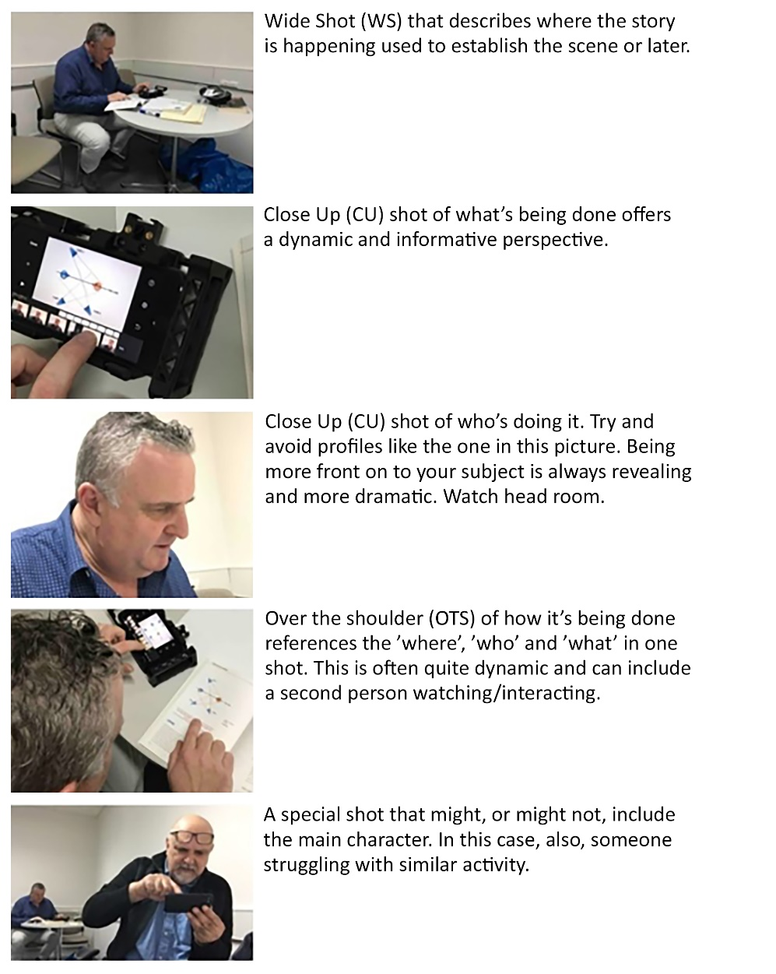 | Figure 4  Sequencing (by Ivo Burum)

Look at these three shots. It is the same shot cropped, yet, each frame provides a different feel. So, choosing your framing is essential to telling the story. Which frame would you begin with and why?

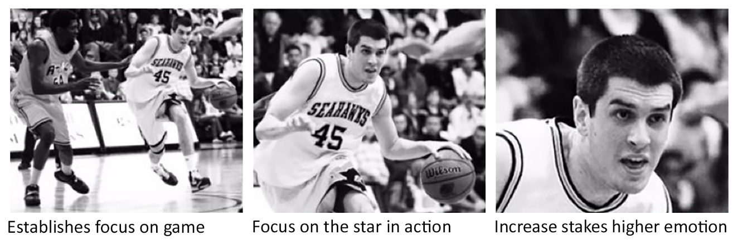
Figure 5. Frame variation (by Ivo Burum)

Add an interview, narration, relevant B roll and, if you’ve planned right, completed SCRAP, and some captured “emotion,” you’ll have the raw material to edit a strong story. The five types of shots (Fig. 4) that form a sequence, plus the main interview and narration, will tell your basic story. But your story may have anything from five to 13 sequences, each identified by a style of shot(s) and each having a structural role. When planning these shots/sequences it’s easiest (if possible) to consider them in the order they might be edited. Hence, my tip is to learn sequence coverage by filming something that has a definite process and structure. For example, practice filming someone cooking pasta, making eggs and bacon, or using a lathe to shape a block of wood into a table leg — how many different sequences are required to cover each of the above processes and to edit them from say 30 minutes, into a two-minute film? How much B roll will you need? What about narration?

Simple process shoots, where structure is evident, enable a coverage focus and in particular sequencing with an emphasis on emotion, information, B roll, interviews and the elements required to turn a long process into a short film.

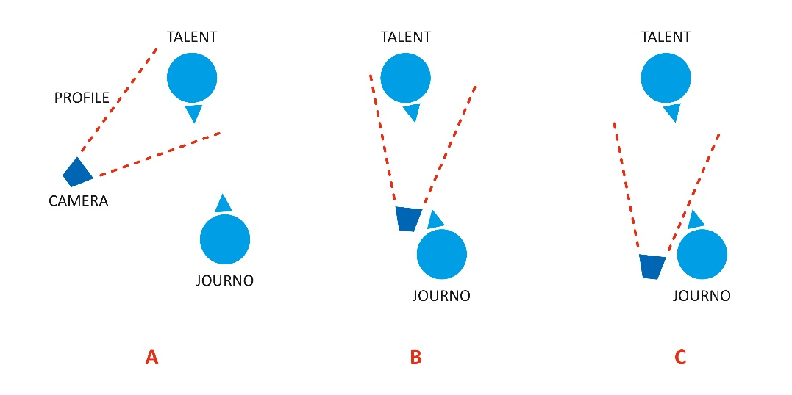 | Figure 6  Eyelines (by Ivo Burum)

Understanding eyeline is important. If you set up for a single-camera location interview, you might consider the front-on eyeline set up in ‘B’. In many regions it is quite acceptable to hold the camera in front — at chest or waist height — and have the interviewee respond over the camera. When adopting ‘B’, place the camera as close to front on as possible, and place the journalist (mojo) next to the lens. Traditional location interview eyeline would have you place the camera behind your eye line ‘C’, but not if you are working solo. ‘C’ is done when working with a camera person, who can check the frame.

If you need the shot to be profile ‘A’, it can be, but avoid profile shots for the following reasons:
- You get more variety of shots, without moving, if you shoot from the front.
- You can easily push the camera in from the wide lens when shooting from the front.
- You can even zoom for a close-up (not advisable unless imperative).
The front-on shot (or almost front on) is more powerful because we see the person’s face, their eyes and their emotion, all without moving the camera away from their eyeline.

Here are a few tips for shooting shots and sequences:
- Switch the smartphone to Airplane mode to avoid unwanted calls and WiFi interference.
- Make sure your battery is charged.
- Make sure you have space on your phone.
- Let someone know where and when you will film.
- Use a structural plan to indicate clearly what you have filmed and how much is left to film; this will help during the shoot and the edit.
- Prepare specific research and questions for your interviewee and set these out against your structure.
- Shoot with the light over your shoulder and on the subject.
- Don’t use the tripod unless you must.
- For stability create a V with your smartphone, hands and your elbows locked into your body (see figure 2 above). Using a wide lens also helps with stability.
- Always switch the camera on and wait for the counter to roll before asking questions.
- Ask open-ended questions that don’t give you a yes or no answer.
- Frame your interviewee in medium close-up (MCU) unless they move their hands about; in which case choose a wider medium shot (MS).
- Try and hold B-roll shots for at least 10 seconds to ensure they are steady and to enable multiple sections of the shot to be used.
- Always shoot a few seconds of static shot before and after a panning shot so your pan is steady at both ends and so you end up with three potential shots.
- Shoot B roll before the interview, for example, as you enter a building, during actuality with interviewees and immediately after the interview.
- When it gets busy, think about information (story) and not the shots.
- Steady movement within a frame, or that which is created by moving the camera, can create more dynamic shots.
- Be aware of screen direction and the 180-degree rule that dictates that you stay (keep your cameras) on one side of the screen line. Figure 7 shows the screen line and in this example if our cameras stay on one side of the line, person A will always be talking left to right and person B right to left, and to each other. Having said that, learn how to break rules and the boring line, by using neutral close-up shots that enable you to cross the line. This is one reason why B roll is so important.

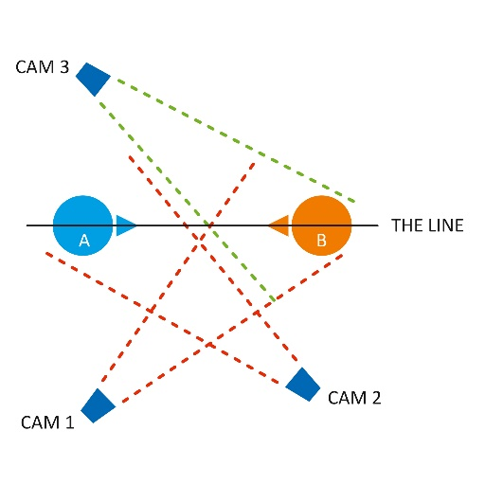 | Figure 7  Screen direction (by Ivo Burum)

- Use the correct mojo gear (see Tools chapter)
Coverage aspects that should be considered are:
- How will interviews and narration create story flow and bounce?
- Don’t forget the detail and your location-setting shots.
- When you feel you have enough B roll, get some more.
- Will you need an audio buzz track of the atmosphere in a room — usually recorded for at least 30 seconds, it’s a continuous audio recording used in post-production to cover and smooth contrasting audio edits.
- Will graphics be required and how and where will these come from?
- If it’s a historical piece, or an update, will archive material be used, where will this come from and who pays for it?
- Will a stand-up, piece to camera (PTC) be needed and if so, why? Stand-ups can be effective when there is no B roll, no interviews or actuality, and to establish the journalist on location.
When shooting a stand-up, keep the script short — 8-10 sec, one thought per sentence and one sentence per paragraph. Choose a key word for each paragraph. Roll into a retake without buttoning off. If there is a problem, it’s usually in the script. If you fix the script and still fluff it, put a sharp stone in your shoe. When your concentration is on the stone, record the stand-up.

Audio Focus
Recording audio in the field is about being ready with the right microphones and a sound strategy to enable you to react to location inputs. The recording task is made more complex because mojos predominantly work on their own, locations can be noisy, and when shooting video quickly on location it’s not always possible to be close to the sound source.
In difficult and changing audio situations, I’d suggest:
- Always have a shotgun mic attached to your phone/cradle and a lapel mic in the bag so that you can respond quickly.
- If you need an interviewee to walk and talk, use a radio mic.
- If you need your questions cleaner, use a splitter and mic yourself with a lapel mic. Remember that both the interviewee’s and interviewer’s microphones will generally be recorded onto the same track on your smartphone. So, don’t overlap your voice with the interviewee.
- If you need a true split, use a device like a Zoom H1 to record a second track of audio and record a clap at the beginning of the record to sync the two tracks in the edit.

In summary, video stories are more than radio with pictures. Understanding the rubric cube nature of combining video elements to create a seamless story is a key step in the mojo workflow. You need discipline in your approach to successfully pull all the pieces together. Working as a mojo is a holistic and organized process. You need to be smart and ready to react to location inputs. You need to think and work like a journalist and focus, record and edit the story like a filmmaker. Staying ethically and legally healthy and understanding the technology — but not being limited by it — is also part of the job. Knowing how to do all this is difficult, but the control it provides mojos over their stories is uplifting. Give it a go and you’ll grin broadly at the unfolding possibilities.

Go mojo...

