For more information, please contact Marta de Paco
On +34 670 780 664 or email press@comunicahair.com

Important:
These images are only available for editorial content.
Credits must be included.
Notification of their publication is expected.

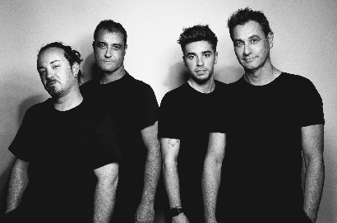
HAIRKRONE
ISNEW Collection

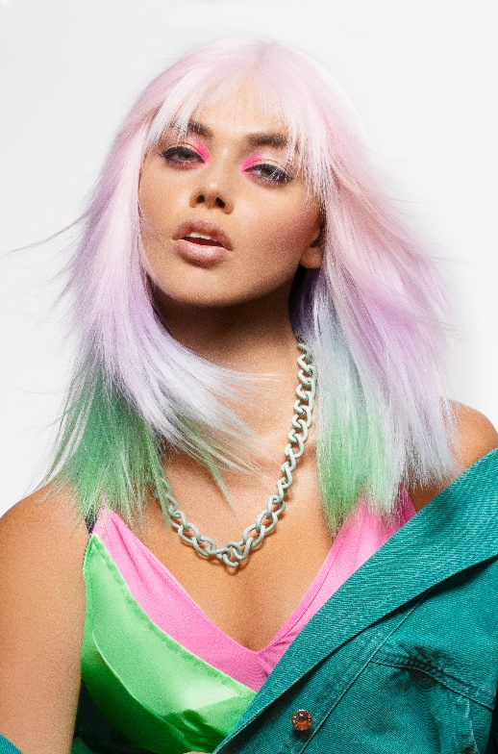
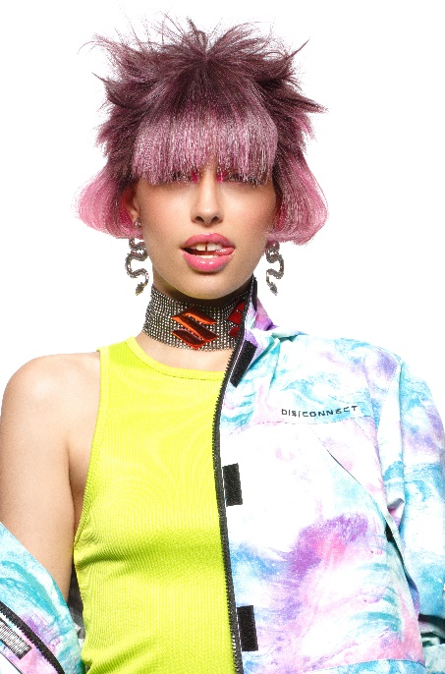
Hair: Hairkrone
Hair Instagram: @hairkrone
Photography: David Arnal
Photography Instagram: @davidarnalteam
Make up: Hairkrone
Make up Instagram: @hairkrone
Styling: Visori FashionArt
Styling Instagram: @visorifashionartstudio
Video: Juan Nito

HAIRKRONE
ISNEW Collection

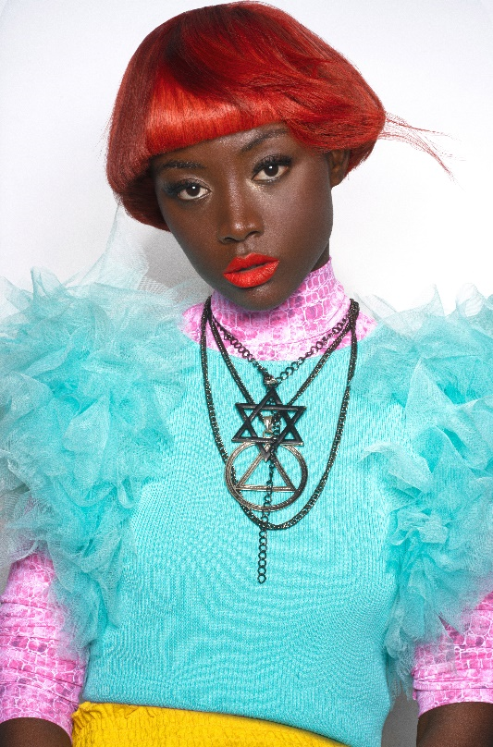

The new catches us with a promise to surprise us and not disappoint us. It is always an attractive and seductive concept of a future that sneaks into the present to shock us. Surprise is like a mantra that we pursue until it fills us, to quickly start the search again.

Devotion to the new is part of Generation Z’s communication mode, and that is what this collection, full of striking images, vibrant colors and finishes that suggest movement, recreates. Hair glides through in an energetic atmosphere, which represents everything that has just arrived. That is why textures are full of creative electricity and colors are intense, as a reflection of emotions and heartbeats caused by new findings.

