UNDER EMBARGO FOR RELEASE ON OCTOBER 9, 2023 08:00 AM EST

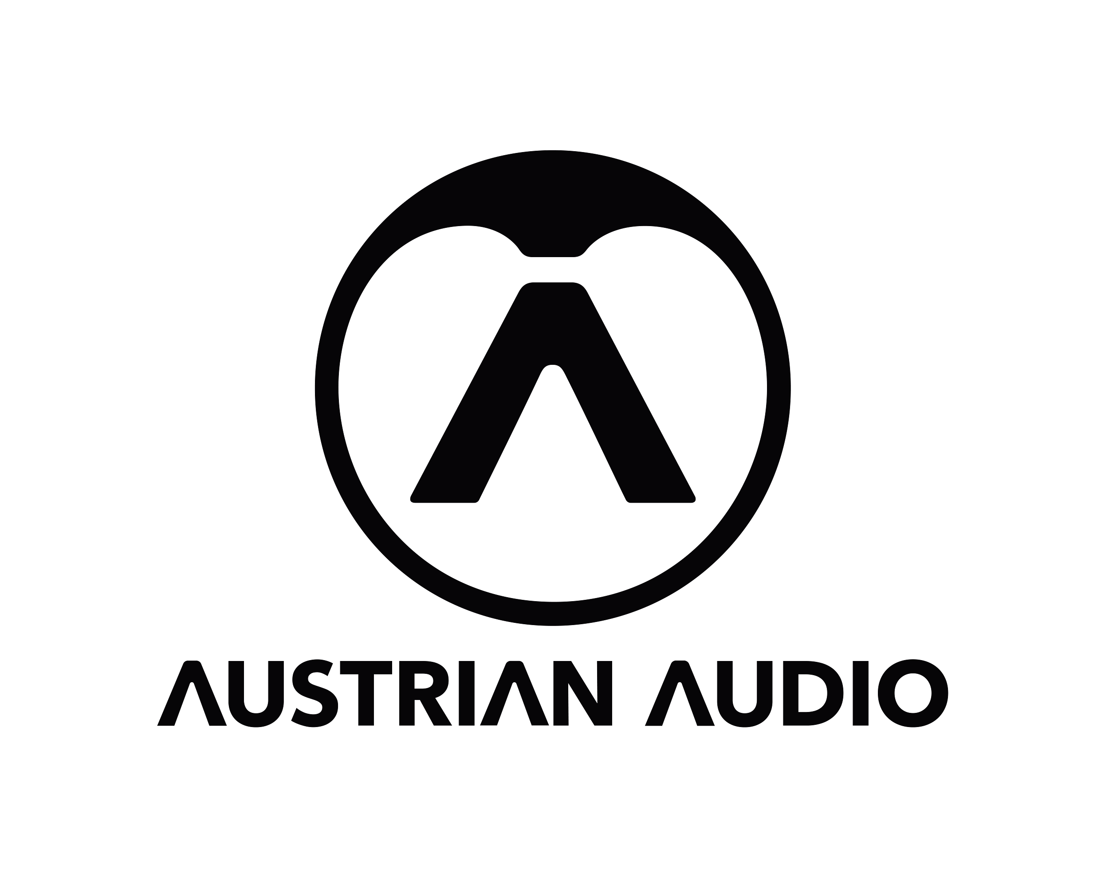
MiCreator Studio: Ultra-Flexible Pocket Recording System From Austrian Audio
Vienna, Austria, October 9, 2023 — Austrian Audio is proud to announce MiCreator Studio, an ultra-flexible pocket recording system that seamlessly combines a condenser microphone and a USB-C audio interface in a compact, rugged design that lets you record what you want, where you want, and when you want.
MiCreator Studio, which features an inspiring aesthetic design and the same top notch audio performance that Austrian Audio has become known for, is suitable for music recording, podcasting, field recording, interviews and a range of other applications.
The new recording system — which is small enough to fit in a jeans pocket — features a condenser microphone and a built-in audio interface, intuitive on-board controls, a line input and a range of expansion options to accommodate different applications. Users can select among three different microphone sensitivity options, including a 'Low Gain' setting that can handle up to 130 dB SPL. An additional input enables multi-tracking possibilities as well as optional stereo recording — all of this in an eye-catching, compact and plug-and-play recording system that fits in your pocket.

​Whether you are at home making demos, rehearsing with your band or creating recordings and interviews on-the-go, MiCreator and its extensive line of accessories provide limitless creative flexibility to record any time or place when creativity strikes.

The right MiCreator for your application
MiCreator Studio, which includes the single microphone / interface unit, is priced at $199 and is a compact and flexible solution, suitable for most users. The system includes a condenser microphone, line input, onboard controls and expansion options — all in a robust, all-metal housing that is ready for next project.

The MiCreator System Set is ideal for recording music and a variety of content and includes MiCreator Studio and a satellite MiCreator microphone for increased flexibility and recording possibilities. By using the satellite microphone, users can capture high-quality audio in stereo, while achieving perfect mic placement with the included MiniBar stereo bar. Accessories include two customizable faceplates and a custom case to keep your rig protected while on the go.

Both MiCreator Studio and MiCreator System Set come with Steinberg Cubase LE digital audio workstation or Wavelab Cast for podcasts and social media.

A myriad of microphone options
The MiCreator Satellite is also available for separate purchase, priced at $99. The MicCreator Y-Lav lavalier microphone, featuring direct latency-free monitoring, is also available — turning your MiCreator system into a mobile content creation powerhouse.

Users are able to record two simultaneous sources by tethering MiCreator Y-Lav to MiCreator Studio — freeing up the Studio mic for another source. Users can also connect MiCreator Satellite or MiCreator Y-Lav into a camera with a Y adapter (1x TRRS to 2x TRS), ensuring that content sounds as good as it looks.

“Many times a quick riff, a scratch vocal, or unplanned content creation is the best performance, so why not capture everything with studio quality sound,” says Martin Seidl, CEO of Austrian Audio. “​Whether you’re at home or on the go, MiCreator Studio always keeps Austrian Audio recording quality within reach.”

Bryan Bradley, President of Group One Limited, Austrian Audio’s US distributor, adds: “This is an exciting new direction for Austrian Audio and we’re excited to put this high-quality mic into the hands of musicians, songwriters, and content creators, making it easier for them to record premium audio whenever and wherever they feel inspired.”

Key Features:

- Plug-and-play USB-C microphone and audio interface
- Condenser capsule for top-notch audio quality
- Max SPL: 130 dB
- Austrian Audio Open Acoustic Technology
- Two gain settings and one knob jogwheel for easy volume control
- “FlexTilt” vertical adjustment of the mic head for ideal positioning
- Input for connecting a second device (MiCreator Satellite, Y-LAV mic, Instrument) - great for interview situations
- Two headphone outputs: Easily collaborate with fellow musician
- Latency-free direct monitoring of the mic and input while recording
- Rugged metal housing with changeable faceplates for a variety of color combinations and customization
- Designed in Vienna, Austria

US Dealer Info:
Austrian Audio products are available in online and brick-and-mortar stores throughout the US. Current and interested Austrian Audio retailers in the US should contact Michael Huckler at Group One Ltd., the exclusive US distributor of leading professional audio and lighting brands from around the world such as Solid State Logic, Klang, DiGiCo, Calrec and more.

About Austrian Audio
Austrian Audio opened its doors in 2017 following the closure of the AKG offices in Vienna and set out to create something new, challenging, and respectful to its heritage. The new company started with a core team of previous AKG personnel from management, acoustics, electronics, test and measurement, mechanical design, RF/wireless and software/firmware, bringing 350 years of cumulative engineering experience to the new company. More information at https://austrian.audio/

